Document: Auxiliary functions
Project: Engine Management System
HMC_V6
Version: a
Date: 17-Dec-97
Number of pages: 119
Revision Code-No.: 153589 from 18.12.97
Construction protocol-No.: –––––
Software version: 650H0000

 | Name | Department | Phone | Date | Sign
Author | Müller O. | AT PT SI TSA 11 | 3211 | 09.12.97
1. Check | Pioch O. | AT PT SI TSA 11 | 3212 | 09.12.97
2. Check | Gessner S. | AT PT SI TSA 11 | 5398 | 09.12.97
Responsible | Brückner D. | AT PT SI TSA 16 | 4279 | 09.12.97
Vehicle Electronik Systems Division Identification No.: 657765.49.08
–––––
Version list
Version | Date | Author | Comment, Description
Table of contents Page
1 Torque reduction for automatic gearshift
2 Air condition compressor control
3 Variable intake manifold control
4 Evaporative emission control
4.1 General
4.2 Evaporative emission control valve duty cycle ( CPPWM_CPS )
4.3 Evaporative emission control in steady operation ( CPPWM )
4.4 Evaporative emission control state STB_CP operation
4.5 Evaporative emission control state MIN operation
4.6 Evaporative emission control state NORMAL operation
4.7 Evaporative emission control duration ( T_CP )
4.8 Evaporative emission control in transient operation ( FAC_CP )
4.8.1 Evaporative emission control mode : RAMP mode
4.9 Evaporative emission control mode : LEARNING mode
4.10 Injection time correction with evaporative emission control ( LAM_TRA )
4.11 Influence of the evaporative emission control on lambda adaptation
5 Cooling and condenser fans control
6 Engine speed limitation
7 Vehicle speed limitation
8 Traction Control
8.1 Interface Description
8.1.1 General information
8.1.2 CAN Communication Signals
8.1.2.1 EMS Input Signals from the CAN
8.1.2.2 EMS Output Signals to the CAN
8.1.3 Status of Torque Intervention (STATE_TQ_INTV)
8.2 Internal auxiliary quantities
8.2.1 Relative torque reduction by misfire detection (TQR_REL_SCC_MIS)
8.2.2 Actual performed relative torque reduction by fuel cut-off (TQR_REL_SCC_AV)
8.2.3 Maximum relative torque reduction by spark retard (TQR_REL_MAX_IGA_N_MAF)
8.2.4 Actual relative torque reduction by spark retard (TQR_REL_IGA_AV)
8.3 Torque model
8.3.1 Standard torque (TQ_STND)
8.3.2 Frictional torque (TQFR)
8.3.3 Indicated engine torque (TQI)
8.3.3.1 Lambda influence weighted by ignition angle
8.3.3.2 Influence of ignition angle
8.3.3.2.1 Reference ignition angle (IGA_REF_TQR)
8.3.3.2.2 Relative Torque Reduction by EMS internal Spark Retard (TQR_REL_IGA_EMS)
8.3.3.3 Relative Torque Reduction by EMS internal Fuel Cut-Off (TQR_REL_SCC_EMS)
8.4 Exhaust gas temperature model
8.4.1 Stationary exhaust gas temperature (TEG_STAT)
8.4.2 Dynamic Exhaust Gas Temperature (TEG_MMV_SUB)
8.5 Torque Intervention for ASR and Gear Shift
8.5.1 Overview of the possible torque interventions
8.5.2 Conditions for ASR- and GS-intervention
8.5.3 Torque Reduction Intervention
8.5.3.1 Relative Nominal Torque Reduction for ASR (TQR_REL_ASR_NV)
8.5.3.2 Relative Nominal Torque Reduction for GS (TQR_REL_GS_NV)
8.5.3.3 Determination of the Torque Reduction Amount
8.5.3.4 Selection of the Torque Reduction Mode
8.5.3.5 Exhaust gas temperature logic
8.5.3.6 Ignition Angle Adjustment (IGA_ADJ) Mode
8.5.3.7 Cylinder Shut-Off (SCC) Mode
8.5.3.8 Torque Reduction by Single Cylinder Shut-Off (SCC) and Ignition Angle Adjustment (IGA_ADJ) Mode
8.5.3.9 Minimum Torque Reduction Pattern
8.5.3.10 Hysteresis between Cylinder Shut-Off and Ignition Angle Adjustment
8.5.4 Torque Intervention by the Application System
8.6 Execution of a Torque Intervention
8.6.1 Ignition Angle Retard Adjustment (IGA_ADJ_TQR)
8.6.2 Selection of Cylinder Shut-Off Patterns
8.7 Auxiliary functions
8.7.1 ASR Warm-up
8.7.2 Leaning Function for Cylinder Shut-Off outside the Warm-Up Mode
8.7.3 Inhibition of Lambda closed loop control
8.7.4 Inhibition of EGR during Cylinder Shut-Off
8.7.5 Cylinder-specific fuel mixture enrichment on restarting fuel-feed
8.7.5.1 Calculation of the Wall-Applied Fuel Film Removal
8.7.5.2 Additional Injection Quantity for Re-Activation of the Cylinder
8.7.5.3 Case studies
8.8 Torque during an torque intervention (TQI_INTV)
8.9 ASR Statistics Counters
8.9.1 Cylinder Shut-Off Time Counter T_SCC_S and T_SCC_L
8.9.2 Event Frequency Counter - Intervention Statistics ASR_STAT_0...15
8 .10 Torque Reduction Emergency Operation
9 Fuel pump relay control

Index Page
A
ACK_TCS_CAN
def 71
ASR_STAT_0...15
def 116
C
C_ACCIN_DLY_1
def 22
C_ACCIN_DLY_4
def 22
C_ACCIN_DLY_5
def 22
C_ACCIN_DLY_6
def 22
C_ACCIN_VS_MAX
def 22
C_COR_FAC_INC_CP
def 40
C_CPPWM_AD_MAX
def 45
C_CPPWM_AD_MIN
def 45
C_CPPWM_AS
def 34
C_CPPWM_CLOSE
def 40
C_FAC_CP_LD_MAX
def 45
C_FAC_MIN_P_CP
def 45
C_IGA_LGRD_TQR
def 107
C_LAM_CYCNR
def 70
C_LAM_DIF_MAX_TRA
def 45
use 46
C_LAM_MAX_CYCNR
def 34
C_LAM_MIN_CP
def 45
C_LAM_MV_BEG_MAX
def 36
C_LAM_MV_CRLC
def 51
C_LAM_MV_DIF_COR_MAX_CP
def 45
use 46
C_LAM_MV_DIF_MAX_1_CP
def 45
C_LAM_MV_MMV_DIF_CP
def 51
C_LAM_TRA_STATE_MIN
def 45
use 46
C_LGRD_TQR_DEC_DIAG
def 118
C_MAF_FAC_ALTI_IS_CP
def 34
C_MAF_LAM_BOL_TRA
def 51
C_MAF_LAM_TOL_TRA
def 51
C_N_ACCIN_OFF
def 22
C_N_ADD_ASR
def 94
C_N_FCUT
def 68
C_N_HYS_VIM
def 26
C_N_MAX
def 68
C_N_MAX_CRK_DIAG
def 68
C_N_MAX_FCUT
def 68
C_N_MAX_HYS
def 68
C_N_MAX_HYS_MAX
def 68
C_N_MAX_IGA_TQR
def 98
C_N_MAX_MAX
def 68
C_N_MAX_TPS_DIAG
def 68
C_N_MAX_TPS_ISAPWM_DIAG
def 68
C_N_MAX_VS_DIAG
def 68
C_SUM_STATE_MAX
def 45
C_T_1_CP
def 36
C_T_2_CP
def 36
C_T_DLY_DIAG_TQR
def 118
C_T_DLY_EGR_TQR
def 111
C_T_DLY_LAM_TQR
def 110
C_T_EFP
def 119
C_T_GS_DLY_DIAG
def 19, 94
C_T_LAM_MAX_STATE
def 45
C_T_N_MAX_FCUT
def 68
C_T_OFF_CFA_ST
def 62
C_T_RTD_DEC_CFA
def 62
C_T_RTD_INC_0_CFA
def 62
C_T_RTD_INC_1_CFA
def 62
C_T_VIM_FAC
def 26
C_TCO_1_CFA
def 62
C_TCO_2_CFA
def 62
C_TCO_3_CFA
def 62
C_TCO_4_CFA
def 62
C_TCO_5_CFA
def 62
use 20
C_TCO_HYS_1_CFA
def 62
C_TCO_HYS_2_CFA
def 62
C_TCO_HYS_3_CFA
def 62
C_TCO_HYS_4_CFA
def 62
use 20
C_TCO_MIN_CP
def 34
C_TCO_MIN_SCC
def 98
C_TCO_N_MAX_FCUT
def 68
C_TCO_ON_CFA_ES
def 62
C_TEG_FAC_IGA
def 103
C_TEG_MAX
def 98
use 104
C_TEG_THD_1
def 98
C_TEG_THD_2
def 98
C_TI_T_AD_1
def 36
C_TI_VS_MAX_COR
use 69
C_TPS_GRD_ACCIN_OFF
def 22
C_TPS_HYS_VIM
def 26
C_TQ_INTV_REL_ERR_MAX
def 75
C_TQ_STND
def 81
C_TQFR_ADD_ACC_H
def 82
C_TQFR_ADD_ACC_L
def 82
C_TQR_AS
def 106
C_TQR_HYS
def 105
C_VB_MIN_VIM
def 26
C_VS_ACCIN_OFF
def 22
C_VS_MAX_CYCNR
def 70
C_VS_MAX_HYS
def 70
C_VS_MIN_VIM
def 26
CONF_CP
use 31
CONF_LAM
use 31
CPPWM
def 30
use 29, 30, 37, 41, 46, 52
CPPWM_CPS 29
CRLC_TEG
def 88
F
FAC_BEG_CP
def 37
use 41
FAC_CP
def 37
use 30, 33, 41
FAC_IGA_TQR
def 79, 86
use 85
FAC_TQR
def 107
use 85
I
ID_CRLC_TEG_DEC__MAF_KGH
def 90
ID_CRLC_TEG_INC__MAF_KGH
def 90
ID_N_MAX_CYCNR__VS
def 68
ID_ON_CFA_ES__TCO__TIA
def 62
ID_PAT_INH_IV_MIN__LAM_SUB__TEG_DIF
def 103
use 100
ID_PAT_INH_IV_TQR__TQR_REL_NV
def 101
use 102
ID_TEG_FAC_SCC__PAT_INH_IV
def 90
ID_TI_DEC_WF__N_32
def 114
ID_TI_INC_WF__N_32
def 114
ID_TI_N_POS_RG__N_32
def 114
ID_TI_SCC__MAF_KGH
def 109
ID_TI_TCO_NEG_WF__TCO
def 114
ID_TI_TCO_POS_WF__TCO
def 114
ID_TQR_REL_SCC__PAT_INH_IV
def 103
use 87
ID_TQR_REL_SCC__PAT_INH_IV_TQR
def 101
ID_VIM__N_32_VIM__TPS_VIM
def 26
IGA_ADJ_TQR
def 107
IGA_BAS
use 85
IGA_CYL_[CYL]
use 86
IGA_DIF_REF_AV
def 79
use 83
IGA_DIF_REF_EMS
def 86
IGA_EGR
use 85
IGA_IGC_CYL_[CYL]
use 79
IGA_OUT_TQR
def 107
IGA_OUT_TQR_NV
def 107
IGA_REF_TQR
def 85
use 79, 86, 107
IP_ACCIN_DLY_2__N_32
def 22
IP_ACCIN_DLY_3__N_32
def 22
IP_CPPWM_ALTI_COR_MAX__N_32__MAF_ALTI_COR
def 34
use 46
IP_CPPWM_ALTI_COR_MIN__N_32__MAF_ALTI_COR
def 34
IP_CPPWM_CPS__CPPWM
def 29
IP_CPPWM_CPS_VB_ADD__VB
def 29
IP_CPPWM_MAX__N__MAF
use 37, 41, 46
IP_CPPWM_MAX__N_32__MAF
def 34
IP_CPPWM_MIN__N__MAF
use 37, 41, 46
IP_CPPWM_MIN__N_32__MAF
def 34
IP_FAC_DEC_CP__MAF_KGH
def 40
IP_FAC_FAC_DEC
def 40
IP_FAC_IGA_TQR__FAC_TQR
def 85
use 107
IP_FAC_INC_CP__MAF_KGH
def 40
IP_FAC_LAM_TQI__LAM_SUB__IGA_DIF_REF_AV
def 83
use 18, 83, 95, 96, 115
IP_FAC_TQR__FAC_IGA_TQR
def 80, 85
use 79, 86
IP_FAC_VS_TEG__VS
def 90
IP_IGA_DIF_MAX_TQR__N_32__MAF
def 80, 107
use 86
IP_LAM_CP__N_32__MAF
def 51
IP_LAM_CP__N_32__MAF_ALTI_COR
def 51
use 41
IP_LAM_DIF_MAX_CP
def 45
IP_LAM_TRA_LGRD__MAF_KGH
def 51
IP_MAF_ALTI_COR_MAX_CPS__N_32
def 34
IP_N_MAX_ISAPWM_DIAG__TPS
def 68
IP_T_VIM__VB
def 26
IP_TEG__N_32__MAF
def 90
IP_TEG_ADD_IGA__POW_DIF
def 90
IP_TEG_FAC_LAM__LAM_SUB
def 90
IP_TEG_STAT_ADD_SCC__MAF_KGH
def 90
IP_TI_TCO_WUP_ASR__TCO__TCO_ST
def 109
IP_TQFR__N_32__MAF
def 82
IP_TQFR_ADD_TCO__TCO
def 82
IP_TQI__N_32__MAF
def 83
use 18, 95, 96, 115
IP_TQR_REL_MAX_IGA__N_32__MAF
def 78
L
L_INH_IV_[CYL]
use 30
LAM_MV_BEG 41
use 35, 46
LAM_MV_DIF_COR_CP 46
use 41
LAM_MV_DIF_CP 40, 41
use 46
LAM_MV_DIF_CP_LD 41
LAM_MV_i 46
use 41
LAM_MV_MMV 46
LAM_MV_MMV_DIF 46
LAM_SUB 84
use 83, 88
LAM_TRA 46
use 30, 41
LV_ACCIN
use 20, 53
LV_ACIN
use 20, 53
LV_ACK_TCS
use 71
LV_ASR_REQ
def 71
use 74, 91
LV_AUTH_LAM_1_AD_LEARN_CP
def 52
LV_AUTH_LAM_2_AD_LEARN_CP
def 52
LV_AUTH_LAM_AD_CP
def 52
use 30, 35
LV_AUTH_LAM_i_AD_LEARN_CP
use 41
LV_CDN_ASR
def 91
use 95
LV_CDN_GS
def 91
use 96
LV_CPS_ERR
use 30, 91
LV_CRK_ERR
use 64
LV_CRK_ERR_LIH
use 64
LV_CT
use 20, 64
LV_DRI
use 18, 64, 91
LV_DUR_IGC_[CYL]_ERR
use 31
LV_ENG_RUN_IS_PL
use 23
LV_ES
use 18, 23, 27, 53, 79, 81, 83, 84, 86, 88, 91, 115, 119
LV_FL
use 20, 41
LV_GS_REQ
def 71
use 18, 74
LV_IGA_ADJ_MOD
def 97
use 99, 100, 102
LV_IGA_ADJ_TQR
def 99, 100, 102
LV_IGA_AST
use 27
LV_IGK
use 53, 119
LV_IS
use 18, 20, 30, 35, 53, 91
LV_ISA_i_ERR
use 31, 64
LV_ISA_MECHA_ERR
use 64
LV_IV_[CYL]_ERR
use 31, 91
LV_LAM_ACT_i
use 46
LV_LAM_LIM_CDN
use 37
LV_LEARN_CP
def 41
use 52
LV_LS_i
use 46
LV_LSCL_1
use 69
LV_LSCL_2
use 69
LV_LSCL_i
use 31
LV_LSH_UP_i_ERR
use 31
LV_MAF_ERR
use 31, 64, 91
LV_MAF_PLAUS_ERR
use 31, 64
LV_MIN_PHA_CP
def 31
use 52
LV_N_MAF_DYW_i
use 46
LV_N_MAX
def 64
LV_N_MAX_FCUT
def 64
LV_NORMAL_PHA_CP
def 33
use 52
LV_OPL_VS_MAX
def 69
LV_PL
use 20, 35
LV_PRS_ACC
use 53, 81
LV_PUC
use 41, 83
LV_RLY_ACCOUT
def 20
use 53, 81
LV_RLY_ACCOUT_CTRL
def 20
LV_RLY_FAN_H
def 53
LV_RLY_FAN_L
def 53
LV_SCC_EGR_TQR
def 111
LV_SCC_LAM_TQR
def 110
LV_SCC_MOD
def 97
use 74, 99, 100, 102
LV_SCC_TQR
def 99, 100, 102
use 108, 109, 110, 111
LV_SLOP_CP
def 37
use 52
LV_SOV_ERR
use 30
LV_SOV_MECHA_ERR
use 30
LV_ST
use 18, 20, 23, 27, 35, 91
LV_STATE_A_MIS
use 31
LV_STB_PHA_CP
def 30
use 29, 52
LV_TCO_ERR
use 31, 53, 64
LV_TCO_PLAUS_ERR
use 31
LV_TEG_MAX
def 97
LV_TI_AST
use 27
LV_TIA_ERR
use 31
LV_TPS_ERR
use 31, 64
LV_TPS_PLAUS_ERR
use 31, 64
LV_VIM
def 23
LV_VIM_CTRL
def 23
LV_VLS_LIM_i_ERR
use 31
LV_VLS_UP_i_ERR
use 31
LV_VS_ERR
use 64
LV_VS_MAX
def 69
M
MAF
use 46, 78, 79, 81, 83, 88
MAF_ALTI_COR
use 31, 33, 41, 46
MAF_FAC_ALTI_MMV
use 30
MAF_KGH
use 46, 88, 109
MIS_NR_OFF_IV
use 76
N
N
use 88, 91, 102
N_32
use 20, 23, 41, 46, 64, 69, 78, 79, 81, 83, 88, 112
N_32_VIM
def 23
N_MAX_MAX
def 64
N_MAX_THD
def 64
N_SP_IS
use 91
NC_CYL_NO
use 79, 86
NC_INI_INH_SWI_IV_SHIFT_NR
use 64, 69
P
PAT_INH_IV
use 30, 88
PAT_INH_IV_MAX_N_VS
def 87
PAT_INH_IV_N_MAX
def 64
use 87
PAT_INH_IV_TQR
def 99, 100, 102
PAT_INH_IV_VS_MAX
def 69
use 87
POW_DIF
def 88
S
STATE_CFA
def 53
STATE_CFA_1
def 53
STATE_CFA_IS
def 53
STATE_TQ_INTV
def 74
use 71
SWI_GS_CAN
use 71
T
T_ASR_CTR
def 116
T_CP
def 35
use 41
T_DLY_DIAG_TQR
def 118
T_DLY_EGR_TQR
def 111
T_DLY_LAM_TQR
def 110
T_GS_DLY_DIAG
def 18, 91
T_SCC_L
def 116
T_SCC_S
def 116
T_VIM
def 23
TCO
use 20, 30, 53, 64, 81, 88, 97, 108, 112
TCO_ST
use 108
TCS_REQ_CAN
use 71
TEG_DIF
def 104
use 102
TEG_MMV_SUB
def 88
use 97, 104
TEG_STAT
def 88
TI_AD_ADD_MMV
use 84
TI_AD_FAC_MMV
use 84
TI_ADD_REAC_SCC_[CYL]
def 112
TI_DIF_WF_[CYL]
def 112
TI_LAM
use 46
TI_LAM_i
use 41
TI_MV
use 84
TI_WUP_COR
def 108
TIA
use 53
TIB
use 84, 112
TPS
use 23, 64
TPS_GRD
use 20
TPS_VIM
def 23
TQ_COR_STAT_CAN
def 71
TQ_INTV_REL_ERR
def 74
TQ_STND
def 81
use 18, 71, 74, 91
TQ_STND_CAN
def 71
TQFR
def 81
use 71
TQFR_CAN
def 71
TQI
def 83
use 18, 71, 88, 91, 102
TQI_ACOR_CAN
def 71
TQI_ASR_REQ
def 71
use 18, 74, 95
TQI_CAN
def 71
TQI_GS_REQ
def 71
use 18, 74, 96
TQI_INTV
def 115
use 71, 74
TQI_TCS_CAN
use 71, 91
TQI_TCU_CAN
use 18, 71, 91
TQR_AS
def 106
use 91
TQR_ASR_MAX
def 116
TQR_REL_ASR_NV
def 95
use 96, 116
TQR_REL_GS_NV
def 96
use 96
TQR_REL_IGA_AV
def 79
use 88, 115
TQR_REL_IGA_EMS
def 86
use 83
TQR_REL_IGA_OUT
def 91, 99, 100, 102
use 91, 107
TQR_REL_MAX_IGA_N_MAF
def 78
use 79, 86, 97, 99, 102, 107
TQR_REL_MAX_IGA_TEG
def 102
TQR_REL_NV
def 96
use 97, 99, 102
TQR_REL_OUT
def 91
TQR_REL_SCC_AV
def 77
use 78, 115, 116
TQR_REL_SCC_EMS
def 87
use 83
TQR_REL_SCC_MIS
def 76
use 77, 87
TQR_REL_SCC_N_VS
def 87
TQR_REL_SCC_OUT
def 91, 99, 100, 102
use 77
V
VB
use 23, 29
VS
use 20, 64, 69, 88
VS_MAX
use 69
VS_STATE_CFA
use 53

Torque reduction for automatic gearshift
Output data:
Name | Mode | Hex. limits | Phys. limits | Resol. | Unit
T_GS_DLY_DIAG | V | 0...FFFFH | 0...655.35 | 0.01 | s
Diagnosis time during gearshift
Input data:
TQI_GS_REQ | LV_GS_REQ | LV_ST | LV_ES
TQI | TQI_ASR_REQ | LV_DRI | TQ_STND
IP_TQI__N_32__MAF | IP_FAC_LAM_TQI__LAM_SUB__IGA_DIF_REF_AV | LV_IS | TQI_TCU_CAN
FUNCTION DESCRIPTION:
General information:
At a car with automatic transmission the engine torque during gearshift event is reduced by retarding of spark advance or, if this is not enough, by cylinder shut-off. The reduced torque is requested by the TCU. The apportionment of the torque reduction between spark retard and cylinder shut-off is done by the torque management control logic, which is described in the chapter „Traction Control - Torque Intervention“.

The gearshift respectively the duration of the torque reduction request is watched by a timer T_GS_DLY_DIAG. If the timer reaches the limit C_T_GS_DLY_DIAG, the torque reduction will be ramped to zero and not performed anymore during the current driving cycle.

Application recurrence: 10 ms
Application conditions:

If LV_IS = 0 (not idle speed)
and LV_ES = 0 (not engine stop)
and LV_ST = 0 (not engine start)
and LV_DRI = 1 (Drive or reverse gear selected)
and TQI_GS_REQ < TQI (actually torque reduction requested)
and TQI_GS_REQ < TQI_ASR_REQ (req. torque for GS below ASR-torque)
and TQI_TCU_CAN < 100% (TQ_STND) (GS requested torque below TQI)
and T_GS_DLY_DIAG < C_T_GS_DLY_DIAG (diagnosis time not exceeded)
then LV_CDN_GS = 1 (torque reduction is possible)
else LV_CDN_GS = 0 (no torque reduction possible)

Formula section :

The torque during gearshift TQR_REL_GS_NV is calculated from the torque reduction control logic as described in chapter „Traction Control - Torque Intervention“.

Calibration data:
Name | Dim | Hex. limits | Phys. limits | Resol. | Unit
C_T_GS_DLY_DIAG | INT | 0...FFFFH | 0...655.35 | 0.01 | s
Diagnosis timer threshold for gearshift

Air condition compressor control
Output data:
Name | Mode | Hex. limits | Phys. limits | Resol. | Unit
LV_RLY_ACCOUT | V | 0...01H | 0...1 | 1 | -
Boolean of air condition compressor relay (OFF / ON).
LV_RLY_ACCOUT_CTRL | V | 0...01H | 0...1 | 1 | -
Boolean to activate ISAPWM correction related to air condition compressor relay
Input data:
LV_ACIN | LV_ACCIN | LV_ST | LV_FL
LV_PL | LV_IS | N_32 | TCO
VS | C_TCO_5_CFA | C_TCO_HYS_4_CFA | LV_CT
TPS_GRD
FUNCTION DESCRIPTION:
General information:
The air condition compressor relay LV_RLY_ACCOUT is controlled by the ECU. It is enabled and disabled versus LV_ACIN and LV_ACCIN information. In order to keep a stable engine speed when A/C compressor is activated or dis-activated, idle speed valve correction are triggered in advance with LV_RLY_ACCOUT_CTRL.

Remind : LV_ACIN : Air condition selected
LV_ACCIN : Air condition requested

Application reccurency = 40 ms

Application conditions:
* Initialization :
LV_RLY_ACCOUT and LV_RLY_ACCOUT_CTRL are set to 0 in the engine operating state engine stopped (LV_ES).

* Activation ( LV_RLY_ACCOUT = ON ) :
If corresponding “Variant Coding” dedicated
and engine operating states engine stopped (LV_ES) not active
and engine operating state start (LV_ST) not active
and air condition selected (LV_ACIN = ACIN)
and air condition requested (LV_ACCIN = ACCIN)
and LV_RLY_ACCOUT= OFF since more than C_ACCIN_DLY_5 seconds
and TCO ≤ C_TCO_5_CFA
then LV_RLY_ACCOUT_CTRL is enabled immediately
LV_RLY_ACCOUT is enabled after IP_ACCIN_DLY_2__N_32 seconds.

* Deactivation ( LV_RLY_ACCOUT = OFF ) :
If one of the deactivation conditions are true, LV_RLY_ACCOUT and LV_RLY_ACCOUT_CTRL are disabled whatever the activation conditions are.

1 - If engine operating state start (LV_ST) active
then LV_RLY_ACCOUT_CTRL is disabled during C_ACCIN_DLY_4 seconds
LV_RLY_ACCOUT is disabled during IP_ACCIN_DLY_2 + C_ACCIN_DLY_4

2 - If acceleration enrichment due to full load (LV_FL) active
and VS < C_ACCIN_VS_MAX
then LV_RLY_ACCOUT_CTRL and LV_RLY_ACCOUT are disabled immediately during C_ACCIN_DLY_1 seconds.

3 - If LV_ACCIN = 0 ( - )
then LV_RLY_ACCOUT_CTRL is disabled immediately
LV_RLY_ACCOUT is disabled after IP_ACCIN_DLY_3__N_32 seconds.

4 - If TCO > C_TCO_5_CFA
then LV_RLY_ACCOUT_CTRL is disabled immediately
LV_RLY_ACCOUT is disabled after IP_ACCIN_DLY_3__N_32 seconds
until TCO ≤ C_TCO_5_CFA - C_TCO_HYS_4_CFA

5 - If TPS_GRD > C_TPS_GRD_ACCIN_OFF ( vehicle take-off detection )
and LV_CT = 0
and VS < C_VS_ACCIN_OFF
and N_32 < C_N_ACCIN_OFF
then LV_RLY_ACCOUT_CTRL and LV_RLY_ACCOUT are disabled immediately during C_ACCIN_DLY_6 seconds

Description:

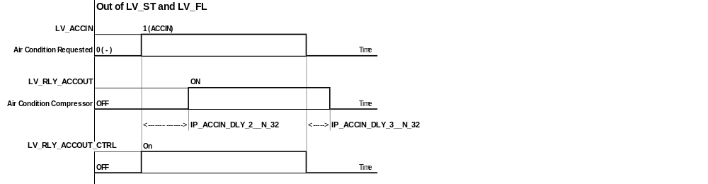
Calibration data:
Name | Dim | Hex. limits | Phys. limits | Resol. | Unit
C_ACCIN_VS_MAX | 1 | 0...FFH | 0...255 | 1 | km/h
Maximum vehicle speed to deactivate the air condition compressor in full load (LV_FL).
C_TPS_GRD_ACCIN_OFF | 1 | 0...FFH | 0...2988 | 11,71 | °TPS/sec
TPS_GRD threshold to detect vehicle take off
C_VS_ACCIN_OFF | 1 | 0...FFH | 0...255 | 1 | km/h
Vehicle speed threshold to detect vehicle take off
C_N_ACCIN_OFF | 1 | 0...FFH | 0...8160 | 32 | rpm
Engine speed threshold to detect vehicle take off
C_ACCIN_DLY_1 | 1 | 01...FFH | 0,1...25,5 | 0,1 | sec
Time delay to deactivate air condition compressor in full load (LV_FL)
IP_ACCIN_DLY_2__N_32 | 3 | 01...FFFFH | 0,01...655,35 | 0,01 | sec
Time delay to activate air condition compressor when LV_ACCIN = 1.
IP_ACCIN_DLY_3__N_32 | 3 | 01...FFFFH | 0,01...655,35 | 0,01 | sec
Time delay to deactivate air condition compressor when LV_ACCIN = 0.
C_ACCIN_DLY_4 | 1 | 01...FFH | 0,1...25,5 | 0,1 | sec
Time delay to deactivate air condition compressor after Start.
C_ACCIN_DLY_5 | 1 | 01...FFH | 0,1...25,5 | 0,1 | sec
Time delay between two air condition activations.
C_ACCIN_DLY_6 | 1 | 01...FFH | 0,1...25,5 | 0,1 | sec
Time delay between to deactivate air condition compressor in case of vehicle take off.

Variable intake manifold control
Output data:
Name | Mode | Hex. limits | Phys. limits | Resol. | Unit
LV_VIM | V | 0...01H | 0...1 | 1 | -
Boolean for variable intake manifold control state (CLOSED / OPEN).
LV_VIM_CTRL | V | 0...01H | 0...1 | 1 | -
Boolean for variable intake manifold control target state (CLOSED / OPEN).
T_VIM | V | 0...FFH | 0...25.5 | 0.1 | s
Time counter for operation of variable intake manifold control.
N_32_VIM | V | 0...FFH | 0...8160 | 32 | rpm
Engine speed used for variable intake manifold control.
TPS_VIM | V | 0...FFH | 0...119.5 | 0,4686 | °TPS
Throttle angle used for variable intake manifold control.
Input data:
N_32 | TPS | LV_ES | LV_ST
LV_ENG_RUN_IS_PL | VB
FUNCTION DESCRIPTION:
General information:
The variable intake system is designed to vary the inertia supercharging effect in order to improve the engine torque and the performances. At low engine speed the engine draws the intake air through long tubes to optimize the torque output, whereas at high engine speed shorter tubes are used to increase the power.

Description:

The VIM is initialized to closed position (LV_VIM=0, LV_VIM_CTRL=0) for engine stop (LV_ES =1) and start (LV_ST=1). To operate the VIM a DC-motor, whose speed depends on VB, is activated if LV_VIM_CTRL changes (0 to 1 or 1 to 0). The duration of opening/closing is determined by a counter, which makes a gradually operation possible.

At transition of LV_VIM_CTRL from 0 to 1, which indicates opening (i.e. forward motor speed) the time-counter T_VIM_{(n)} is increased each 100 msec until it reaches IP_T_VIM__VB, which takes into consideration the dependency on VB.
For closing (i.e. reverse motor speed) the same time-counter is increased until IP_T_VIM__VB at transition of LV_VIM_CTRL from 1 to 0. If the opening time should be different from the closing time, the difference can be calibrated by the correction factor C_T_VIM_FAC, which is apllied to IP_T_VIM__VB if LV_VIM_CTRL = 0.

To avoid too many shiftings, hysteresis on N_32 and TPS are used in both directions.

The application recurrence is 100 msec.
Application conditions:

Available for all engine operating states.
Formula section:

* N_32_VIM-calculation:

If LV_ES = 1
or LV_ST = 1

then N_32_VIM = N_32
else

If ⏐N_32_VIM - N_32⏐ > C_N_HYS_VIM
then N_32_VIM = N_32

If LV_VIM = and LV_VIM_CTRL = 0 ( VIM closing period)
or LV_VIM = 0 and LV_VIM_CTRL = 1 ( VIM opening period)

then N_32_VIM is not updated

* TPS_VIM-calculation:

If LV_ES = 1
or LV_ST = 1

then TPS_VIM = TPS
else

If ⏐TPS_VIM - TPS⏐ > C_TPS_HYS_VIM
then TPS_VIM = TPS

If LV_VIM = 1 and LV_VIM_CTRL = 0 ( VIM closing period)
or LV_VIM = 0 and LV_VIM_CTRL = 1 ( VIM opening period)

then TPS_VIM is not updated

* VIM-Activation for normal operation:

If LV_ES = 1
or LV_ST = 1
or VS < C_VS_MIN_VIM

then LV_VIM_CTRL = 0
else LV_VIM_CTRL = ID_VIM__N_32_VIM__TPS_VIM

Remark:
If VB < C_VB_MIN_VIM then the variable intake manifold is not operated.
* VIM-Activation for anti-sticking operation :

To avoid valve sticking, it is necessary to open and close the valve only one time after
ignition key off is detected during power latch period.

If LV_IGK=0 ( Ignition key off)
and LV_ENG_RUN_IS_PL = 1
and VB > C_VB_MIN_VIM

then LV_VIM_CTRL = 1 during T_VIM period ( VIM opening) and sequentially
LV_VIM_CTRL = 0 during T_VIM period ( VIM closing)

else (LV_IGK = 1 detected during VIM operating)
stop activation of VIM immediately
close VIM after engine cranking (LV_ST = 0 and LV_ES = 0)

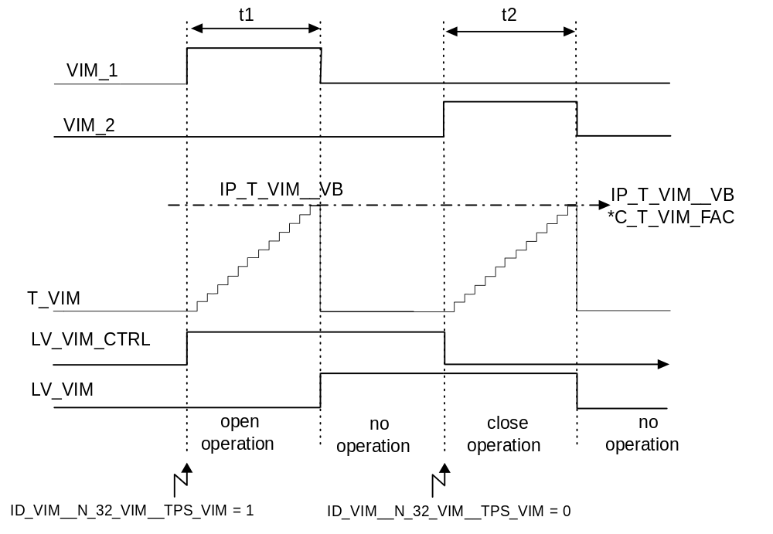
VIM_1 : opening comand from ECU t1 : opening time
VIM_2 : closing comand from ECU t2 : closing time

Calibration data:
Name | Dim | Hex. limits | Phys. limits | Resol. | Unit
ID_VIM__N_32_VIM__TPS_VIM | 8 x 8 | 0...01H | 0...1 | 1 | -
Variable intake manifold state versus operating point (N, TPS)
IP_T_VIM__VB | 6 | 0...FFH | 0...25,5 | 0,1 | s
Time to operate variable intake manifold versus VB
C_N_HYS_VIM | 1 | 0...FFH | 0...8160 | 32 | rpm
Engine speed hysteresis to determine variable intake manifold state.
C_TPS_HYS_VIM | 1 | 0...FFH | 0...119,5 | 0,47 | °TPS
Throttle angle hysteresis to determine variable intake manifold state.
C_T_VIM_FAC | 1 | 0...FFH | 0...1,992 | 0,0078 | -
Correction factor for Variable intake manifold closing time .
C_VB_MIN_VIM | 1 | 0...FFH | 0...25.8984 | 0,10116 | V
Battery voltage threshold to determine variable intake manifold state.
C_VS_MIN_VIM | 1 | 0...FFH | 0...255 | 1 | km/h
Vehicle speed threshold to determine variable intake manifold state.

Evaporative emission control

General
Input data:
LV_ES | LV_ST | LV_TI_AST | LV_IGA_AST

The evaporative emission control is closely related to the A/F regulation loop and lambda adaptation.
In some engine operating states, these functions must be controlled in a specific manner.

In the case of A/F regulation loop for an engine with two separate exhaust - system branches, the evaporative emission control mostly interacts with only one of the two lambda controllers (i.e. determination of the charcoal canister saturation degree).

The desired cylinder group is selected using the applicative constant C_CONF_CP , please refer to chapter „General“.

Application recurrence : 100 msec.
The application recurrence is independent to the control frequency of the CPS.
General information:
The evaporative emission control includes the following partial functions :

* Steady operation :
- STB_CP operation : no purging (evaporative emission control valve closed).
- MIN operation : purging with a flow rate for an unknown degree of charcoal canister saturation.
- NORMAL operation : purging with a flow rate adapted to the degree of charcoal canister saturation.

* Transient operation :
- RAMP mode : opening and closing the evaporative emission control valve.
- LEARNING mode : determination of the charcoal canister saturation degree.

The charcoal - canister purge is performed in all engine operating states except :

- engine stopped (LV_ES)
- engine operating state start (LV_ST)
- post - start function (LV_TI_AST or LV_IGA_AST) is enabled and not over.
The duty cycle used to adjust the evaporative emission control valve (CPS) is formed of a pre-control value and a correction value during normal operation.

The degree of the charcoal-canister saturation is determined by a defined shift of this correction value by means of evaluating the A/F regulation loop signal.

The unmetered A/F mixture supplied to the engine via the evaporative emission control valve is limited to an applicable value when determining the degree of the charcoal-canister saturation. This is used to control the maximum enrichment of the mixture supplied to the engine.

Remark : If CONF_LAM = 0
then charcoal-canister purge is possible only during MIN operation, due to the fact that the degree of saturation cannot be determined.
Description:
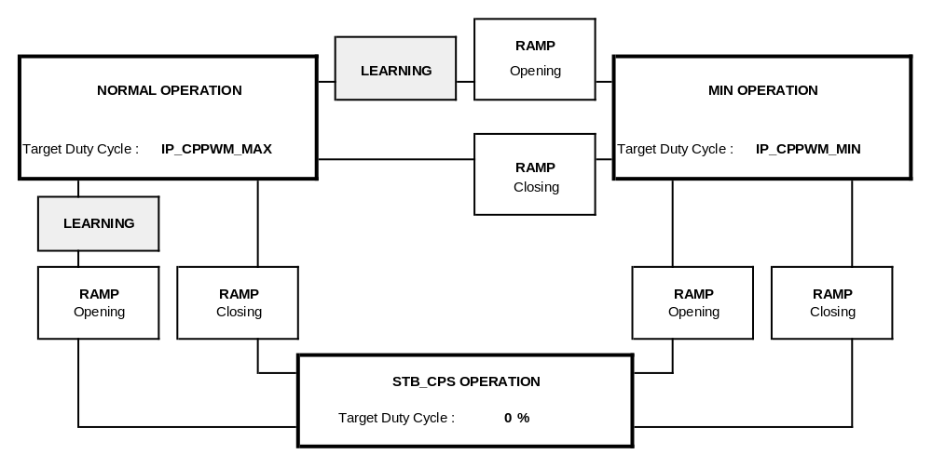

Evaporative emission control valve duty cycle ( CPPWM_CPS )
Output data:
Name | Mode | Hex. limits | Phys. limits | Resol. | Unit
CPPWM_CPS | V | 00...FFH | 0...99.609 | 0.3891 | %
Evaporative emission control duty cycle corrected with the characteristic of the valve.
Input data:
CPPWM | VB | LV_STB_PHA_CP
FUNCTION DESCRIPTION:
General information:
The control duty cycle CPPWM_CPS is formed from the opening value duty cycle calculated CPPWM (%), the valve characteristic correction IP_CPPWM_CPS__CPPWM and the battery voltage correction IP_CPPWM_CPS_VB_ADD__VB. To be sure the canister purge valve is closed in Stand-By mode, battery voltage correction is not taken in account in Stand-By mode.

Formula section:
If LV_STB_PHA_CP = 0
Then
CPPWM_CPS = IP_CPPWM_CPS__CPPWM + IP_CPPWM_CPS_VB_ADD__VB
Else
CPPWM_CPS = IP_CPPWM_CPS__CPPWM
Calibration data:
Name | Dim | Hex. limits | Phys. limits | Resol. | Unit
IP_CPPWM_CPS__CPPWM | 5 | 00...FFH | 0...99.609 | 0.3891 | %
Evaporative emission control valve characteristic correction vs. CPPWM.
IP_CPPWM_CPS_VB_ADD__VB | 8 | 0...FFH | -5...4.961 | 10 / 256 | %
Evaporative emission control valve characteristic correction vs. VB.

Evaporative emission control in steady operation ( CPPWM )
Output data:
Name | Mode | Hex. limits | Phys. limits | Resol. | Unit
CPPWM | 1 | 00...FFH | 0...99.609 | 0.3891 | %
Evaporative emission control duty cycle calculated.

Evaporative emission control state STB_CP operation
Output data:
Name | Mode | Hex. limits | Phys. limits | Resol. | Unit
LV_STB_PHA_CP | V | 0...01H | 0...1 | 1 | -
Evaporative emission control state : STB_CP operation.
Input data:
TCO | LAM_TRA | FAC_CP | CPPWM
LV_AUTH_LAM_AD_CP | MAF_FAC_ALTI_MMV | PAT_INH_IV | LV_CPS_ERR
L_INH_IV_[CYL] | LV_SOV_MECHA_ERR | LV_SOV_ERR | LV_IS
FUNCTION DESCRIPTION:
General information:
The evaporative emission control valve duty cycle CPPWM and the injection time correction LAM_TRA are not computed in this evaporative emission control state.

Application conditions:

* STB_CP operation (LV_STB_PHA_CP) :

If TCO ≤ C_TCO_MIN_CP
or LV_CPS_ERR = 1 (error currently present on evap. emission control valve)
or A/F regulation loop limit reached (lean or rich) for more than C_LAM_MAX_CYCNR
or LV_SOV_ERR = 1 (error currently present on the shut-off valve)
or LV_SOV_MECHA_ERR = 1 (mechanical problem detected on the shut-off valve)
or L_INH_IV_[CYL] = 1 (cylinder shut - off active)
or PAT_INH_IV ≠ 0 (fuel shut-off pattern index status)
or (LV_IS = 1
and MAF_FAC_ALTI_MMV < C_MAF_FAC_ALTI_IS_CP) (high altitude)

then LV_STB_PHA_CP = 1

Remark : All these conditions (except the two latest conditions) use the RAMP mode
in the closing way to reach STB_CP operation state.
Formula section:
If LV_STB_PHA_CP = 1

then FAC_CP = 0
and CPPWM = 0
and LAM_TRA = 0
and LV_AUTH_LAM_AD_CP = 1 (Active)

Evaporative emission control state MIN operation
Output data:
Name | Mode | Hex. limits | Phys. limits | Resol. | Unit
LV_MIN_PHA_CP | V | 0...01H | 0...1 | 1 | -
Evaporative emission control state : MIN operation.
Input data:
LV_ISA_i_ERR | LV_LSH_UP_i_ERR | MAF_ALTI_COR | LV_STATE_A_MIS
LV_TPS_ERR | LV_TPS_PLAUS_ERR | LV_IV_[CYL]_ERR | CONF_CP
LV_MAF_ERR | LV_MAF_PLAUS_ERR | LV_TCO_ERR | LV_TCO_PLAUS_ERR
LV_VLS_LIM_i_ERR | LV_TIA_ERR | LV_DUR_IGC_[CYL]_ERR | LV_LSCL_i
LV_VLS_UP_i_ERR | CONF_LAM
FUNCTION DESCRIPTION:
General information:
The evaporative emission control state MIN operation is used when the charcoal - canister must be purged even if the degree of saturation is unknown.

The opening of the evaporative emission control valve is designed to maintain optimal vehicle handling and emission values.

Application conditions:

* MIN operation (LV_MIN_PHA_CP) :

If (CONF_CP = 1 and CONF_LAM = 0)
or LV_TCO_ERR= 1 ← (error currently present on coolant temp. sensor)
or LV_TCO_PLAUS_ERR= 1 ← (plaus. error currently present on coolant temp. sensor)
or LV_TIA_ERR = 1 ← (error currently present on air temperature sensor)
or LV_ISA_i_ERR = 1 ← (error currently present on idle charge actuator)
or LV_TPS_ERR = 1 ← (error currently present on throttle position sensor)
or LV_TPS_PLAUS_ERR = 1 ← (error currently present on throttle position sensor)
or LV_MAF_ERR = 1 ← (error currently present on mass air - flow sensor)
or LV_MAF_PLAUS_ERR = 1 ← (error currently present on mass air - flow sensor)
or LV_VLS_UP_i_ERR = 1 ← (error currently present on lambda - probe voltage)
or LV_VLS_LIM_i_ERR = 1 ← (error currently present on lambda - probe voltage excursion)
or LV_IV_[CYL]_ERR = 1 ← (error currently present on injector output)
or LV_DUR_IGC_[CYL]_ERR = 1 ← (error currently present on corresponding ignition output)
or LV_LSH_UP_i_ERR = 1 ← (error currently present on upstream oxygen sensor heater)
or LV_STATE_A_MIS = 1 ← (misfire status CARB A (catalyst damage))
or LV_LSCL_i = 0 ← (lambda regulation loop of the related bank open)

then LV_MIN_PHA_CP = 1

Formula section:
A canister purge solenoid CPS with non - linear characteristic needs an altitude compensation. Therefore, a load threshold can be determined to start the correction calculation for CPPWM.

If LV_MIN_PHA_CP = 1
then

If MAF_ALTI_COR > IP_MAF_ALTI_COR_MAX_CPS__N_32

then

CPPWM = IP_CPPWM_ALTI_COR_MIN__N_32__MAF_ALTI_COR + C_CPPWM_AS

(the applied duty cycle must be altitude - compensated, in order to prevent a prohibitive high lambda deviation due to evaporative emission control)

else

CPPWM = IP_CPPWM_MIN__N_32__MAF + C_CPPWM_AS

(the applied duty cycle needs no altitude compensation)

Evaporative emission control state NORMAL operation
Output data:
Name | Mode | Hex. limits | Phys. limits | Resol. | Unit
LV_NORMAL_PHA_CP | V | 0...01H | 0...1 | 1 | -
Evaporative emission control state : NORMAL operation.
Input data:
FAC_CP | MAF_ALTI_COR
FUNCTION DESCRIPTION:
General information:
The NORMAL operation is used when the determination of the degree of charcoal - canister saturation is finished and neither MIN operation or STB_CP operation are required.

For NORMAL operation the duty cycle CPPWM to be applied results from a pre-control map, which is altitude compensated in a defined load range.
Application conditions:
Activation:
If none of the activation conditions for STB_CP operation true
and none of the activation conditions for MIN operation true
and determination of the charcoal - canister saturation degree not required.

then LV_NORMAL_PHA_CP = 1

Formula section:

If LV_NORMAL_PHA_CP = 1
then

If MAF_ALTI_COR > IP_MAF_ALTI_COR_MAX_CPS__N_32

then

CPPWM = (IP_CPPWM_ALTI_COR_MAX__N_32__MAF_ALTI_COR + C_CPPWM_AS) * FAC_CP

(the applied duty cycle must be altitude - compensated, in order to prevent a prohibitive high lambda deviation due to evaporative emission control)

else

CPPWM = ( IP_CPPWM_MAX__N_32__MAF + C_CPPWM_AS ) * FAC_CP

(the applied duty cycle needs no altitude compensation)

Calibration data:
Name | Dim | Hex. limits | Phys. limits | Resol. | Unit
IP_CPPWM_ALTI_COR_MIN__N_32__MAF_ALTI_COR | 7 x 8 | 0...FFH | 0...99.61 | 0.39 | %
Evaporative emission control duty cycle in MIN operation.
IP_CPPWM_ALTI_COR_MAX__N_32__MAF_ALTI_COR | 7 x 8 | 0...FFH | 0...99.61 | 0.39 | %
Evaporative emission control duty cycle in NORMAL operation.
IP_MAF_ALTI_COR_MAX_CPS__N_32 | 3 | 0...FFH | 0...1389 | 5.4471 | mg/TDC
Mass air flow threshold to apply the altitude compensation on CPPWM calculation.
C_CPPWM_AS | 1 | 80...7FH | -50...49.609 | 0.3891 | %
Global correction for CPS duty cycle control with Application System.
C_MAF_FAC_ALTI_IS_CP | 1 | 0...FFH | 0...1.992 | 7.78 E-3 | -
Mass air flow threshold of MAF_FAC_ALTI_MMV in idle for activation conditions of STB_CP operation.
C_LAM_MAX_CYCNR | 1 | 0...FFH | 0...255 | 1 | msec
Time delay of the A/F regulation loop on limit for activation conditions of STB_CP operation (x 20 msec).
C_TCO_MIN_CP | 1 | 0...FEH | -48...142.5 | 0.75 | ° C
Coolant temperature threshold for activation conditions of STB_CP operation.
IP_CPPWM_MIN__N_32__MAF | 7 x 8 | 0...FFH | 0...99.61 | 0.39 | %
Evaporative emission control duty cycle in MIN operation.
IP_CPPWM_MAX__N_32__MAF | 7 x 8 | 0...FFH | 0...99.61 | 0.39 | %
Evaporative emission control duty cycle in NORMAL operation.

Evaporative emission control duration ( T_CP )
Output data:
Name | Mode | Hex. limits | Phys. limits | Resol. | Unit
T_CP | V | 01...FFFFH | 0.1...6553.5 | 0.1 | sec
Evaporative emission control duration.
Input data:
LV_ST | LV_PL | LV_IS | LV_AUTH_LAM_AD_CP
LAM_MV_BEG
FUNCTION DESCRIPTION:
General information:

The evaporative emission control process is divided into time ranges : Injection time adaptation and canister purge are active alternatively.
Time range T_CP starts following the transition from the engine operating state Start (LV_ST) to Idle (LV_IS) or Part Load (LV_PL) with C_T_1_CP (Canister purge active). This time range is followed by the alternating time ranges C_TI_T_AD_1 (Injection time adaptation active) and C_T_2_CP (Canister purge active).
At the beginning of the C_TI_T_AD_1 time ranges, the evaporative emission control valve is closed via the RAMP mode and the lambda adaptation can be performed (LV_AUTH_LAM_AD_CP = 1 (Active)).
The maximum duration of NORMAL operation is therefore time T_CP minus the time required to determine the charcoal - canister saturation degree (LEARNING mode).

Under certain conditions, NORMAL operation is intercepted when STB_CP operation
or MIN operation is required or for instance, when a determination of the charcoal - canister saturation degree is required.

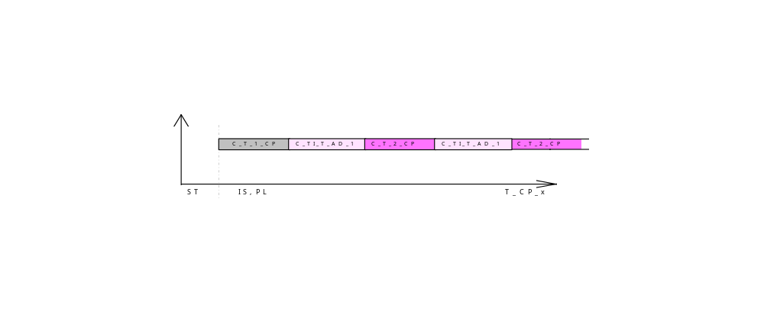

This pre-defined time sequence for injection time adaptation and canister purge can be modified in case of big TI_LAM deviation. If LAM_MV_BEG is out of pre-defined limits, injection time adaptation is immediately activated.

If ⏐ LAM_MV_BEG ⏐ > C_LAM_MV_BEG_MAX
Then
T_CP is reseted and swiches to the next sequence (injection time adaptation C_TI_T_AD_1)

Calibration data:
Name | Dim | Hex. limits | Phys. limits | Resol. | Unit
C_T_1_CP | 1 | 01...FFFFH | 0.1...6553.5 | 0.1 | sec
Duration after start to perform the evaporative emission control process.
C_T_2_CP | 1 | 01...FFFFH | 0.1...6553.5 | 0.1 | sec
Duration to perform a purging phase on NORMAL or MIN operation.
C_TI_T_AD_1 | 1 | 01...FFFFH | 0.1...6553.5 | 0.1 | sec
Duration to perform the lambda adaptation without purging evaporative emission.
C_LAM_MV_BEG_MAX | 1 | 8000...FFFFH | 0...49.998 | 1.526E-3 | %
Maximum LAM_MV_BEG absolute value to perform canister saturation degree determination

Evaporative emission control in transient operation ( FAC_CP )

Evaporative emission control mode : RAMP mode
Output data:
Name | Mode | Hex. limits | Phys. limits | Resol. | Unit
FAC_CP | V | 00...FFH | 0...1.000 | 3.906E-3 | -
Opening or closing ramp slope of the evaporative emission control valve.
FAC_BEG_CP | V | 00...FFH | 0...1.000 | 3.906E-3 | -
Ramp slope initialisation of the evaporative emission control valve.
LV_SLOP_CP | V | 0...01H | 0...1 | 1 | -
Evaporative emission control state : RAMP mode.
Input data:
IP_CPPWM_MAX__N__MAF | IP_CPPWM_MIN__N__MAF | CPPWM | LV_LAM_LIM_CDN
FUNCTION DESCRIPTION:
General information:
The RAMP mode serves as a transition function between the three different steady states of the evaporative emission control process (STB_CP operation, NORMAL operation, MIN operation) in the opening or closing way.

The duty cycle CPPWM during RAMP mode is calculated like in NORMAL operation with the difference that FAC_CP is variable by decrement or increment.

During RAMP mode LV_SLOP_CP = 1.
Application conditions:

- Exit to : STB_CP operation

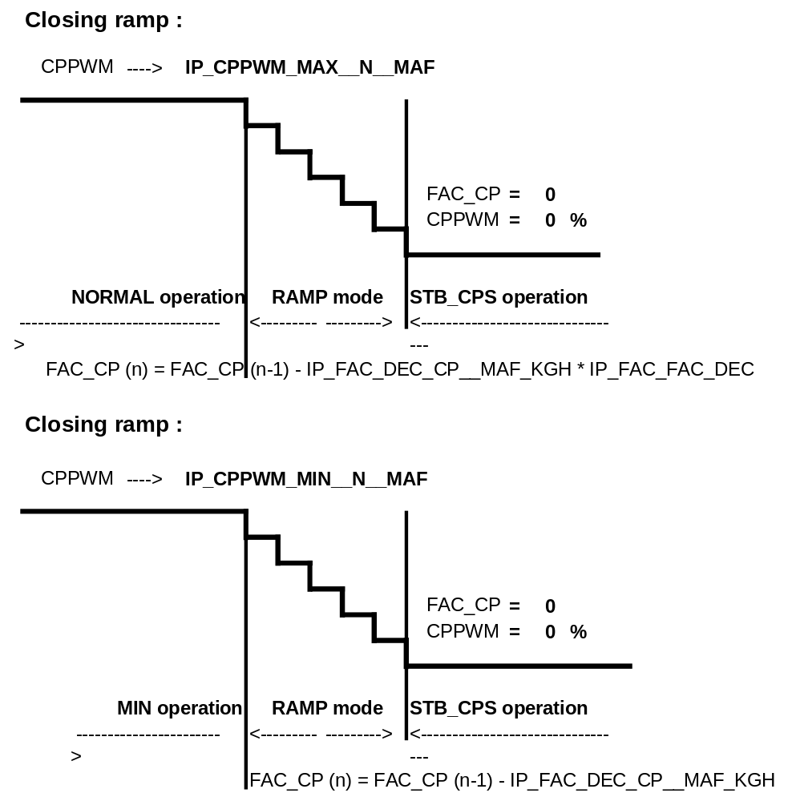
CPPWM_{(n)} = CPPWM_{(n-1)} * FAC_CP

If no value FAC_CP is available upon entry in RAMP mode (i.e. previous operation state was MIN operation), FAC_CP is computed with FAC_BEG_CP as follows :

FAC_BEG_CP= CPPWM_{(n-1)} / IP_CPPWM_MAX__N__MAF
- Exit to : MIN operation
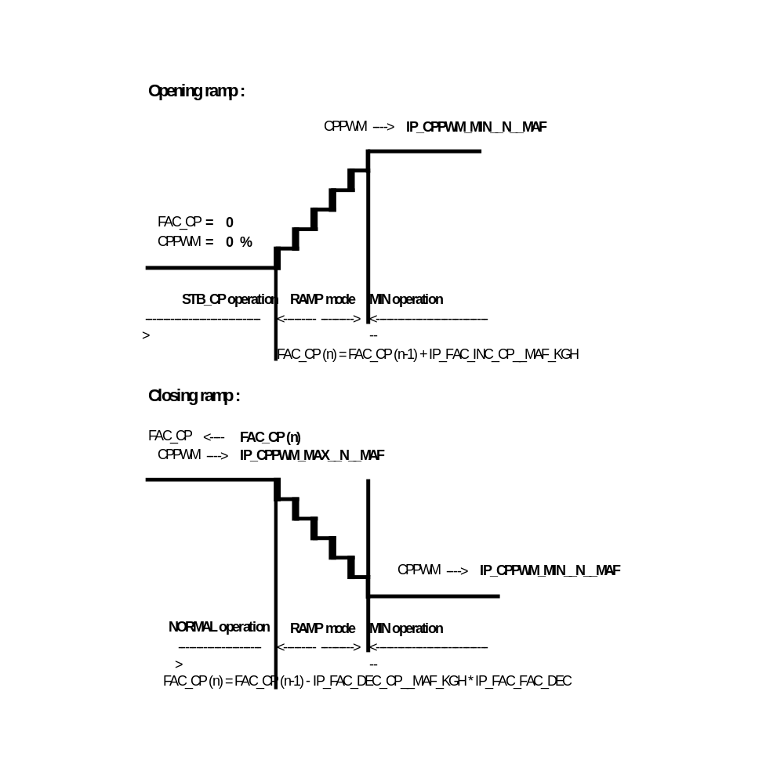
CPPWM_{(n)} = CPPWM_{(n-1)} * FAC_CP

Formula section:
* Opening ramp :
FAC_CP_{(n)} = FAC_CP_{(n-1)} + IP_FAC_INC_CP__MAF_KGH

* Closing ramp :
FAC_CP_{(n)} = FAC_CP_{(n-1)} - IP_FAC_DEC_CP__MAF_KGH

Remark: the closing ramp decrement is multiplied with a factor, if a saturation degree is available, that means Normal-mode was active before closing ramp.
Remark :
- The decrement and increment are applied as a function of mass air flow and are mutually independent.
- If the lambda controller reaches its own limits (LV_LAM_LIM_CDN = 1), then FAC_CP is weighted with C_COR_FAC_INC_CP only during LEARNING mode with RAMP opening.

- The decrement of the closing ramp is multiplied with a saturation-degree-depending factor to make the closing time shorter with lower saturation degrees.

- If the CPPWM reaches during closing ramp C_CPPWM_CLOSE then CPPWM is closed immediately and FAC_CP and LAM_TRA are set to 0.
Calibration data:
Name | Dim | Hex. limits | Phys. limits | Resol. | Unit
IP_FAC_INC_CP__MAF_KGH | 8 | 00...FFH | 0...1.000 | 3.906E-3 | -
Incrementation of the ramp slope for opening the evaporative emission control valve CPS.
IP_FAC_DEC_CP__MAF_KGH | 8 | 00...FFH | 0...1.000 | 3.906E-3 | -
Decrementation of the ramp slope for closing the evaporative emission control valve CPS.
C_COR_FAC_INC_CP | 1 | 00...FFH | 0...0.996 | 3.891E-3 | -
Weighting factor for FAC_CP when the lambda controller reaches its limits.
IP_FAC_FAC_DEC | 6 | 0...FFH | 0...31,875 | 0,125 | -
LAM_MV_DIF_CP
Factor for closing ramp decrement, depending on saturation degree.
C_CPPWM_CLOSE | 1 | 0...FFH | 0...99,6 | 0,3891 | %
Threshold for immediately closing CPS

Evaporative emission control mode : LEARNING mode
Output data:
Name | Mode | Hex. limits | Phys. limits | Resol. | Unit
LAM_MV_DIF_CP | V | 00...FFFFH | -50...49.998 | 1.526E-3 | %
Degree of the charcoal - canister saturation.
LAM_MV_DIF_CP_LD | V | 00...FFFFH | -50...49.998 | 1.526E-3 | %
Degree of the charcoal - canister saturation for fuel system diagnosis inhibition.
LV_LEARN_CP | V | 0...01H | 0...1 | 1 | -
Evaporative emission control state : LEARNING mode.
LAM_MV_BEG | V | 0...FFFFH | -50...49.998 | 1.526E-3 | %
Value of LAM_MV at the beginning of RAMP mode
Input data:
TI_LAM_i | LAM_MV_i | LAM_MV_DIF_COR_CP | CPPWM
FAC_BEG_CP | IP_CPPWM_MIN__N__MAF | LAM_TRA | LV_PUC
LV_FL | IP_CPPWM_MAX__N__MAF | T_CP | FAC_CP
IP_LAM_CP__N_32__MAF_ALTI_COR | LV_AUTH_LAM_i_AD_LEARN_CP | N_32 | MAF_ALTI_COR
FUNCTION DESCRIPTION:
Application conditions:
Target duty cycle : NORMAL operation (IP_CPPWM_MAX__N__MAF)

The determination of the charcoal-canister saturation degree is required and possible in STB_CP operation and MIN operation.

If

The determination of the charcoal - canister saturation degree is required :

If ( time range T_CP starts ( T_CP = C_T_2_CP ) and STB_CP
operation or MIN operation has been triggered before )
or TI_LAM_i_{(n)} < C_LAM_MIN_CP is detected in NORMAL operation
or ⏐LAM_MV_DIF_COR_CP_{(n)}⏐ > C_LAM_MV_DIF_COR_MAX_CP is detected in NORMAL operation.

The determination of the charcoal - canister saturation degree is possible if :

If LV_LAM_ACT_i = 1 (Active)
(lambda controller operability in its own limits)
and LV_LS_i = 1 (Active)
(A/F regulation oxygen sensor operability effective)
and LV_N_MAF_DYW_i = 1 (Active)
(engine speed and load dynamics condition status)
and C_CPPWM_AD_MIN < IP_CPPWM_MAX__N__MAF < C_CPPWM_AD_MAX
(determination of the charcoal - canister saturation degree only in useful load range)
and IP_LAM_CP__N_32__MAF_ALTI_COR ≥ C_LAM_TRA_STATE_MIN
(consideration of altitude influence for purging capability)

then LV_LEARN_CP = 1

General information:
The determination of the charcoal - canister saturation degree is performed according to the following actions :
1 - determination of the A/F regulation loop value LAM_MV_BEG = LAM_MV_{(n)} with the evaporative emission control valve completely or partially closed.
(stabilisation for LAM_MV_BEG determination with waiting for C_FAC_MIN_P_CP -
p-jumps
and
injection time adaptation LV_AUTH_LAM_i_AD_LEARN_CP = 1 (Active) )
2 - defined opening of the evaporative emission control valve (RAMP mode).
3 - determination of the A/F regulation loop value LAM_MV_{(n)} with the evaporative emission control valve open.

( LAM_MV_{(n)} - LAM_MV_BEG ) is representative of the charcoal-canister saturation degree

This determination operates only in a quasi - stationary suitable operating point for the engine. (refer to the section " Activation of the learning mode ")
The tuning of the ramp slope must assume that the A/F ratio controller can compensate the deviation of the lambda, which results from the purge flow rate through the evaporative emission control valve.
The determination of the charcoal - canister saturation degree is most accurate when the evaporative emission control valve is completely closed at the beginning.
However, in some cases, it makes sense to only close the evaporative emission control valve to duty cycle in MIN operation, in order to obtain the necessary charcoal - canister purge rate.
Application conditions:
- First determination of the charcoal - canister saturation degree :

The first determination of the charcoal - canister saturation degree begin only from STB_CP operation (CPPWM = 0 %) and within T_CP, as long as C_SUM_STATE_MAX has been reached (maximum number of attempts to determine the charcoal - canister saturation degree).

The corresponding counter is incremented when a determination of the charcoal - canister saturation degree has been aborted after computation of LAM_MV_BEG.

- Initialisation value FAC_BEG_CP of FAC_CP for each determination of the charcoal - canister saturation degree :

. From STB_CP operation :
FAC_BEG_CP = 0

. From MIN operation (only when C_SUM_STATE_MAX has been reached)
FAC_BEG_CP = CPPWM_{(n-1)} / IP_CPPWM_MAX__N__MAF

Formula section:

- Sequence for determination of charcoal - canister saturation degree :

1 - Activation conditions for LEARNING mode enabled

2 - Determine LAM_MV_BEG

3 - Opening evaporative emission control valve using RAMP mode.
The opening RAMP cannot be stopped until there is a minimum opening of the evaporative emission control valve in order to get a reliable result :

FAC_CP_{(n)} / (FAC_CP_{(n)} - FAC_BEG_CP) ≤ C_FAC_CP_LD_MAX

If during LEARNING mode this condition is fulfilled, there are several possibilities to stop the RAMP mode :

If FAC_CP = 1
or [ FAC_CP_{(n)} / (FAC_CP_{(n)} - FAC_BEG_CP)] <= C_FAC_CP_LD_MAX
and A/F regulation loop limit is reached

or ⏐TI_LAM_{(n)}+LAM_TRA - LAM_MV_BEG⏐
≥ IP_LAM_DIF_MAX_CP__N_32__MAF_ALTI_COR

4 - The lambda deviation is shifted to LAM_TRA for the first time if :
( LAM_MV_BEG- TI_LAM_{(n)} ) > C_LAM_DIF_MAX_TRA

The lambda controller is shifted of the equivalent LAM_TRA.
This process is activated every time the lambda deviation is more than C_LAM_DIF_MAX_TRA.
There will be a deviation of the lambda controller if the charcoal - canister is not totally empty.
Thus, it is possible to minimize the lambda deviation if there is any load condition changing during the RAMP opening.

5 - At the end of RAMP operation, stabilisation (limited LAM (n) dynamics condition) for C_FAC_MIN_P_CP * P-jumps of the A/F regulation loop.

LAM_MV_DIF_CP_{(n)} = ( LAM_MV_{(n)} + LAM_TRA - LAM_MV_BEG )
x [ FAC_CP_{(n)} / (FAC_CP_{(n)} - FAC_BEG_CP) ]

6 - Limitation of positive lambda deviation :
LAM_MV_DIF_CP_{(n)} ≤ C_LAM_MV_DIF_MAX_1_CP
7 - Fuel system diagnosis interface :
LAM_MV_DIF_CP_LD = LAM_MV_DIF_CP_{(n)}

8 - LAM_MV_DIF_COR_CP is initialized with 0 at the end of the ramp.

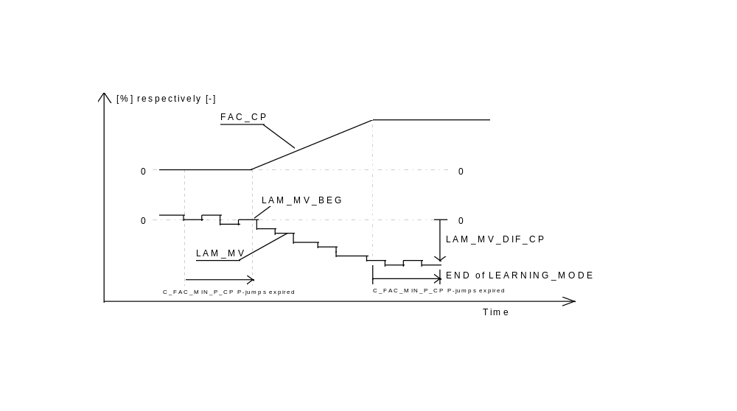
Remark :
- The opening ramp is complete at the latest when FAC_CP = 1.

- If the A/F regulation loop is open during the RAMP mode (trailing throttle fuel cut off (LV_PUC full load (LV_FL) ...), the RAMP mode is aborted, FAC_CP and TI_LAM are retained and a timer C_T_LAM_MAX_STATE is started.
If the A/F regulation loop is closed again before expiration of this timer, the RAMP is continued.

Otherwise, depending of the activation conditions, the evaporative emission control valve is totally closed to STB_CP operation ( CPPWM = 0 % ) without RAMP mode or partially to MIN operation ( IP_CPPWM_MIN__N__MAF ) with RAMP mode.

- If a new determination of the charcoal - canister saturation degree is requested then
LAM_MV_MMV= LAM_MV_BEG = LAM_MV and LAM_MV_DIF_COR_CP = 0.

Calibration data:
Name | Dim | Hex. limits | Phys. limits | Resol. | Unit
C_SUM_STATE_MAX | 1 | 0...FFH | 0...255 | 1 | -
Maximum number of attempts to determine the charcoal - canister saturation degree.
C_FAC_MIN_P_CP | 1 | 0...FFH | 0...255 | 1 | -
Counter to validate the limited N / MAF dynamics condition.
C_T_LAM_MAX_STATE | 1 | 01...FFH | 0.1...25.5 | 0.1 | sec.
Maximum value of the timer to enable again the ramp when A/F regulation loop has been opened.
C_LAM_MV_DIF_MAX_1_CP | 1 | B000...5000H | -31.25...31.25 | 0.0015 | %
LAM_MV_DIF_CP high threshold in RAMP mode for LEARNING mode
IP_LAM_DIF_MAX_CP | 7*8 | 1...FFFFH | 0...99,6 | 0.0015 | %
LAM_DIF_CP high threshold in RAMP mode for LEARNING mode.
C_LAM_DIF_MAX_TRA | 1 | 8000...D000H | 0...31.25 | 0.0015 | %
LAM_DIF condition to shift LAM_TRA during LEARNING mode.
C_FAC_CP_LD_MAX | 1 | 0100...0500H | 1...5 | 1 / 256 | -
Minimum factor for reliable opening of the evaporative emission control valve.
C_LAM_TRA_STATE_MIN | 1 | 01...4000H | 0.00...0.25 | 0.0000153 | -
Weighting factor threshold for the injection time correction LAM_TRA.
C_CPPWM_AD_MAX | 1 | 00...FFH | 0...99.609 | 0.3891 | %
High threshold of the purging duty cycle for activation conditions of LEARNING mode.
C_CPPWM_AD_MIN | 1 | 00...FFH | 0...99.609 | 0.3891 | %
Low threshold of the purging duty cycle for activation conditions of LEARNING mode.
C_LAM_MIN_CP | 1 | 3000...8000H | -31.25...0 | -0.00153 | %
LAM threshold for activation conditions of LEARNING mode.
C_LAM_MV_DIF_COR_MAX_CP | 1 | 8000...D000H | 0...31.25 | 0.00153 | %
LAM_MV_DIF_COR_CP threshold for activation conditions of LEARNING mode.

Injection time correction with evaporative emission control ( LAM_TRA )
Output data:
Name | Mode | Hex. limits | Phys. limits | Resol. | Unit
LAM_TRA | V | 0...FFH | -50...49.609 | 0.39 | %
Injection time correction.
LAM_MV_i | V | 0...FFH | -50...49.609 | 0.39 | %
Moving average value of LAM.
LAM_MV_MMV | V | 4000...C000H | -25...24.9985 | 0.0015 | %
Moving average value of LAM_MV.
LAM_MV_MMV_DIF | V | 00...FFFFH | -50...49.998 | 1.526E-3 | %
LAM_MV_MMV deviation in NORMAL operation used for updating injection time correction LAM_TRA.
LAM_MV_DIF_COR_CP | V | 3000...D000H | -31.25...31.25 | 0.00153 | %
LAM_MV_MMV-deviation during Normal-operation for request of a new learning
Input data:
LAM_MV_DIF_CP | IP_CPPWM_MAX__N__MAF | CPPWM | C_LAM_TRA_STATE_MIN
MAF | C_LAM_MV_DIF_COR_MAX_CP | TI_LAM | C_LAM_DIF_MAX_TRA
MAF_KGH | IP_CPPWM_MIN__N__MAF | MAF_ALTI_COR | IP_CPPWM_ALTI_COR_MAX__N_32__MAF_ALTI_COR
LAM_MV_BEG | LV_LS_i | LV_N_MAF_DYW_i | LV_LAM_ACT_i
N_32
FUNCTION DESCRIPTION:
General information:
The injection time correction due to the mixture influence from the evaporative emission control is performed only in the NORMAL operation state, following the LEARNING mode.

During tuning activity in NORMAL operation, a variable set value is determined for the A/F regulation loop controller.
This set value is stored in a table IP_LAM_CP__N_32__MAF_ALTI_COR depending on engine operating point.
It corresponds to the real lambda deviation if the evaporative emission control valve is controlled with IP_CPPWM_ALTI_COR_MAX__N_32__MAF_ALTI_COR or IP_CPPWM_MAX__N_32__MAF and the charcoal - canister totally saturated.

For the calculation of LAM_TRA the result of the LEARNING mode LAM_MV_DIF_CP is weighted for different load condition.
Formula section:
1 - Injection time correction :

LAM_TRA = LAM_MV_DIF_CP_{(n)} * IP_LAM_CP₍₀₎ / IP_LAM_CP_{(n)}
(0) : current value
(n) : last determination of LAM_MV_DIF_CP

If MAF_ALTI_COR > IP_MAF_ALTI_COR_MAX_CPS__N_32

then IP_LAM_CP = IP_LAM_CP__N_32__MAF_ALTI_COR

else IP_LAM_CP = IP_LAM_CP__N_32__MAF

The calculation of LAM_TRA is activated the first time during LEARNING mode and is continued until the end of NORMAL operation.
At the end of NORMAL operation, LAM_TRA is decremented step by step.
(refer to “Injection time correction LAM_TRA during RAMP operation”)

All changes of LAM_TRA which are not compensated by shift of the lambda controller in the opposite direction are limited in speed by the gradient limitation IP_LAM_TRA_LGRD__MAF_KGH.

2 - Weighting of the injection time correction :

2.1 - Injection time correction LAM_TRA during RAMP operation :

a - During opening RAMP and the first LEARNING mode, the following calculations are performed if ( LAM_MV_BEG - LAM_{(n)} ) > C_LAM_DIF_MAX_TRA :

LAM_MV_DIF_CP = C_LAM_DIF_MAX_TRA
and LAM_TRA= LAM_MV_DIF_CP_{(n)} * IP_LAM_CP₍₀₎ / IP_LAM_CP_{(n)}

TI_LAM_{(n)} , LAM_MV_{(n)} and LAM_MV_MMV_{(n)} are shifted in the opposite direction.

b - The next time where ( LAM_MV_BEG - TI_LAM_{(n)} ) > C_LAM_DIF_MAX_TRA the following calculation is activated :

1 - LAM_TRA = ( LAM_MV_DIF_CP_{(n)} * IP_LAM_CP₍₀₎ / IP_LAM_CP_{(n)} ) - C_LAM_DIF_MAX_TRA
2 - IP_LAM_CP(n) is updated and LAM_MV_DIF_CP = LAM_TRA.

The same algorithm is performed as long as the lambda deviation is higher than C_LAM_DIF_MAX_TRA.

LAM_TRA during RAMP mode.

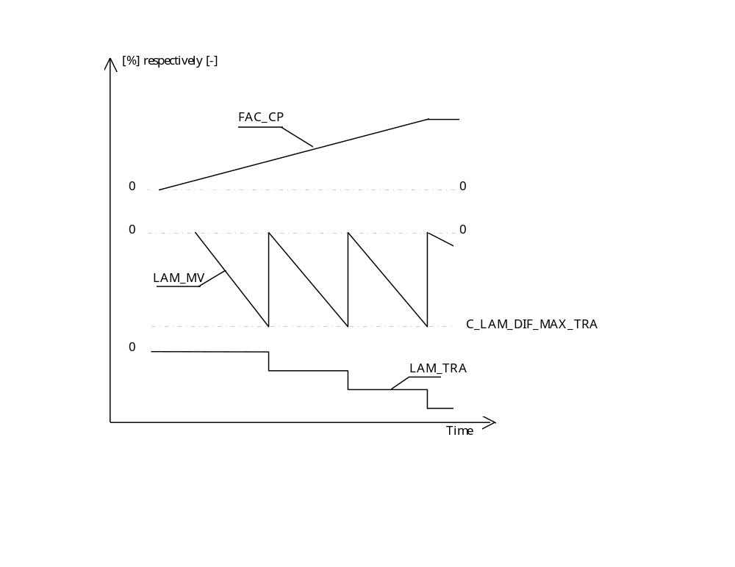
2.2 - Injection time correction LAM_TRA during NORMAL operation :

When the charcoal - canister saturation degree changes during NORMAL operation, the injection time correction LAM_TRA must be corrected.
This change is detected by observing the A/F regulation loop controller mean value LAM_MV at suitable operating points.

For this purpose, the floating average LAM_MV_MMV of the lambda - controller mean value LAM_MV is calculated under the following conditions :

NORMAL operation active
and limited lambda dynamics condition exists for more than one P jump
and C_MAF_LAM_BOL_TRA < MAF_KGH < C_MAF_LAM_TOL_TRA
and CPPWM > 0
and IP_LAM_CP__N_32__MAF_ALTI_COR ≥ C_LAM_TRA_STATE_MIN

then At the beginning of NORMAL operation :
- LAM_TRA is applied
- Initialisation of LAM_MV_MMV and LAM_MV_BEG with LAM_MV
- Initialisation of LAM_MV_DIF_COR_CP with 0

LAM_MV_MMV_{(n)} =
LAM_MV_MMV_{(n-1)} + (LAM_MV_{(n)} - LAM_MV_MMV_{(n-1)} ) * C_LAM_MV_CRLC

During NORMAL operation :
- Calculation of LAM_MV_MMV_DIF :

LAM_MV_MMV_DIF_{(n)} = LAM_MV_BEG - LAM_MV_MMV_{(n)}

- Calculation of LAM_MV_ DIF_COR_CP :

LAM_MV_DIF_COR_CP_{(n)} = LAM_MV_DIF_COR_CP_{(n-1)} - LAM_MV_MMV_DIF_{(n)}

If ⏐LAM_MV_MMV_DIF_{(n)}⏐ > C_LAM_MV_MMV_DIF_CP
then LAM_MV_DIF_CP_{(n)} = LAM_MV_DIF_CP_{(n-1)} - LAM_MV_MMV_DIF_{(n)}
and LAM_TRA is corrected by applying LAM_MV_DIF_CP_{(n)} ,
shifting TI_LAM_{(n)}, LAM_MV_{(n)} and LAM_MV_MMV_{(n).}
So that the result is LAM_MV_MMV_DIF_{(n)} = 0.

In this way, the process can repeat itself several times within NORMAL operation.
Limitation :
The total correction of LAM_MV_DIF_CP (LAM_MV_MMV_DIF = LAM_MV_DIF_COR_CP) within one NORMAL operation cycle is stored and compared to a limit.
If ⏐LAM_MV_DIF_COR_CP⏐ > C_LAM_MV_DIF_COR_MAX_CP
then the NORMAL operation state is disabled, and a new determination of the degree of charcoal - canister saturation is required.

2.3 - Injection time correction LAM_TRA during RAMP closing :

Beginning with the closing , LAM_TRA is also decremented step by step and the maximum decrement is C_LAM_DIF_MAX_TRA.

a - ⏐LAM_TRA⏐ ≤ C_LAM_DIF_MAX_TRA

In this case, the injection time correction LAM_TRA is set to 0 just from the beginning of the RAMP closing.

b - ⏐LAM_TRA⏐ > C_LAM_DIF_MAX_TRA

In this case, the injection time correction LAM_TRA is computed as following :
LAM_TRA = ( LAM_MV_DIF_CP_{(n)} * IP_LAM_CP₍₀₎ / IP_LAM_CP_{(n)} )
+ C_LAM_DIF_MAX_TRA
For the further steps IP_LAM_CP_{(n)} is updated and LAM_MV_DIF_CP_{(n)} is set to the new LAM_TRA value.

This results in a deviation of the lambda controller in the positive direction. With the gradually RAMP closing, the lambda controller will reach the value
LAM_MV_BEG from the beginning of the LEARNING mode.
If this value is reached, the LAM_TRAwill be decremented in the same way like the first RAMP closing.
Latest, if the final duty cycle of the RAMP closing is reached, or the RAMP mode is finished in any other way, the remaining LAM_TRA value is set to 0.

For each shift of LAM_TRA, the values of LAM_{(n)} , LAM_MV_{(n)} , LAM_MV_MMV_{(n)} are switched in the opposite direction.
Calibration data:
Name | Dim | Hex. limits | Phys. limits | Resol. | Unit
C_MAF_LAM_BOL_TRA | 1 | 0...FFFFH | 0...16383.75 | 0.25 | kg / h
MAF low threshold to weight the injection time correction LAM_TRA.
C_MAF_LAM_TOL_TRA | 1 | 0...FFFFH | 0...16383.75 | 0.25 | kg / h
MAF high threshold to weight the injection time correction LAM_TRA.
C_LAM_MV_CRLC | 1 | 0...FFH | 0...0.996 | 0.0039 | -
Correlation factor for LAM_MV_MMV calculation.
C_LAM_MV_MMV_DIF_CP | 1 | 8000...D000H | 0...31.25 | 0.001275 | %
Intermediate threshold for updating injection time correction in NORMAL operation.
IP_LAM_TRA_LGRD__MAF_KGH | 8 | 01...4000H | 0.000015...0.25 | 0.000015 | -
Gradient limitation for LAM_TRA.
IP_LAM_CP__N_32__MAF_ALTI_COR | 7 x 8 | 01...FFFFH | 0...1 | 0.0000153 | -
Weighting factor for the injection time correction LAM_TRA.
IP_LAM_CP__N_32__MAF | 7 x 8 | 01...FFFFH | 0...1 | 0.0000153 | -
Weighting factor for the injection time correction LAM_TRA.

Influence of the evaporative emission control on lambda adaptation
Output data:
Name | Mode | Hex. limits | Phys. limits | Resol. | Unit
LV_AUTH_LAM_AD_CP | V | 0...01H | 0...1 | 1 | -
Boolean information for lambda adaptation out of LEARNING mode.
LV_AUTH_LAM_1_AD_LEARN_CP | V | 0...01H | 0...1 | 1 | -
Boolean information for lambda adaptation during LEARNING mode with CPPWM = 0 for lambda controller n° 1.
LV_AUTH_LAM_2_AD_LEARN_CP | V | 0...01H | 0...1 | 1 | -
Boolean information for lambda adaptation during LEARNING mode with CPPWM = 0 for lambda controller n° 2.
Input data:
LV_STB_PHA_CP | LV_MIN_PHA_CP | LV_NORMAL_PHA_CP | LV_SLOP_CP
LV_LEARN_CP | CPPWM
FUNCTION DESCRIPTION:
These boolean information are in direct relationship with the determination of the correlation factor C_TI_AD_COR_CRLC_xx for lambda adaptation calculation.

If the LEARNING mode is active, during stabilisation of the lambda controller, lambda adaptation can be performed only if CPPWM = 0.
In this case, LV_AUTH_LAM_i_AD_LEARN_CP is set to 1.

In the other modes, out of LEARNING mode, the flag LV_AUTH_LAM_AD_CP is set to 1 and LV_AUTH_LAM_i_AD_LEARN_CP is set to 0.

Cooling and condenser fans control
Output data:
Name | Mode | Hex. limits | Phys. limits | Resol. | Unit
STATE_CFA | V | 0...03H | 0...3 | 1 | -
Cooling and condenser fans state (0,1,2,3).
STATE_CFA_IS | V | 0...03H | 0...3 | 1 | -
Cooling and condenser fans state for idle - charge actuator opening corrections (0,1,2,3).
STATE_CFA_1 | - | 0...03H | 0...3 | 1 | -
Intermediate cooling and condenser fans state for STATE_CFA and STATE_CFA_IS calculation (0,1,2,3)
LV_RLY_FAN_L | V | 0...01H | 0...1 | 1 | -
Logic output from ECU for cooling and condenser fans control (LOW) - (OFF / ON).
LV_RLY_FAN_H | V | 0...01H | 0...1 | 1 | -
Logic output from ECU for cooling and condenser fans control (HIGH) - (OFF / ON).
Input data:
VS_STATE_CFA | TCO | LV_ACIN | LV_IGK
LV_ES | TIA | LV_ACCIN | LV_IS
LV_TCO_ERR | LV_PRS_ACC | LV_RLY_ACCOUT | LV_ES
FUNCTION DESCRIPTION:
General information:
The cooling and condenser fans activation is controlled by the ECU, using two logic outputs :
LV_RLY_FAN_L (LOW) and LV_RLY_FAN_H (HIGH)

They are set ON or OFF depending on :
- coolant temperature TCO
- air condition request LV_ACCIN
- vehicle speed state VS_STATE_CFA
- Pressure in the A/C circuit LV_PRS_ACC

Each fan is controlled with 3 speeds : LOW, MIDDLE, HIGH

The computation of the variable STATE_CFA determines the level of the two logic outputs LV_RLY_FAN_L and LV_RLY_FAN_H. The fan speed depends on these outputs and the air condition request switch state (LV_ACCIN).

If the pressure in the A/C circuit is high (LV_PRS_ACC = 1) then cooling and condenser fans speed is set to high in order to fastly decrease the pressure.

The application recurrence is 40 msec.
Description:

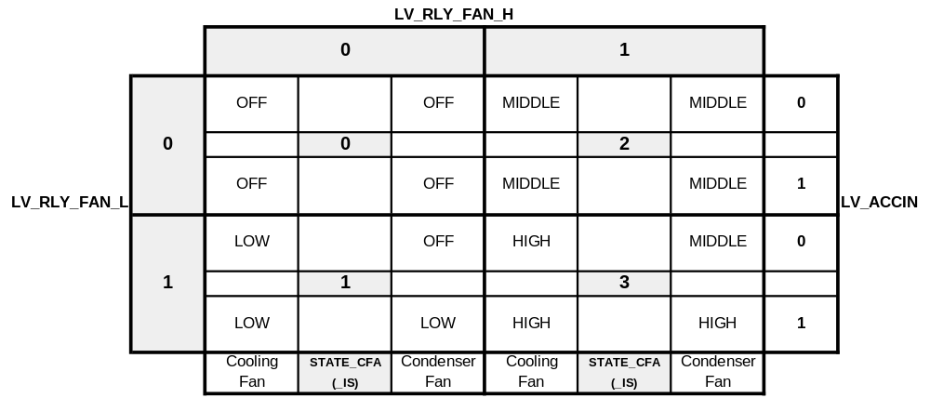

The states of LV_RLY_FAN_L, LV_RLY_FAN_H, LV_ACCIN correspond to logical state :

Logical state 0 ⇔ OFF ⇔ +12 Volt present on the corresponding pin - out of the ECU
Logical state 1 ⇔ ON ⇔ Ground present on the corresponding pin - out of the ECU

Remark :
LV_ACIN : air condition selected
LV_ACCIN : air condition requested
LV_RLY_ACCOUT : air condition compressor active.
Application conditions:

- STATE_CFA_IS calculation:

STATE_CFA_IS is used to activate the idle speed valve corrections.

If Engine operating state LV_ES = 1
and TCO > C_TCO_ON_CFA_ES
then A timer is started and STATE_CFA_IS = STATE_CFA_1
When the timer has reached ID_CFA_ON_ES__TIA__TCO,
STATE_CFA_IS is set back to 0.

else
If Engine operating state LV_ST = 1
then STATE_CFA_IS = 0 during C_T_OFF_CFA_ST seconds
else
If LV_TCO_ERR = 1 (error currently present on coolant temperature sensor)
or ( LV_PRS_ACC = 1 and LV_ACIN = 1 )
then STATE_CFA_IS = 3 (high pressure in A/C circuit)
else STATE_CFA_IS = STATE_CFA_1 (low pressure in A/C circuit)
Endif
Endif
Endif.

- STATE_CFA calculation:

STATE_CFA is equal to STATE_CFA_IS except if STATE_CFA_IS value is updated. Then a time delay is applied to increase or decrease STATE_CFA.

If STATE_CFA_IS (n) = STATE_CFA_IS (n-1) (STATE_CFA_IS stays constant)
then STATE_CFA = STATE_CFA_IS
else
If STATE_CFA_IS (n) > STATE_CFA_IS (n-1) (STATE_CFA_IS increases)
then STATE_CFA = STATE_CFA_IS after the time delay C_T_RTD_INC_x_CFA
(If LV_PRS_ACC = 1
then C_T_RTD_INC_x_CFA = C_T_RTD_INC_1_CFA
else C_T_RTD_INC_x_CFA = C_T_RTD_INC_0_CFA
else (STATE_CFA_IS decreases)
STATE_CFA = STATE_CFA_IS after the time delay C_T_RTD_DEC_CFA

- STATE_CFA_1 calculation:

1 - LV_ACCIN = 0 and VS_STATE_CFA = 0

1.1 - If LV_ACCIN or VS_STATE_CFA values were different just before
then

If TCO < C_TCO_3_CFA
then STATE_CFA_1 = 0

If C_TCO_3_CFA ≤ TCO < C_TCO_4_CFA
then STATE_CFA_1 = 1

If C_TCO_4_CFA ≤ TCO < C_TCO_5_CFA
then STATE_CFA_1 = 2

If TCO ≥ C_TCO_5_CFA
then STATE_CFA_1 = 3

1.2 - If LV_ACCINand VS_STATE_CFA values remain the same
then

Conditions to increase STATE_CFA_1 :

If TCO ≥ C_TCO_3_CFA and STATE_CFA_1 = 0
then STATE_CFA_1 = 1

If TCO ≥ C_TCO_4_CFA and STATE_CFA_1 = 1
then STATE_CFA_1 = 2

If TCO ≥ C_TCO_5_CFA and STATE_CFA_1 = 2
then STATE_CFA_1 = 3

Conditions to decrease STATE_CFA_1 :

If TCO ≤ (C_TCO_3_CFA - C_TCO_HYS_1_CFA) and STATE_CFA_1 = 1
then STATE_CFA_1 = 0

If TCO ≤ (C_TCO_4_CFA - C_TCO_HYS_2_CFA) and STATE_CFA_1 = 2
then STATE_CFA_1 = 1

If TCO ≤ (C_TCO_5_CFA - C_TCO_HYS_3_CFA) and STATE_CFA_1 = 3
then STATE_CFA_1 = 2

2 - LV_ACCIN = 0 and VS_STATE_CFA = 1

2.1 - If LV_ACCIN or VS_STATE_CFA values were different just before
then

If TCO < C_TCO_2_CFA
then STATE_CFA_1 = 0

If C_TCO_2_CFA ≤ TCO < C_TCO_4_CFA
then STATE_CFA_1 = 1

If TCO ≥ C_TCO_4_CFA
then STATE_CFA_1 = 3

2.2 - If LV_ACCIN and VS_STATE_CFA values remain the same
then

Conditions to increase STATE_CFA_1 :

If TCO ≥ C_TCO_2_CFA and STATE_CFA_1 = 0
then STATE_CFA_1 = 1

If TCO ≥ C_TCO_4_CFA and STATE_CFA_1 = 1
then STATE_CFA_1 = 3

Conditions to decrease STATE_CFA_1 :

If TCO ≤ (C_TCO_2_CFA - C_TCO_HYS_1_CFA) and STATE_CFA_1 = 1
then STATE_CFA_1 = 0

If TCO ≤ (C_TCO_4_CFA - C_TCO_HYS_2_CFA) and STATE_CFA_1 = 3
then STATE_CFA_1 = 1

3 - LV_ACCIN = 0 and VS_STATE_CFA = 2

3.1 - If LV_ACCIN or VS_STATE_CFA values were different just before
then

If TCO < C_TCO_4_CFA
then STATE_CFA_1 = 0

If TCO ≥ C_TCO_4_CFA
then STATE_CFA_1 = 3

3.2 - If LV_ACCIN and VS_STATE_CFA values remain the same
then

Conditions to increase STATE_CFA_1 :

If TCO ≥ C_TCO_4_CFA and STATE_CFA_1 = 0
then STATE_CFA_1 = 3

Conditions to decrease STATE_CFA_1 :

If TCO ≤ (C_TCO_4_CFA - C_TCO_HYS_2_CFA) and STATE_CFA_1 = 3
then STATE_CFA_1 = 0

4 - LV_ACCIN = 1 and VS_STATE_CFA = 0

4.1 - If LV_ACCIN or VS_STATE_CFA values were different just before.
then

If TCO < C_TCO_1_CFA
then STATE_CFA_1 = 0

If C_TCO_1_CFA ≤ TCO < C_TCO_4_CFA
then STATE_CFA_1 = 1

If C_TCO_4_CFA ≤ TCO < C_TCO_5_CFA
then STATE_CFA_1 = 2

If TCO ≥ C_TCO_5_CFA
then STATE_CFA_1 = 3

4.2 - If LV_ACCIN and VS_STATE_CFA values remain the same
then

Conditions to increase STATE_CFA_1 :

If TCO ≥ C_TCO_1_CFA and STATE_CFA_1 = 0
then STATE_CFA_1 = 1

If TCO ≥ C_TCO_4_CFA and STATE_CFA_1 = 1
then STATE_CFA_1 = 2

If TCO ≥ C_TCO_5_CFA and STATE_CFA_1 = 2
then STATE_CFA_1 = 3

Conditions to decrease STATE_CFA_1 :

If TCO ≤ C_TCO_1_CFA and STATE_CFA_1 = 1
then STATE_CFA_1 = 0

If TCO ≤ (C_TCO_4_CFA - C_TCO_HYS_2_CFA) and STATE_CFA_1 = 2
then STATE_CFA_1 = 1

If TCO ≤ (C_TCO_5_CFA - C_TCO_HYS_4_CFA) and STATE_CFA_1 = 3
then STATE_CFA_1 = 2

5 - LV_ACCIN = 1 and VS_STATE_CFA = 1

5.1 - If LV_ACCIN or VS_STATE_CFA were different just before
then

If TCO < C_TCO_1_CFA
then STATE_CFA_1 = 0

If C_TCO_1_CFA ≤ TCO < C_TCO_4_CFA
then STATE_CFA_1 = 1

If TCO ≥ C_TCO_4_CFA
then STATE_CFA_1 = 3

5.2 - If LV_ACCIN and VS_STATE_CFA remain the same
then

Conditions to increase STATE_CFA_1 :

If TCO ≥ C_TCO_1_CFA and STATE_CFA_1 = 0
then STATE_CFA_1 = 1

If TCO ≥ C_TCO_4_CFA and STATE_CFA_1 = 1
then STATE_CFA_1 = 3

Conditions to decrease STATE_CFA_1 :

If TCO ≤ (C_TCO_4_CFA - C_TCO_HYS_2_CFA) and STATE_CFA_1 = 3
then STATE_CFA_1 = 1

If TCO ≤ C_TCO_1_CFA and STATE_CFA_1 = 1
then STATE_CFA_1 = 0

6 - LV_ACCIN = 1 and VS_STATE_CFA = 2

6.1 - If LV_ACCIN or VS_STATE_CFA values were different just before
then

If TCO < C_TCO_4_CFA
then STATE_CFA_1 = 0

If TCO ≥ C_TCO_4_CFA
then STATE_CFA_1 = 3

6.2 - If LV_ACCIN and VS_STATE_CFA values remain the same
then

Conditions to increase STATE_CFA_1 :

If TCO ≥ C_TCO_4_CFA and STATE_CFA_1 = 0
then STATE_CFA_1 = 3

Conditions to decrease STATE_CFA_1 :

If TCO ≤ (C_TCO_4_CFA - C_TCO_HYS_2_CFA) and STATE_CFA_1 = 3
then STATE_CFA_1 = 0

Remark :
C_TCO_1_CFA ≤ C_TCO_2_CFA ≤ C_TCO_3_CFA ≤ C_TCO_4_CFA ≤ C_TCO_5_CFA

Calibration data:
Name | Dim | Hex. limits | Phys. limits | Resol. | Unit
C_TCO_1_CFA | 1 | 0...FFH | -48...142,5 | 0,75 | °C
Coolant temperature threshold for fans control.
C_TCO_2_CFA | 1 | 0...FFH | -48...142,5 | 0,75 | °C
Coolant temperature threshold for fans control.
C_TCO_3_CFA | 1 | 0...FFH | -48...142,5 | 0,75 | °C
Coolant temperature threshold for fans control.
C_TCO_4_CFA | 1 | 0...FFH | -48...142,5 | 0,75 | °C
Coolant temperature threshold for fans control.
C_TCO_5_CFA | 1 | 0...FFH | -48...142,5 | 0,75 | °C
Coolant temperature threshold for fans control.
C_TCO_HYS_1_CFA | 1 | 0...FFH | 0...191,25 | 0,75 | °C
Coolant temperature hysteresis for STATE_CFA transition 1->0.
C_TCO_HYS_2_CFA | 1 | 0...FFH | 0...191,25 | 0,75 | °C
Coolant temperature hysteresis for STATE_CFA transition 2->1 or 2->0.
C_TCO_HYS_3_CFA | 1 | 0...FFH | 0...191,25 | 0,75 | °C
Coolant temperature hysteresis for STATE_CFA transition 3->2.
C_TCO_HYS_4_CFA | 1 | 0...FFH | 0...191,25 | 0,75 | °C
Coolant temperature hysteresis for STATE_CFA transition 3->2.
C_T_RTD_INC_0_CFA | 1 | 0...FFH | 0...10,24 | 0,040 | sec
Time delay before increasing STATE_CFA if LV_PRS_ACC = 0
C_T_RTD_INC_1_CFA | 1 | 0...FFH | 0...10,24 | 0,040 | sec
Time delay before increasing STATE_CFA if LV_PRS_ACC = 1
C_T_RTD_DEC_CFA | 1 | 0...FFH | 0...10,24 | 0,040 | sec
Time delay before decreasing STATE_CFA
C_T_OFF_CFA_ST | 1 | 0...FFH | 0...255 | 1 | sec
Time to deactivate fans during engine operating state start (LV_ST) detection.
C_TCO_ON_CFA_ES | 1 | 0...FFH | -48...142,5 | 0,75 | °C
Minimum coolant temperature to start fans under power latch.
ID_ON_CFA_ES__TCO__TIA | 5 x 5 | 0...FFH | 0...255 | 1 | sec
Activation duration of the fans under power latch.
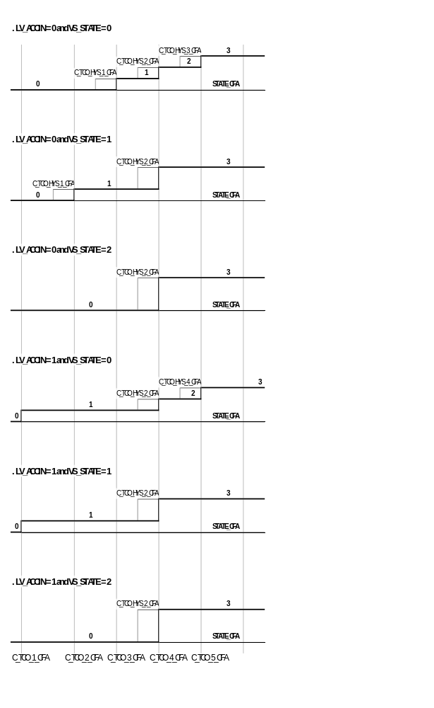

Engine speed limitation
Output data:
Name | Mode | Hex. limits | Phys. limits | Resol. | Unit
LV_N_MAX | V | 0...01H | 0...1 | 1 | -
Boolean for engine speed limitation
LV_N_MAX_FCUT | V | 0...01H | 0...1 | 1 | -
Boolean for engine speed limitation in case of vehicle stopped
N_MAX_THD | V | 0...FFH | 0...8160 | 32 | rpm
Maximum engine speed threshold for cylinder shut - off.
N_MAX_MAX | V | 0...FFH | 0...8160 | 32 | rpm
Maximum engine speed threshold for immediate cylinders cut - off.
PAT_INH_IV_N_MAX | V | 0...maxH | 0...max | 1 | -
Fuel shut-off pattern index in case of maximum engine speed - max = NC_INI_INH_SWI_IV_SHIFT_NR.
Input data:
LV_ISA_i_ERR | LV_VS_ERR | TPS | N_32
LV_MAF_ERR | VS | LV_ISA_MECHA_ERR | LV_TPS_ERR
NC_INI_INH_SWI_IV_SHIFT_NR | LV_CT | TCO | LV_DRI
LV_CRK_ERR | LV_TCO_ERR | LV_VS_ERR | LV_TPS_PLAUS_ERR
LV_MAF_PLAUS_ERR | LV_CRK_ERR_LIH
FUNCTION DESCRIPTION:
General information:
This fuel shut - off allows to protect the engine against overspeed.
There are two kinds of overspeed fuel shut-off :

1 - the injectors are shut - off progressively, according to the cylinder shut - off pattern
PAT_INH_IV_N_MAX. This corresponds to engine speed threshold N_MAX_THD.
N_MAX_THD is defined according to the present failures (ISAPWM,TPS, MAF...)

2 - the injectors are cut-off immediately. This corresponds to engine speed threshold N_MAX_MAX. Injectors are shut-off immediately if progressive fuel shut-off was no sufficient (engine speed still increasing) or if engine speed stays high during a long time with vehicle stopped.
Application conditions:

1) LV_N_MAX_FCUT determination :

In order to prevent the catalyst system from over-heating, it is detected if engine speed stays high with vehicle stopped during a pre-defined time.

At each engine Start, LV_N_MAX_FCUT is initialised to 0.

LV_N_MAX_FCUT is set to 1 if during C_T_N_MAX_FCUT seconds:
- LV_CT = 0
- and VS = 0
- and TCO > C_TCO_N_MAX_FCUT
- and N_32 > C_N_FCUT
- and LV_DRI = 0
- and LV_CRK_ERR = 0
- and LV_TCO_ERR = 0
- and LV_VS_ERR = 0

LV_N_MAX_FCUT is set back to 0 if:
- LV_CT = 1
- or VS > 0
- or TCO < C_TCO_N_MAX_FCUT
- or LV_DRI = 1
- or LV_CRK_ERR = 1
- or LV_TCO_ERR = 1
- or LV_VS_ERR = 1

2) N_MAX_MAX calculation :

If there is a risk to damage the catalyst, maximum engine speed is reduced.

If LV_N_MAX_FCUT = 1

then N_MAX_MAX = C_N_MAX_FCUT

else N_MAX_MAX = C_N_MAX_MAX

3) N_MAX_THD calculation :

Normal maximum engine speed can be modified due some present failures.

- If ( LV_ISA_1_ERR = 1 or LV_ISA_MECHA_ERR = 1 )
(Idle speed actuator coil 1 - only if short to ground detected or
Idle speed actuator mechanical error - only if ISA stuck open detected)
then
If ( LV_TPS_ERR = 1 or LV_TPS_PLAUS_ERR = 1 )
(an error is currently present on the throttle position sensor)
then N_MAX_THD_1 = C_N_MAX_TPS_ISAPWM_DIAG
else N_MAX_THD_1 = IP_N_MAX_ISAPWM_DIAG__TPS
else N_MAX_THD_1 = 8160 rpm

- If ( LV_TPS_ERR = 1 or LV_TPS_PLAUS_ERR = 1 )
and ( LV_MAF_ERR = 1 or LV_MAF_PLAUS_ERR = 1 )
(an error is currently present on the throttle position sensor and on the mass air flow sensor )
then N_MAX_THD_2 = C_N_MAX_TPS_DIAG
else N_MAX_THD_2 = 8160 rpm

- If LV_VS_ERR = 1
(an error is currently present on vehicle speed)
then N_MAX_THD_3 = C_N_MAX_VS_DIAG
else N_MAX_THD_3 = 8160 rpm

- If LV_CRK_ERR_LIH = 1
(Limp home for crankshaft sensor active)
then N_MAX_THD_4 = C_N_MAX_CRK_DIAG
else N_MAX_THD_4 = 8160 rpm

N_MAX_THD = Min. ( N_MAX_THD_1,
N_MAX_THD_2,
N_MAX_THD_3,
N_MAX_THD_4,
N_MAX_MAX,
C_N_MAX )

4) Progressive cylinder shut-off in case of over speed :

If N_32 > N_MAX_THD
then :
- LV_N_MAX is set to 1
- Cylinder shut-off level (PAT_INH_IV_N_MAX) is increased by 1 each ID_N_MAX_CYCNR__VS cycles until:
- N_32 < N_MAX_THD - C_N_MAX_HYS
- or PAT_INH_IV_N_MAX reaches its maximum value (13)

5) Immediate cylinder fuel cut-off in case of over speed :

If N_32 > N_MAX_MAX
then :
- LV_N_MAX is set to 1
- All the injectors are cut-off immediately (PAT_INH_IV_N_MAX = 13)

6) Progressive cylinders rewetting

If N_32 < N_MAX_THD - C_N_MAX_HYS
and LV_N_MAX_FCUT = 0
then :
- Cylinder shut - off level (PAT_INH_IV_N_MAX) is decreased by 1 each ID_N_MAX_CYCNR__VS cycles until it reaches 0
- LV_N_MAX is set back to 0 when PAT_INH_IV_N_MAX = 0

7) Immediate cylinders rewetting

If N_32 < N_MAX_THD - C_N_MAX_HYS_MAX
then :
- Cylinder shut - off level (PAT_INH_IV_N_MAX) is set to 0
- LV_N_MAX is set to 0
Calibration data:
Name | Dim | Hex. limits | Phys. limits | Resol. | Unit
C_N_MAX | 1 | 0...FFH | 0...8160 | 32 | rpm
Engine speed threshold for engine speed limitation (fuel shut - off cylinder by cylinder).
C_N_MAX_MAX | 1 | 0...FFH | 0...8160 | 32 | rpm
Engine speed threshold for engine speed limitation (fuel cut - off all cylinders) if LV_N_MAX_FCUT = 0
C_N_MAX_HYS | 1 | 0...FFH | 0...8160 | 32 | rpm.
Engine speed hysteresis to enable again the injection.
C_N_MAX_HYS_MAX | 1 | 0...FFH | 0...8160 | 32 | rpm
Engine speed hysteresis to enable all the injectors.
C_N_MAX_TPS_DIAG | 1 | 0...FFH | 0...8160 | 32 | rpm
Maximum engine speed (limitation) in case of simultaneous failure on TPS and MAF.
C_N_MAX_TPS_ISAPWM_DIAG | 1 | 0...FFH | 0...8160 | 32 | rpm
Maximum engine speed (limitation) in case of error currently present on ISA and TPS.
IP_N_MAX_ISAPWM_DIAG__TPS | 3 | 0...FFH | 0...8160 | 32 | rpm
Maximum engine speed (limitation) in case of error currently present on ISA.
C_N_MAX_VS_DIAG | 1 | 0...FFH | 0...8160 | 32 | rpm
Maximum engine speed (limitation) in case of error currently present on VS signal.
C_N_MAX_CRK_DIAG | 1 | 0...FFH | 0...8160 | 32 | rpm
Maximum engine speed (limitation) in case of crankshaft sensor Limp-Home active.
ID_N_MAX_CYCNR__VS | 5 | 01...FFH | 1...255 | 1 | -
Number of cycles to increase by 1 the cylinder shut - off level in case of over speed fuel shut - off.
C_T_N_MAX_FCUT | - | 01...FFFFH | 0,1...6553,5 | 0,1 | sec.
Time to detect LV_N_MAX_FCUT
C_TCO_N_MAX_FCUT | - | 00...FEH | -48...142,5 | 0,75 | °C
Minimum coolant temperature to detect LV_N_MAX_FCUT
C_N_FCUT | - | 00...FFH | 0...8160 | 32 | rpm
Minimum engine speed to detect LV_N_MAX_FCUT
C_N_MAX_FCUT | - | 00...FFH | 0...8160 | 32 | rpm
Engine speed threshold for engine speed limitation (fuel cut - off all cylinders) if LV_N_MAX_FCUT = 1

Vehicle speed limitation
Output data:
Name | Mode | Hex. limits | Phys. limits | Resol. | Unit
LV_VS_MAX | V | 0...01H | 0...1 | 1 | -
Boolean for vehicle speed limitation ( Passive / Active ).
LV_OPL_VS_MAX | V | 0...01H | 0...1 | 1 | -
Boolean for A/F regulation loop opened because of vehicle speed limitation ( Passive / Active).
PAT_INH_IV_VS_MAX | V | 0...maxH | 0...max | 1 | -
Fuel shut-off pattern index in case of vehicle speed limitation - max = NC_INI_INH_SWI_IV_SHIFT_NR.
Input data:
VS | NC_INI_INH_SWI_IV_SHIFT_NR | LV_LSCL_1 | N_32
C_TI_VS_MAX_COR | LV_LSCL_2 | VS_MAX
FUNCTION DESCRIPTION:
General information:
If the vehicle speed exceeds the vehicle speed limitation, the following actions are taken with the priorities :
1 - deactivation of all enrichments.
2 - A/F regulation loop opened and mixture leaning
3 - injectors shut - off progressively according to the cylinder shut - off pattern PAT_INH_IV_VS_MAX
4 - when all cylinders are shut - off, the fuel pump is switched off.

These measures are cancelled following a definite process if the vehicle speed decreases under the vehicle speed limitation minus an hysteresis.
In order to avoid engine stall when the driver releases the clutch with cylinders shut - off due to vehicle speed limitation, the injection is enabled below the engine speed 3000 rpm.
The application recurrence is 1 sec.
Application conditions:
Activation:
If VS ≥ VS_MAX
and N_32 > 3000 rpm
then LV_VS_MAX = 1 (Active).
Deactivation:
If VS < VS_MAX - C_VS_MAX_HYS
or N_32 ≤ 3000 rpm
then LV_VS_MAX = 0 (Passive).
Formula section:

* LV_VS_MAX = 1 (Active) - Vehicle speed limitation activation :

1 - All the enrichments are cancelled.
2 - A/F regulation loop is opened (LV_LSCL_1 = LV_LSCL_2 = 0) and mixture is leaned using (1 - C_TI_VS_MAX_COR).
3 - The cylinder shut - off level is set to 1 and increased by 1 every C_VS_MAX_CYCNR cycles.
4 - When all the cylinders are shut-off, the fuel pump is switched off.

* LV_VS_MAX = 0 (Passive) - Vehicle speed limitation deactivation :

1 - The fuel pump is switched on (if it has been switched off before).
2 - The cylinder shut - off level is decreased by 1 every C_VS_MAX_CYCNR cycles.
3 - Once all the injectors are switched on again, all enrichments are enabled.
4 - A/F regulation loop is closed after C_LAM_CYCNR seconds.

Remark :

If N_32 ≤ 3000 rpm.
then the fuel pump is switched on (if it has been switched off before), all the cylinders are switched on, all enrichments are enabled and A/F regulation loop is closed after C_LAM_CYCNR seconds. These actions are performed together.

Calibration data:
Name | Dim | Hex. limits | Phys. limits | Resol. | Unit
C_VS_MAX_HYS | 1 | 0...FFH | 0...255 | 1 | km/h
Hysteresis on maximum vehicle speed.
C_VS_MAX_CYCNR | 1 | 0...FFH | 0...255 | 1 | sec.
Time delay between two cylinders shut-off or reset during vehicle speed limitation ( x 1 sec).
C_LAM_CYCNR | 1 | 01...FFFFH | 0,01...655,35 | 0,01 | sec.
Time delay before closing the A/F regulation loop.

Traction Control

Interface Description
Output data:
Name | Mode | Hex. limits | Phys. limits | Resol. | Unit
TQI_ASR_REQ | V | 0...3FH | 0...630 | 10 | Nm
Torque reduction requested for ASR from TCS control unit
TQI_GS_REQ | V | 0...3FH | 0...630 | 10 | Nm
Torque reduction requested for gear shift from TCU
LV_ASR_REQ | V | 0...1H | 0...1 | 1 | -
Boolean for ASR intervention requested by the TCS control unit
LV_GS_REQ | V | 0...1H | 0...1 | 1 | -
Boolean for GS intervention requested by the transmission control unit
TQ_STND_CAN | - | 0...3FH | 0...630 | 10 | Nm
standard torque to which all torque reduction requests are related (CAN-value)
TQI_CAN | V | 0...FFH | 0...99.61 | 0.391 | %
indicated engine torque without torque intervention (CAN-value)
TQI_ACOR_CAN | V | 0...FFH | 0...99.61 | 0.391 | %
indicated engine torque during torque intervention (CAN-value)
TQFR_CAN | V | 0...FFH | 0...99.61 | 0.391 | %
engine friction torque (CAN_value)
ACK_TCS_CAN | - | 0...1H | 0...1 | 1
acknowledge bit from EMS (CAN-value)
TQ_COR_STAT_CAN | - | 0...3H | 0...3 | 1
status of torque intervention from EMS (CAN-value)
Input data:
TQI_TCS_CAN | TQI_TCU_CAN | TCS_REQ_CAN | SWI_GS_CAN
TQ_STND | TQI | TQI_INTV | TQFR
LV_ACK_TCS | STATE_TQ_INTV

General information
The communication between the engine management system and the TCS control unit as well as the transmission control unit is done via the CAN bus.
This function description refers only to the torque management related CAN data. For a detailed description of the CAN functions please refer to the separate CAN specification.
To clearly distinguish between variables which are used for EMS internal calculation and variables that are available on the CAN all CAN-related variables are marked with the extension „_CAN“ at their name. However, in this chapter only the EMS internal variable names are used.

CAN Communication Signals

EMS Input Signals from the CAN

Input as CAN data Input to EMS
(from the CAN) internal functions

TQI_TCS_CAN Torque reduction request for ASR TQI_ASR_REQ
[%] from TCS control unit [Nm]

TQI_ASR_REQ =

TQI_TCU_CAN Torque reduction request for Gear-Shift TQI_GS_REQ
[%] from TCU [Nm]
TQI_GS_REQ =

TCS_REQ_CAN Status-Bit = High, if ASR is requested LV_ASR_REQ

SWI_GS_CAN Status-Bit = High, if GS is requested LV_GS_REQ

EMS Output Signals to the CAN

Output from EMS Output to CAN
internal functions

TQ_STND Standard engine torque in Nm, TQ_STND_CAN
[Nm] to which the percentage torque quantities [Nm]
TQx_yyy are related.
--> see subchapter Torque Model

TQI Indicated engine torque corresponding to TQI_CAN
[Nm] the torque requested from the driver; [%]
including knock control, catalyst overheating
protection and other ignition angle corrections;
torque interventions are not included.
--> see subchapter Torque Model

TQI_CAN = * 100%

TQI_INTV Indicated engine torque during torqe TQI_ACOR_CAN
[Nm] intervention. [%]
--> see subchapter Torque Model

TQI_ACOR_CAN = * 100%

TQFR Engine friction torque TQFR_CAN
[Nm] --> see subchapter Torque Model [%]

TQFR_CAN = * 100%

LV_ACK_TCS Monitoring of the messages from the TCS ACK_TCS_CAN
control unit. The engine management system
checks whether at least one new message from
the TCS control unit has been transmitted within
500 ms. If so, the bit is set; else the bit is reset.

STATE_TQ_INTV Status of torque intervention. TQ_COR_STAT_CAN
Check-back signal from the engine management system about to which extent a torque reduction
is actually performed.

Status of Torque Intervention (STATE_TQ_INTV)
Output data:
Name | Mode | Hex. limits | Phys. limits | Resol. | Unit
STATE_TQ_INTV | V | 0...3H | 0...3 | 1
status torque intervention from EMS
TQ_INTV_REL_ERR | V | 0...FFH | 0...0.996 | 0.0039 | 100%
relative error as difference between actual torque and requested torque related to the standard torque
Input data:
LV_ASR_REQ | LV_GS_REQ | TQI_INTV | TQI_ASR_REQ
TQI_GS_REQ | TQ_STND | LV_SCC_MOD
FUNCTION DESCRIPTION:
General information:
The engine management system uses the variable STATE_TQ_INTV to inform the transmission control unit and/or the traction system control unit about the state of the torque intervention. That means if and to which extent an ignition angle intervention and/or a cylinder shut-off intervention are admitted.

Status | Bit 5 | Bit 4 | Meaning
0 | 0 | 0 | The desired intervention regarding ignition angle retardation and cylinder shut-off is executed. (Default value)
1 | 0 | 1 | The desired intervention regarding ignition angle retardation and cylinder shut-off is executed; however, the requested target torque can not be adjusted precisely (torque steps)
2 | 1 | 0 | The torque reduction regarding the ignition angle retardation cannot be completely executed. A cylinder shut-off is not possible at this time. Therefore the residual torque (as difference between TQI_ASR_REQ and TQI_INTV) remains present and cannot be reduced.
3 | 1 | 1 | Due to a failure detected by a diagnosis function of the engine management system, the desired torque intervention regarding the ignition angle and cylinder shut-off is no longer executed.  The torque intervention is terminated, the engine management system resets the requested engine torque to the TQI value using a ramp.

Activation: LV_ASR_REQ = 1 or LV_GS_REQ = 1
Deactivation: LV_ASR_REQ = 0 and LV_GS_REQ = 0

Formula section:

Relative Error of torque reduction intervention

TQ_INTV_REL_ERR =

Status of torque intervention:

Status 0: If ⏐TQ_INTV_REL_ERR⏐≤ C_TQ_INTV_REL_ERR_MAX
then STATE_TQ_INTV = 0

Status 1: If ⏐TQ_INTV_REL_ERR⏐> C_TQ_INTV_REL_ERR_MAX
and LV_SCC_MOD = 1
then STATE_TQ_INTV = 1

Status 2: If ⏐TQ_INTV_REL_ERR⏐> C_TQ_INTV_REL_ERR_MAX
and LV_SCC_MOD = 0
then STATE_TQ_INTV = 2

Status 3: If no torque intervention is possible
(for example due to a failure detected by a diagnosis function)
then STATE_TQ_INTV = 3
and TQ_INTV_REL_ERR is set to 100%

Calibration data:
Name | Dim | Hex. limits | Phys. limits | Resol. | Unit
C_TQ_INTV_REL_ERR_MAX | 1 | 0...FFH | 0...0.997 | 0.0039 | 100%
threshold for relative error of torque intervention for status output

Internal auxiliary quantities

Relative torque reduction by misfire detection (TQR_REL_SCC_MIS)
Output data:
Name | Mode | Hex. limits | Phys. limits | Resol. | Unit
TQR_REL_SCC_MIS | V | 0...FFH | 0...0.996 | 0.0039 | 100%
actual performed relative torque reduction by cylinder shut-off due to detected misfire
Input data:
MIS_NR_OFF_IV

FUNCTION DESCRIPTION:
The injection for misfiring cylinders is inhibited by the misfire detection function in order to prevent the catalyst from overheating. These fuel cut-off cylinders have to be considered for the calculation of the indicated engine torque without torque intervention (TQI) and the indicated engine torque during torque intervention (TQI_INTV).

TQR_REL_SCC_MIS =
Calibration data:
non adjustable value: NC_CYL_NO = 6

Actual performed relative torque reduction by fuel cut-off (TQR_REL_SCC_AV)
Output data:
Name | Mode | Hex. limits | Phys. limits | Resol. | Unit
TQR_REL_SCC_AV | V | 0...FFH | 0...0.996 | 0.0039 | 100%
actual performed relative torque reduction by any fuel cut-off action
Input data:
TQR_REL_SCC_MIS | TQR_REL_SCC_OUT

FUNCTION DESCRIPTION:
TQR_REL_SCC_AV is the actual performed relative torque reduction which can result from any fuel cut-off intervention including...
...fuel cut-off acivated by the misfire detection : TQR_REL_SCC_MIS and/or
...fuel cut-off by a cylinder shut-off pattern : TQR_REL_SCC_OUT
(from engine speed or vehicle speed limitation, torque reduction by TCU or TCS)
Formula section:

TQR_REL_SCC_AV = TQR_REL_SCC_OUT + TQR_REL_SCC_MIS -
(TQR_REL_SCC_OUT * TQR_REL_SCC_MIS)

Maximum relative torque reduction by spark retard (TQR_REL_MAX_IGA_N_MAF)
Output data:
Name | Mode | Hex. limits | Phys. limits | Resol. | Unit
TQR_REL_MAX_IGA_N_MAF | V | 0...FFH | 0...0.996 | 0.0039 | 100%
maximum possible relative torque reduction by spark retard
Input data:
N_32 | MAF | TQR_REL_SCC_AV

FUNCTION DESCRIPTION:
The maximum allowed ignition angle spark retard (regarding exhaust gas temperature) for torque intervention is taken from IP_IGA_DIF_MAX_TQR__N_32__MAF and results in a maximum relative torque reduction of IP_TQR_REL_MAX_IGA__N_32__MAF.

In order to take into account the torque decreasing influence of a currently performed cylinder shut-off, the factor (1 - TQR_REL_SCC_AV) is applied.

TQR_REL_MAX_IGA_N_MAF is calculated each 10 msecs.

Formula section:

TQR_REL_MAX_IGA_N_MAF =
IP_TQR_REL_MAX_IGA__N_32__MAF * (1 - TQR_REL_SCC_AV)

Calibration data:
Name | Dim | Hex. limits | Phys. limits | Resol. | Unit
IP_TQR_REL_MAX_IGA__N_32__MAF | 8x8 | 0...FFH | 0...0.996 | 0.0039 | 100%
maximum possible relative torque reduction by spark retard

Actual relative torque reduction by spark retard (TQR_REL_IGA_AV)
Output data:
Name | Mode | Hex. limits | Phys. limits | Resol. | Unit
IGA_DIF_REF_AV | V | 0...FFH | 0...-95.625 | 0.375 | ° CRK
applied relative ignition angle retardation to calculate the resulting torque reduction
(difference between the reference IGA and the average of the actual IGAs of all cylinders)
TQR_REL_IGA_AV | V | 0...FFH | 0...0.996 | 0.0039 | 100%
resulting actual value of the relative torque reduction by spark retard
FAC_IGA_TQR | - | 0...FFH | 0...-95.625 | 0.375 | ° CRK
relative actual retardation related to the maximum possible spark retard
Input data:
IGA_IGC_CYL_[CYL] | IGA_REF_TQR | N_32 | MAF
TQR_REL_MAX_IGA_N_MAF | NC_CYL_NO | LV_ES | IP_FAC_TQR__FAC_IGA_TQR

FUNCTION DESCRIPTION:
General information:
TQR_REL_IGA_AV includes every spark retard intervention refering to the reference ignition angle IGA_REF_TQR.

Signal flow diagram:
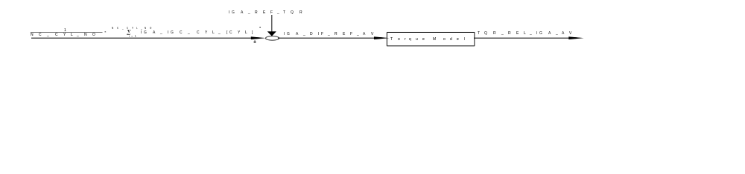

Activation: LV_ES = 0

Deactivation: LV_ES = 1

Formula section:

IGA_DIF_REF_AV = 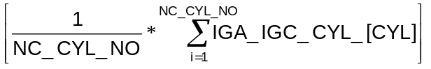- IGA_REF_TQR
(limited to ≤ 0 °CRK)

FAC_IGA_TQR =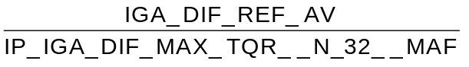

TQR_REL_IGA_AV = IP_FAC_TQR__FAC_IGA_TQR * TQR_REL_MAX_IGA_N_MAF
Calibration data:
Name | Dim | Hex. limits | Phys. limits | Resol. | Unit
IP_IGA_DIF_MAX_TQR__N_32__MAF | 8x8 | 0...FFH | 0...-95.625 | 0.375 | °CRK
maximum allowed spark retard for torque reduction
IP_FAC_TQR__FAC_IGA_TQR | 8 | 0...FFH | 0...0.996 | 0.0039 | 100%
relative standard inverse ignition cog

Torque model

Standard torque (TQ_STND)
Output data:
Name | Mode | Hex. limits | Phys. limits | Resol. | Unit
TQ_STND | V | 0...3FH | 0...630 | 10 | Nm
standard engine torque

The standard engine torque TQ_STND is taken from C_TQ_STND and transmitted by the engine management system to the CAN stations (TCS control unit and TCU).
It is the reference torque to which the torque reduction quantities are related. The result are relative torque quantities as percentage which are put on the CAN.
Calibration data:
Name | Dim | Hex. limits | Phys. limits | Resol. | Unit
C_TQ_STND | 1 | 0...3FH | 0...630 | 10 | Nm
standard engine torque

Frictional torque (TQFR)
Output data:
Name | Mode | Hex. limits | Phys. limits | Resol. | Unit
TQFR | V | 0...FFH | 0...-255 | 1 | Nm
engine friction torque
Input data:
N_32 | MAF | TCO | LV_RLY_ACCOUT
LV_PRS_ACC | LV_ES

FUNCTION DESCRIPTION:
General information:
The frictional torque is a negative quantity. The following influences are considered in this model:

- N_32 engine speed
- MAF mass air flow
- TCO coolant temperature
- ACC air condition compressor on/off

Application conditions:
Activation: LV_ES = 0
Deactivation: TQFR = 0 at engine operating state LV_ES = 1

Formula section:
If LV_RLY_ACCOUT = 0
then TQFR = IP_TQFR__N_32__MAF (Influence of engine speed / load)
+ IP_TQFR_ADD _TCO__TCO (Influence of coolant temperature)

If LV_RLY_ACCOUT = 1
and LV_PRS_ACC = 0
then TQFR = IP_TQFR__N_32__MAF (Influence of engine speed / load)
+ IP_TQFR_ADD_TCO__TCO (Influence of coolant temperature)
+ C_TQFR_ADD_ACC_L (Influence of air condition compressor with low system pressure)

If LV_RLY_ACCOUT = 1
and LV_PRS_ACC = 1
then TQFR = IP_TQFR__N_32__MAF (Influence of engine speed / load)
+ IP_TQFR_ADD_TCO__TCO (Influence of coolant temperature)
+ C_TQFR_ADD_ACC_H (Influence of air condition compressor with high system pressure)

Calibration data:
Name | Dim | Hex. limits | Phys. limits | Resol. | Unit
IP_TQFR__N_32__MAF | 8x2 | 0...FFH | 0...-255 | 1 | Nm
basic engine friction torque
IP_TQFR_ADD_TCO__TCO | 8 | 0...FFH | +128...-127 | 1 | Nm
coolant temperature correction for friction torque calculation
C_TQFR_ADD_ACC_H | 2 | 0...FFH | 0...-255 | 1 | Nm
Air condition compressor correction for friction torque calculation (High system pressure)
C_TQFR_ADD_ACC_L | 2 | 0...FFH | 0...-255 | 1 | Nm
Air condition compressor correction for friction torque calculation (Low system pressure)

Indicated engine torque (TQI)
Output data:
Name | Mode | Hex. limits | Phys. limits | Resol. | Unit
TQI | V | 0...FFH | 0...510 | 2 | Nm
indicated engine torque
Input data:
N_32 | MAF | TQR_REL_SCC_EMS | TQR_REL_IGA_EMS
IP_FAC_LAM_TQI__LAM_SUB__IGA_DIF_REF_AV | LV_ES | LV_PUC | IGA_DIF_REF_AV
LAM_SUB
FUNCTION DESCRIPTION:
General information:
The indicated engine torque TQI refers to the drivers wish and is calculated from the mass air flow and engine speed. Additionally a lambda correction factor and a factor coming from spark retard and fuel cut-off is applied.
For the TQI calculation only spark retard interventions from EMS internal functions (e.g. knock correction, catalyst heating, anti jerk, etc.) or fuel cut-off due to engine speed limitation, vehicle speed limitation or misfire detection is considered.
However, the TQI calculation is independent from torque influence from ASR or gear shift.
The table IP_FAC_LAM_TQI__LAM_SUB__IGA_DIF_REF_AV is used to correct the indicated torque as a function of LAM_SUB and IGA_DIF_REF_AV.
Application conditions:
Activation: LV_ES = 0, LV_PUC = 0
Deactivation: TQI = 0 at engine operating states PUC and ES
Formula section:
TQI = IP_TQI__N_32__MAF (Influence of engine speed / load)
* IP_FAC_LAM_TQI__LAM_SUB__IGA_DIF_REF_AV (Influence of Lambda)
* [1 - (TQR_REL_IGA_EMS (Influence of spark retard by EMS)
+TQR_REL_SCC_EMS) ] (Influence of cylinder shut-off effected by EMS)
(N_MAX, VS_MAX, PUC and misfire)
Calibration data:
Name | Dim | Hex. limits | Phys. limits | Resol. | Unit
IP_TQI__N_32__MAF | 8x2 | 0...FFH | 0...510 | 2 | Nm
Basis indicated engine torque
IP_FAC_LAM_TQI__LAM_SUB__IGA_DIF_REF_AV | 6x6 | 0...FFH | 0...1.992 | 0.0078 | -
Lambda correction for indicated engine torque
Remark: In the application system this map is named IP_FAC_LAM_TQI__LAM_SUB__IGA_DIF

Lambda influence weighted by ignition angle
Output data:
Name | Mode | Hex. limits | Phys. limits | Resol. | Unit
LAM_SUB | V | 00...FFH | 0...1.992 | 7.782E-3 | -
Lambda substitute value
Input data:
TIB | TI_MV |  | LV_ES
TI_AD_FAC_MMV | TI_AD_ADD_MMV
FUNCTION DESCRIPTION:
With increasing retardation of the ignition angle the lambda dependence of the indicated engine torque TQI is enhanced.

Activation: LV_ES = 0

Deactivation: LV_ES = 1
Formula section:

LAM_SUB = 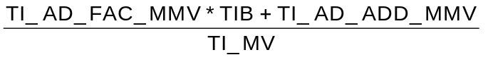

Remark: TIB and TI_MV are without dead time.

Influence of ignition angle
Input data:
FAC_IGA_TQR | FAC_TQR
Description:
The influence of the ignition angle on the indicated engine torque TQI is modeled via a general (relative) ignition cog. There are two tables for the relation between an ignition angle retard adjustment (compared to the absolute reference ignition angle IGA_REF_TQR) and the related relative reduction of the engine torque:
- IP_FAC_TQR__FAC_IGA_TQR to calculate the relative torque reduction for a differential ignition angle adjustment (relation IGA --> TQR)
- IP_FAC_IGA_TQR__FAC_TQR to calculate the ignition angle adjustment for a torque reduction request (relation TQI --> IGA)
For the calculation of TQI all ignition angle adjustments, such as knock control, catalyst heating, etc., are considered. ASR and GS are not included in the calculation of TQI.
Calibration data:
Name | Dim | Hex. limits | Phys. limits | Resol. | Unit
IP_FAC_IGA_TQR__FAC_TQR | 8 | 0...FFH | 0...0.996 | 0.0039 | 100%
relative standard ignition cog
IP_FAC_TQR__FAC_IGA_TQR | 8 | 0...FFH | 0...0.996 | 0.0039 | 100%
relative standard inverse ignition cog

Reference ignition angle (IGA_REF_TQR)
Output data:
Name | Mode | Hex. limits | Phys. limits | Resol. | Unit
IGA_REF_TQR | V | 0...FFH | -23...72.5 | 0.375 | °CRK
Reference ignition angle for torque intervention
Input data:
IGA_BAS | IGA_EGR
FUNCTION DESCRIPTION:
The reference ignition angle IGA_REF_TQR for this model approach is an absolute ignition angle, which is approximately identical to the ignition angle existing at maximum torque.
Formula section:
IGA_REF_TQR = IGA_BAS Basic ignition angle without EGR
or
IGA_EGR Basic ignition angle with EGR active

Relative Torque Reduction by EMS internal Spark Retard (TQR_REL_IGA_EMS)
Output data:
Name | Mode | Hex. limits | Phys. limits | Resol. | Unit
IGA_DIF_REF_EMS | V | 0...FFH | 0...-95.625 | 0.375 | ° CRK
difference between actual ignition angle and torque reference ignition angle
FAC_IGA_TQR | - | 0...FFH | 0...-95.625 | 0.375 | ° CRK
relative EMS internal ignition angle retardation related to the maximum possible spark retard
TQR_REL_IGA_EMS | V | 0...FFH | 0...0.996 | 0.0039 | 100%
Relative torque reduction by EMS internal spark retard
Input data:
IGA_CYL_[CYL] | IGA_REF_TQR | LV_ES | NC_CYL_NO
IP_IGA_DIF_MAX_TQR__N_32__MAF | TQR_REL_MAX_IGA_N_MAF | IP_FAC_TQR__FAC_IGA_TQR
FUNCTION DESCRIPTION:
TQR_REL_IGA_EMS represents the EMS internal relative torque reduction by ignition angle retard adjustment (e.g. catalyst heating, knock control, transient spark retard, anti jerk function, etc.) related to the reference ignition angle IGA_REF_TQR.
IGA_DIF_REF_EMS is the current differential ignition angle relative to IGA_REF_TQR without ASR and GS intervention.
Application conditions:
Activation: not ES (LV_ES = 0)
Deactivation: ES (LV_ES = 0)
Formula section:
IGA_DIF_REF_EMS = 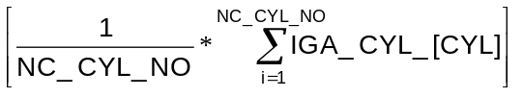- IGA_REF_TQR
(limited to ≤ 0 °CRK)

FAC_IGA_TQR = 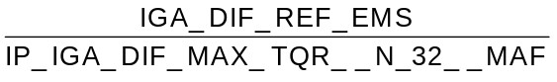

TQR_REL_IGA_EMS = IP_FAC_TQR__FAC_IGA_TQR * TQR_REL_MAX_IGA_N_MAF

Relative Torque Reduction by EMS internal Fuel Cut-Off (TQR_REL_SCC_EMS)
Output data:
Name | Mode | Hex. limits | Phys. limits | Resol. | Unit
PAT_INH_IV_MAX_N_VS | V | 0...DH | 0...13 | 1 | -
maximum choice of pattern index between engine speed and vehicle speed limitation
TQR_REL_SCC_EMS | V | 0...FFH | 0...0.996 | 0.0039 | 100%
relative torque reduction by EMS internal fuel cut-off functions
TQR_REL_SCC_N_VS | V | 0...FFH | 0...0.996 | 0.0039 | 100%
maximum relative torque reduction by engine speed and vehicle speed limitation fuel cut-off functions
Input data:
ID_TQR_REL_SCC__PAT_INH_IV | PAT_INH_IV_N_MAX | PAT_INH_IV_VS_MAX | TQR_REL_SCC_MIS
FUNCTION DESCRIPTION:
General information:
Cylinder shut-offs by N_MAX and VS_MAX limitations are based on the same cylinder shut-off patterns as the TCS function. The effect of these cylinder shut-offs on the engine torque is included in the calculation by the internal quantity TQR_REL_SCC_EMS.
If a cylinder shut-off is requested by several functions at the same time, this results in a maximum selection of the pattern index requests PAT_INH_IV_MAX_N_VS and the resulting relative torque reduction TQR_REL_SCC_N_VS.

If the misfire detection inhibits a certain cylinder, it will remain inhibited until switched back on by the misfire detection. A cylinder which is shut-off due to misfire is ignored by the TCS shut-off pattern. This shut-off cylinder influences the TQI and is considered in the engine torque model by the relative torque reduction TQR_REL_SCC_MIS.

Formula section:
PAT_INH_IV_MAX_N_VS = max (PAT_INH_IV_N_MAX, PAT_INH_IV_VS_MAX)
TQR_REL_SCC_N_VS = ID_TQR_REL_SCC__PAT_INH_IV_MAX_N_VS
The total effect of the resulting relative torque reduction by EMS internal fuel shut-off functions and misfiring cylinder inhibition is given by following interference formula:
TQR_REL_SCC_EMS = TQR_REL_SCC_N_VS + TQR_REL_SCC_MIS -
(TQR_REL_SCC_N_VS * TQR_REL_SCC_MIS)
This formula is only valid for rolling pattern and steady state fuel shut-off of one or more individual cylinder (like misfire cylinder inhibition).

Exhaust gas temperature model
Output data:
Name | Mode | Hex. limits | Phys. limits | Resol. | Unit
TEG_STAT | V | 0...7FF0H | 0...2047 | 0.0625 | °C
steady state exhaust gas temperature
TEG_MMV_SUB | V | 0...7FF0H | 0...2047 | 0.0625 | °C
dynamic exhaust gas temperature
POW_DIF | V | 0...FD03H | 0...69.08 | 1.067E-03 | kW
Power representing the increase of the exhaust gas temperature due to spark retardation
CRLC_TEG | - | 0...FFFFH | 0...0.999985 | 1.525E-05 | -
Correlation constant for exhaust gas temperature calculation
Input data:
N | N_32 | MAF | MAF_KGH
VS | PAT_INH_IV | LAM_SUB | TCO
TQR_REL_IGA_AV | LV_ES | TQI
FUNCTION DESCRIPTION:
General information:
The exhaust gas temperature model calculates a theoretical exhaust gas temperature TEG_MMV_SUB upstream of the catalytic converter. This temperature serves as a decision criterion for the torque reduction logic module to apportion the desired torque reduction into an IGA- and a SCC-component.

The following input variables are used by the first order model approach to calculate the TEG_MMV_SUB in intervals of 1 second:
- N_32 engine speed
- MAF, MAF_KGH mass air flow
- VS vehicle speed
- POW_DIF differential power representing the
exhaust gas temperature increase by spark retardation
- PAT_INH_IV fuel shut-off pattern index
- LAM_SUB lambda substitute value

The calculated temperature TEG_MMV_SUB is initialized at engine start, using the actual measured coolant temperature TCO.

Application conditions:
Activation: not ES (LV_ES = 0)
Deactivation: ES (LV_ES = 0)

Stationary exhaust gas temperature (TEG_STAT)
Formula section:

TEG_STAT =
[ 1 - ID_TEG_FAC_SCC__PAT_INH_IV ] influence of cylinder shut-off
* [ ( IP_TEG__N_32__MAF basic stationary exhaust gas temperature
+ IP_TEG_ADD_IGA__POW_DIF Temperature rise due to
) retarded ignition angle
* IP_TEG_FAC_LAM__LAM_SUB Lambda dependence of exhaust gas
temperature
* IP_TEG_FAC_VS__VS influence of cooling air as a function of
] driving speed
+ ID_TEG_FAC_SCC__PAT_INH_IV influence of cylinder shut-off
* ( TCO + IP_TEG_STAT_ADD_SCC__MAF_KGH)
correction for stationary exhaust gas
temperature at fuel shut-off

Temperature increase by spark retard:
This model approach relates the temperature increase to the retarded ignition angle. It is assumed that this decrease of the engine power is directly turned into heat.
The connection between the rise of the exhaust gas temperature and the applied relative spark retard is given by the differential power POW_DIF, which represents the amount of reduced torque that is turned into heat. It is calculated using the actual relative torque reduction by spark retard TQR_REL_IGA_AV, the engine speed N and the indicated engine torque TQI.

Formula section:
POW_DIF = TQI * N * TQR_REL_IGA_AV

Dynamic Exhaust Gas Temperature (TEG_MMV_SUB)

Filter constants:

If TEG_STAT > TEG_MMV_SUB then CRLC_TEG = ID_CRLC_TEG_INC__MAF_KGH
If TEG_STAT ≤ TEG_MMV_SUB then CRLC_TEG = ID_CRLC_TEG_DEC__MAF_KGH

Exhaust gas model temperature:

TEG_MMV_SUB_{n} = TEG_MMV_SUB_{n-1} + CRLC_TEG * (TEG_STAT - TEG_MMV_SUB_{n-1})

Calibration data:
Name | Dim | Hex. limits | Phys. limits | Resol. | Unit
IP_TEG__N_32__MAF | 8x8 | 0...7FF0H | 0...2047 | 0.0625 | °C
basic table of the exhaust gas temperature
ID_TEG_FAC_SCC__PAT_INH_IV | 14 | 0...FFH | 0...1.992 | 0.0078 | -
influence of fuel cut-off on the exhaust gas temperature
IP_TEG_FAC_LAM__LAM_SUB | 6 | 0...FFH | 0...1.992 | 0.0078 | -
influence of lambda on the exhaust gas temperature
IP_FAC_VS_TEG__VS | 6 | 0...FFH | 0...1.992 | 0.0078 | -
influence of the vehicle speed on the exhaust gas temperature
IP_TEG_ADD_IGA__POW_DIF | 4 | 0...7FF0H | 0...2047 | 1 | °C
temperature rise due to retarded ignition angle
ID_CRLC_TEG_INC__MAF_KGH | 6 | 0...FFFFH | 0...1.000 | 1.53E-5 | -
correlation constant for exhaust gas temperature increase
ID_CRLC_TEG_DEC__MAF_KGH | 6 | 0...FFFFH | 0...1.000 | 1.53E-5 | -
correlation constant for exhaust gas temperature decrease
IP_TEG_STAT_ADD_SCC__MAF_KGH | 6 | 0...FFH | -100...300 | 1.569 | °C
temperature rise due to cylinder shut-off

Torque Intervention for ASR and Gear Shift
Output data:
Name | Mode | Hex. limits | Phys. limits | Resol. | Unit
TQR_REL_IGA_OUT | V | 0...FFH | 0...0.996 | 0.0039 | 100%
Relative output torque reduction by spark retard
TQR_REL_SCC_OUT | V | 00...FFH | 0...0.997 | 0.0039 | 100%
Relative output torque reduction by fuel cut-off
LV_CDN_ASR | - | 0...1H | 0...1 | 1 | -
logical value for possible ASR intervention
LV_CDN_GS | V | 0...1H | 0...1 | 1 | -
logical value for possible gear shift
TQR_REL_OUT | V | 0...FFH | 0...0.996 | 0.0039 | 100%
General output of torque reduction
T_GS_DLY_DIAG | V | 0...FFFFH | 0...655.35 | 0.01 | s
Diagnosis time during gear-shift
Input data:
LV_IV_[CYL]_ERR | LV_MAF_ERR | LV_CPS_ERR | N
N_SP_IS | TQI_TCS_CAN | TQ_STND | TQI
TQR_AS | LV_ASR_REQ | LV_ES | LV_ST
LV_IS | LV_DRI | TQI_TCU_CAN | TQR_REL_IGA_OUT

FUNCTION DESCRIPTION:
General information:
The torque intervention logic of the engine management system determines the valid target torque TQI_ASR_REQ or TQI_GS_REQ, which can be requested by the traction control system or the transmission control unit.
This target torque can be reached by ignition angle adjustment and/or cylinder shut-off.

The indicated engine torque is linearly decreased by cylinder shut-off, depending on the number of shut-off cylinders respectively the index of the shut-off pattern. The transitions are performed by a steady ignition angle adjustment.
The torque intervention logic module decides about the applied apportionment of IGA and SCC components to reach the requested target torque (TQI_ASR_REQ or TQI_GS_REQ) based on the following conditions:
- Engine operating point (N, MAF)
- Operating states (WUP, catalyst protection)
- Exhaust gas temperature (TEMP_MMV_SUB)
- Engine speed and TCO limits (VS, TCO)
The torque resulting from the torque model as actual target torque for the intervention (TQI_INTV) is put on the CAN by the engine management system. The torque intervention logic adjusts to a reduced torque which is the closest to the requested torque.
Under limit conditions (for example when a high exhaust gas temperature is present or when the catalyst overheating protection is active or due to the minimum cylinder shut-off pattern ID_NR_PAT_MIN__LAM_SUB__TEG_DIF) it is possible that the requested torque can not be adjusted.

Output variables are the torque intervention to be executed via ignition angle adjustment TQR_REL_IGA_OUT and via cylinder shut-off TQR_REL_SCC_OUT.

Three operating modes are available for a torque reduction intervention:
- IGA ignition angle adjustment exclusively
- SCC/IGA cylinder shut-off in combination with ignition angle adjustment
- SCC cylinder shut-off exclusively

The ignition angle adjustment mode allows a quick torque reaction resulting in a good driveability. However, it can cause an increase of the exhaust gas temperature and is therefore only admissible up to a certain exhaust gas temperature.
The combination mode of cylinder shut-off and ignition angle adjustment is less critical regarding the exhaust gas temperature and permits extended torque interventions, but with the disadvantage of a worse driveability.
If a maximum exhaust gas temperature is exceeded during the combined intervention, the ignition angle intervention is no longer accepted, but only the cylinder shut-off will be effective.

Overview of the possible torque interventions

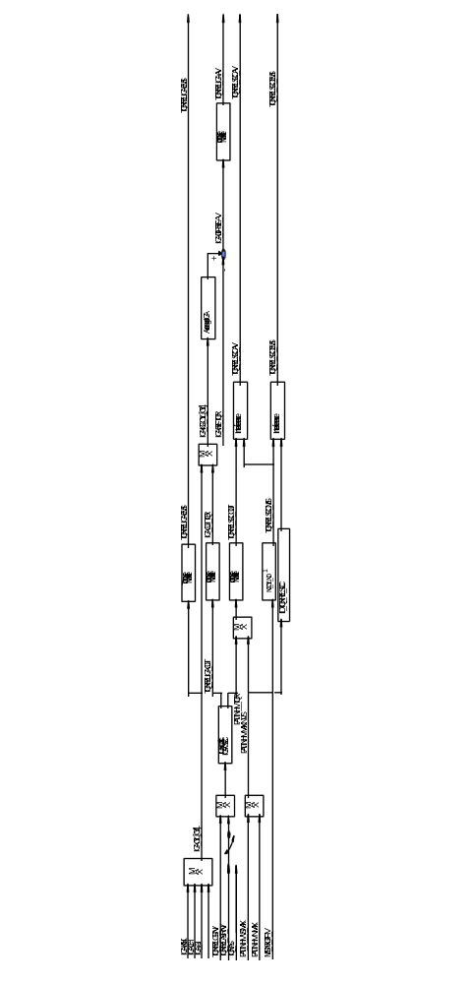

Conditions for ASR- and GS-intervention

Conditions for a ASR intervention:
If LV_IV_[CYL]_ERR = 0 (no error at the injectors)
and LV_MAF_ERR = 0 (no error at the mass air flow sensor)
and LV_CPS_ERR = 0 (no error at the canister purge solenoid)
and N > N_SP_IS + C_N_ADD_ASR (engine speed threshold)
and [ TQI_TCS_CAN < 100% (TQ_STND)(ASR-req. torque below TQ_STND)
and TQI_ASR_REQ < TQI (ASR-requested torque below TQI)
and LV_ASR_REQ = 1 (ASR intervention requested by control unit)
] or TQR_AS > 0 (torque intervention by application system)
then LV_CDN_ASR = 1 (ASR intervention possible)
else LV_CDN_ASR = 0 (ASR intervention not possible)

Conditions for a Gear-Shift intervention:
If LV_ES = 0
and LV_ST = 0
and LV_IS = 0
and LV_DRI = 1 (With A/T: Drive selected)
and TQI_TCU_CAN < 100% (TQ_STND) (GS-requested torque below TQ_STND)
and TQI_GS_REQ < TQI (GS-requested torque below TQI)
and TQI_GS_REQ < TQI ASR REQ (req. torque for GS below ASR-request)
and T_GS_DLY_DIAG < C_T_GS_DLY_DIAG (GS duration below limit)
then LV_CDN_GS = 1 (Gear shift intervention possible)
else LV_CDN_GS = 0 (Gear shift intervention not possible)

Calibration data:
Name | Dim | Hex. limits | Phys. limits | Resol. | Unit
C_N_ADD_ASR | 1 | 0...FFH | 0...8160 | 32 | rpm
engine speed offset to nominal speed value for activation of ASR
C_T_GS_DLY_DIAG | 1 | 0...FFFFH | 0...655.35 | 0.01 | s
Diagnosis timer threshold for gear shift

Torque Reduction Intervention

Relative Nominal Torque Reduction for ASR (TQR_REL_ASR_NV)
Output data:
Name | Mode | Hex. limits | Phys. limits | Resol. | Unit
TQR_REL_ASR_NV | V | 0...FFH | 0...0.996 | 0.0039 | 100%
Nominal torque reduction for ASR
Input data:
LV_CDN_ASR | TQI_ASR_REQ | IP_TQI__N_32__MAF | IP_FAC_LAM_TQI__LAM_SUB__IGA_DIF_REF_AV

Application conditions:

If LV_CDN_ASR = 1
then TQR_REL_ASR_NV =
1 -

else TQR_REL_ASR_NV = 0

Relative Nominal Torque Reduction for GS (TQR_REL_GS_NV)
Output data:
Name | Mode | Hex. limits | Phys. limits | Resol. | Unit
TQR_REL_GS_NV | V | 0...FFH | 0...0.997 | 0.0039 | 100%
Torque Reduction for Gear Shift
Input data:
LV_CDN_GS | TQI_GS_REQ | IP_TQI__N_32__MAF | IP_FAC_LAM_TQI__LAM_SUB__IGA_DIF_REF_AV

Application conditions:

If LV_CDN_GS = 1
then TQR_REL_GS_NV =
1 -

else TQR_REL_GS_NV = 0

Determination of the Torque Reduction Amount
Output data:
Name | Mode | Hex. limits | Phys. limits | Resol. | Unit
TQR_REL_NV | V | 0...FFH | 0...0.997 | 0.0039 | 100%
Torque reduction input for torque model based on ASR- and GS-request
Input data:
TQR_REL_GS_NV | TQR_REL_ASR_NV

General information:
A torque intervention for gear shift and ASR can happen at the same time. The intervention is done according to the lowest requested torque.

Formula Section:

TQR_REL_NV = MAX (TQR_REL_GS_NV, TQR_REL_ASR_NV)

Selection of the Torque Reduction Mode

Output data:
Name | Mode | Hex. limits | Phys. limits | Resol. | Unit
LV_IGA_ADJ_MOD | V | 0...1H | 0...1 | 1 | -
Boolean for ignition angle adjustment for torque reduction
LV_SCC_MOD | V | 0...1H | 0...1 | 1 | -
Boolean for fuel cut-off for torque reduction
LV_TEG_MAX | V | 0...1H | 0...1 | 1 | -
Boolean for maximum allowed exhaust gas temperature exceeded

Input data:
TCO | TQR_REL_NV | TQR_REL_MAX_IGA_N_MAF | TEG_MMV_SUB

General Information:

A hysteresis is used for determination of the torque reduction mode.

If TCO > C_TCO_MIN_SCC
then if [ TQR_REL_NV > TQR_REL_MAX_IGA_N_MAF
or N_32 > C_N_MAX_IGA_TQR ]
then LV_SCC_MOD = 1
else if TEG_MMV_SUB > C_TEG_THD_2
then LV_SCC_MOD = 1
else if TEG_MMV_SUB < C_TEG_THD_1
then LV_SCC_MOD = 0
else LV_SCC_MOD = 0

If N_32 < C_N_MAX_IGA_TQR
then if [ LV_TEG_MAX = 0 and TEG_MMV_SUB < C_TEG_MAX]
or [ LV_TEG_MAX = 1 and TEG_MMV_SUB < C_TEG_THD_2]
then LV_IGA_ADJ_MOD = 1
else if TEG_MMV_SUB > C_TEG_MAX
then LV_IGA_ADJ_MOD = 0
and LV_TEG_MAX = 1
else LV_IGA_ADJ_MOD = 0
and LV_TEG_MAX = 0

Reset of LV_TEG_MAX:
If TQR_REL_NV = 0
then LV_TEG_MAX = 0
and LV_SCC_MOD = 0
and LV_IGA_ADJ_MOD = 0

Exhaust gas temperature logic
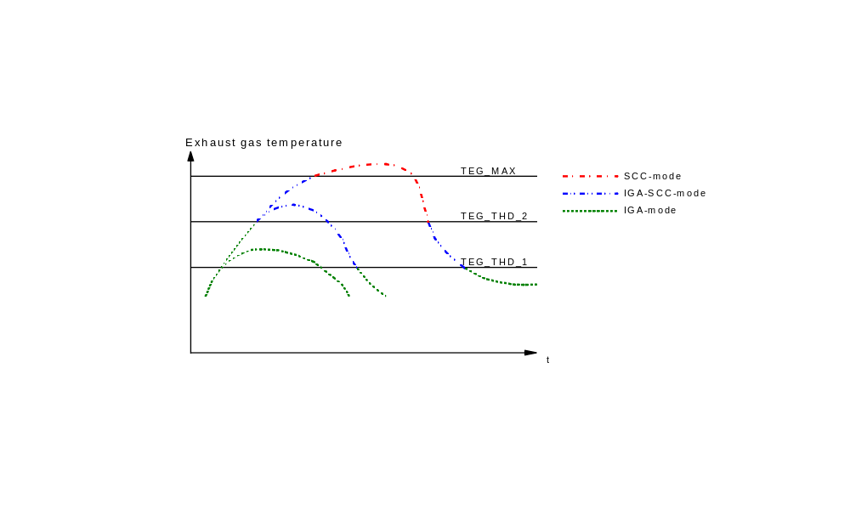The above diagram represents possible exhaust gas temperatures TEG_MMV_SUB during an ASR intervention with the three operating modes available for torque reduction.

Calibration data:
Name | Dim | Hex. limits | Phys. limits | Resol. | Unit
C_TCO_MIN_SCC | 1 | 0...FEH | -48...142.50 | 0.55 | °C
exhaust gas temperature threshold 1
C_TEG_THD_1 | 1 | 0...7FF0H | 0...2047 | 0.0625 | °C
exhaust gas temperature threshold 1
C_TEG_THD_2 | 1 | 0...7FF0H | 0...2047 | 0.0625 | °C
exhaust gas temperature threshold 2
C_TEG_MAX | 1 | 0...7FF0H | 0...2047 | 0.0625 | °C
maximum allowable exhaust gas temperature
C_N_MAX_IGA_TQR | 1 | 0...FF0H | 0...8160 | 32 | rpm
maximum allowed engine speed for ignition angle intervention

Ignition Angle Adjustment (IGA_ADJ) Mode
Output data:
Name | Mode | Hex. limits | Phys. limits | Resol. | Unit
TQR_REL_IGA_OUT | V | 0...FFH | 0...0.997 | 0.0039 | 100%
relative torque reduction by ignition angle adjustment
TQR_REL_SCC_OUT | V | 0...FFH | 0...0.996 | 0.0039 | 100%
relative torque reduction by fuel cut-off
PAT_INH_IV_TQR | V | 0...DH | 0...13 | 1 | -
index pattern for cylinder shut-off for torque reduction
LV_IGA_ADJ_TQR | V | 0...1H | 0...1 | 1 | -
Boolean for torque reduction by spark retard
LV_SCC_TQR | V | 0...1H | 0...1 | 1 | -
Boolean for torque reduction by fuel cut-off
Input data:
LV_IGA_ADJ_MOD | LV_SCC_MOD | TQR_REL_NV | TQR_REL_MAX_IGA_N_MAF

FUNCTION DESCRIPTION:
General information:
In the ignition angle adjustment mode, the required torque reduction TQR_REL_NV is performed exclusively via spark retard. Torque interventions by ignition angle intervention are clearly preferred as they do not affect the driveability.
Vehicle take-off or slip occurring during cornering require a very quick torque intervention. In such cases, a new ASR request is executed exclusively by spark retard up to the possible extent (limitations by exhaust gas temperature or ignition angle).

- The following function is effected by the ignition angle adjustment:
- Knock adaptation is inhibited
Application conditions:
Activation / Deactivation

If LV_IGA_ADJ_MOD = 1
and LV_SCC_MOD = 0
then TQR_REL_IGA_OUT = Min (TQR_REL_NV, TQR_REL_MAX_IGA_N_MAF)
and LV_IGA_ADJ_TQR = 1
and LV_SCC_TQR = 0
and TQR_REL_SCC_OUT = 0
and PAT_INH_IV_TQR = 0

Cylinder Shut-Off (SCC) Mode
Output data:
Name | Mode | Hex. limits | Phys. limits | Resol. | Unit
TQR_REL_IGA_OUT | V | 00...FFH | 0...0.997 | 0.0039 | 100%
relative torque reduction by spark retard
TQR_REL_SCC_OUT | V | 0...FFH | 0...0.996 | 0.0039 | 100%
relative torque reduction by fuel cut-off
PAT_INH_IV_TQR | V | 0...DH | 0...13 | 1 | -
index of fuel cut-off pattern for torque reduction
LV_IGA_ADJ_TQR | V | 0...1H | 0...1 | 1 | -
Boolean for torque reduction by spark retard
LV_SCC_TQR | V | 0...1H | 0...1 | 1 | -
Boolean for torque reduction by fuel cut-off
Input data:
LV_SCC_MOD | LV_IGA_ADJ_MOD | ID_PAT_INH_IV_MIN__LAM_SUB__TEG_DIF
FUNCTION DESCRIPTION:
General information:
With this mode the torque reduction request TQR_REL_NV is answered exclusively by a cylinder shut-off.
With the used cylinder shut-off pattern the engine torque can be only adjusted in steps. However, as a shut-off pattern of 13 is used, the steps are very small and therefore the torque reduction performance and the driveability are not effected excessively.

- The following functions are effected by the cylinder shut-off:
- Lambda control loop is opened
- Catalyst overheating protection function
- Warm-up enrichment is switched to separate ASR warm-up enrichment
- Full load enrichment is inhibited
- Cold post-start enrichment is inhibited
- Knock adaptation is inhibited
- CPS is closed
- EGR valve is closed
- Fuel leaning function during cylinder shut-off is enabled

Application conditions:
Activation / Deactivation

If LV_SCC_MOD = 1
and LV_IGA_ADJ_MOD = 0
then PAT_INH_IV_TQR = Max (ID_PAT_INH_IV_MIN__LAM_SUB__TEG_DIF,
ID_PAT_INH_IV_TQR__TQR_REL_NV)
If PAT_INH_IV_TQR > 0
then LV_SCC_TQR = 1
and TQR_REL_SCC_OUT = ID_TQR_REL_SCC__PAT_INH_IV_TQR
and TQR_REL_IGA_OUT = 0
and LV_IGA_ADJ_TQR = 0
else TQR_REL_SCC_OUT = 0
and LV_SCC_TQR = 0

Calibration data:
Name | Dim | Hex. limits | Phys. limits | Resol. | Unit
ID_TQR_REL_SCC__PAT_INH_IV_TQR | 14 | 0...FFH | 0...0.996 | 0.0039 | 100%
relative torque reduction by fuel cut-off pattern
Remark: In the application system the name of this map is ID_TQR_REL_SCC__PAT_INH_IV
ID_PAT_INH_IV_TQR__TQR_REL_NV | 6x6 | 0...DH | 0...13 | 1
Cylinder shut-off pattern number for torque reduction

Torque Reduction by Single Cylinder Shut-Off (SCC) and
Ignition Angle Adjustment (IGA_ADJ) Mode
Output data:
Name | Mode | Hex. limits | Phys. limits | Resol. | Unit
TQR_REL_IGA_OUT | V | 00...FFH | 0...0.997 | 0.0039 | 100%
relative torque reduction by ignition angle adjustment
TQR_REL_SCC_OUT | V | 0...FFH | 0...0.997 | 0.0039 | 100%
relative torque reduction by fuel cut-off
TQR_REL_MAX_IGA_TEG | V | 0...FFH | 0...0.997 | 0.0039 | 100%
maximum relative torque reduction by ignition angle adjustment regarding exhaust gas temperature
PAT_INH_IV_TQR | V | 0...DH | 0...13 | 1 | -
index for fuel cut-off pattern for torque reduction
LV_IGA_ADJ_TQR | V | 0...1H | 0...1 | 1 | -
Boolean for torque reduction by spark retard
LV_SCC_TQR | V | 0...1H | 0...1 | 1 | -
Boolean for torque reduction by fuel cut-off
Input data:
LV_SCC_MOD | LV_IGA_ADJ_MOD | ID_PAT_INH_IV_TQR__TQR_REL_NV | TQR_REL_MAX_IGA_N_MAF
TEG_DIF | N | TQI | TQR_REL_NV
FUNCTION DESCRIPTION:
General information:
In case of this torque reduction mode the requested torque is executed by a combination of cylinder shut-off and ignition angle retard adjustment.
This mode is activated if the ignition angle adjustment mode can no longer be kept alone and if the following conditions are met.
Application conditions:
If LV_SCC_MOD = 1
and LV_IGA_ADJ_MOD = 1
then
a) Determination of the torque reduction portion by cylinder shut-off
PAT_INH_IV_TQR = Max (ID_PAT_INH_IV_MIN__LAM_SUB__TEG_DIF,
ID_PAT_INH_IV_TQR__TQR_REL_NV)
If PAT_INH_IV_TQR > 0
then TQR_REL_SCC_OUT = ID_TQR_REL_SCC__PAT_INH_IV_TQR
and LV_SCC_TQR = 1
else TQR_REL_SCC_OUT = 0
and LV_SCC_TQR = 0
b) Determination of the torque reduction portion by ignition angle adjustment
If TQR_REL_NV - TQR_REL_SCC_OUT > 0
then TQR_REL_MAX_IGA_TEG =
and TQR_REL_IGA_OUT = Min (TQR_REL_NV - TQR_REL_SCC_OUT,
TQR_REL_MAX_IGA_N_MAF,
TQR_REL_MAX_IGA_TEG)
and LV_IGA_ADJ_TQR = 1
else TQR_REL_IGA_OUT = 0
and LV_IGA_ADJ_TQR = 0
When the requested torque reduction TQR_REL_NV increases (or either TQI_ASR_REQ or TQI_GS_REQ decreases), the retard adjustment of the ignition angle TQR_REL_IGA_OUT moves to a maximum value, which is given by ID_TQR_REL_SCC__PAT_INH_IV_TQR.
The maximum ignition angle retard adjustment is limited by TQR_REL_MAX_IGA_N_MAF, or TQR_REL_MAX_IGA_TEG.
To avoid an excessive rise of the exhaust gas temperature, there is a minimum cylinder shut-off pattern ID_NR_PAT_MIN__LAM_SUB__TEG_DIF. A hysteresis function enables the return to the "zero pattern" using TQR_REL_SCC_OUT = 0. The cylinder shut-off is only canceled if the torque request condition TQR_REL_NV = 0 is present.

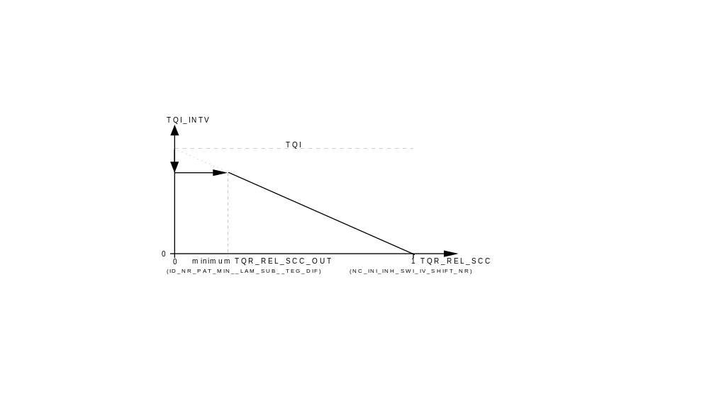
Calibration data:
Name | Dim | Hex. limits | Phys. limits | Resol. | Unit
C_TEG_FAC_IGA | 1 | 0...FFFFH | 0...0.1 | 1.53E-6
factor temperature increase of spark retard
ID_TQR_REL_SCC__PAT_INH_IV | 14 | 0...FFH | 0...0.996 | 0.0035
relative torque reduction by fuel cut-off pattern
ID_PAT_INH_IV_MIN__LAM_SUB__TEG_dif | 6x6 | 0...DH | 0...13 | 1
Minimum pattern number for torque reduction

Minimum Torque Reduction Pattern
Output data:
Name | Mode | Hex. limits | Phys. limits | Resol. | Unit
TEG_DIF | V | 0...FFF0H | -2048...2047 | 0.0625 | °C
Difference between calculated and maximum allowed exhaust gas temperature
Input data:
TEG_MMV_SUB | C_TEG_MAX
FUNCTION DESCRIPTION:
In case of a cylinder shut-off, all stationary mixture enrichments have to be terminated. To prevent the exhaust gas temperature from increasing even more by a cylinder shut-off after an active catalyst overheating prevention enrichment, only activation of cylinder shut-off patterns PAT_INH_IV_TQR ≥ ID_PAT_INH_IV_MIN__LAM_SUB__TEG_DIF are admitted. This minimum allowed cylinder shut-off pattern is selected as a function of TEG_DIF and of the lambda substitute value LAM_SUB.

The differential temperature TEG_DIF is calculated at intervals of a second.

TEG_DIF = TEG_MMV_SUB - C_TEG_MAX

Hysteresis between Cylinder Shut-Off and Ignition Angle Adjustment
FUNCTION DESCRIPTION:
The switch point to a different shut-off pattern is expanded to a switch range using the hysteresis C_TQR_HYS. This way, a permanent switching between the IGA_ADJ and SCC modes is avoided, if the desired torque TQI_ASR_REQ fluctuates around a certain operating point.

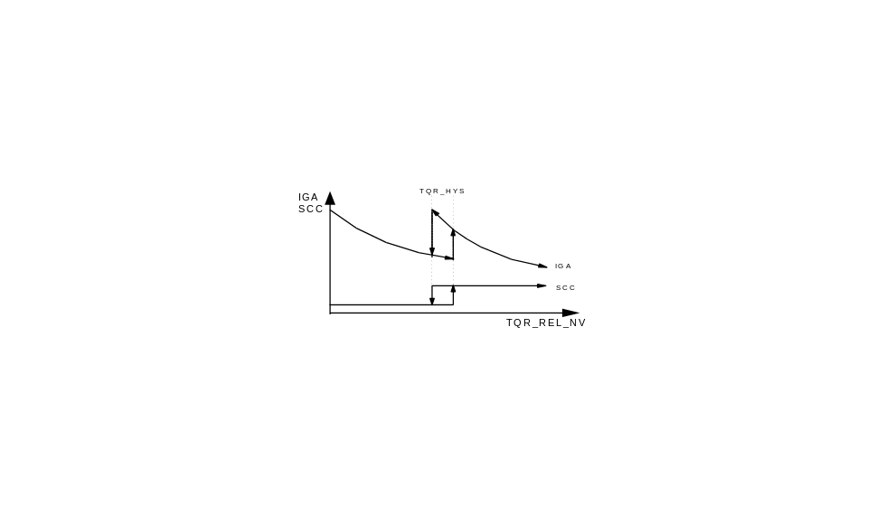

Hysteresis between cylinder shut-off (SCC) and ignition angle adjustment (IGA)

Calibration data:
Name | Dim | Hex. limits | Phys. limits | Resol. | Unit
C_TQR_HYS | 1 | 00...FFH | 0...0.997 | 3.895E-3
Hysteresis between ignition angle adjustment and cylinder shut-off

Torque Intervention by the Application System
Output data:
Name | Mode | Hex. limits | Phys. limits | Resol. | Unit
TQR_AS | V | 00...FFH | 0...0.997 | 0.0039 | 100%
torque reduction request by application tool

Application conditions:
Activation:
The constant C_TQR_AS is implemented to assist in the application process.
If C_TQR_AS > 0 then the requested torque is determined by the maximum selection of TQR_REL_ASR_NV, TQR_REL_GS_NV or TQR_AS.

Deactivation: C_TQR_AS = 0

Calibration data:
Name | Dim | Hex. limits | Phys. limits | Resol. | Unit
C_TQR_AS | 1 | 00...FFH | 0...0.997 | 3.895E-3
application assistance relative torque reduction

Execution of a Torque Intervention

Ignition Angle Retard Adjustment (IGA_ADJ_TQR)
Output data:
Name | Mode | Hex. limits | Phys. limits | Resol. | Unit
IGA_ADJ_TQR | V | 0...FFH | 0...-95.625 | 0.375 | °CRK
ignition angle adjustment for torque intervention
IGA_OUT_TQR_NV | V | 0...FFH | 72...-23.625 | 0.375 | °CRK
applied ignition angle for torque intervention without gradient limitation
IGA_OUT_TQR | V | 0...FFH | 72...-23.625 | 0.375 | °CRK
applied ignition angle for torque intervention with gradient limitation
FAC_TQR | V | 0...FFH | 0...0.997 | 0.0039 | 100%
relative torque reduction by ignition angle adjustment
Input data:
TQR_REL_IGA_OUT | TQR_REL_MAX_IGA_N_MAF | IGA_REF_TQR | IP_FAC_IGA_TQR__FAC_TQR

Signal flow diagram:

Formula section:

If TQR_REL_IGA_OUT > 0
then FAC_TQR = TQR_REL_IGA_OUT / TQR_REL_MAX_IGA_N_MAF
and IGA_ADJ_TQR =
IP_FAC_IGA_TQR__FAC_TQR * IP_IGA_DIF_MAX_TQR__N_32__MAF
and IGA_OUT_TQR_NV = IGA_REF_TQR - IGA_ADJ_TQR
and IGA_OUT_TQR = IGA_OUT_TQR_NV - C_IGA_LGRD_TQR
Ignition angle retard adjustments are effected without limitation gradient,
advance adjustments are effected with the gradient limitation C_IGA_LGRD_TQR.
Calibration data:
Name | Dim | Hex. limits | Phys. limits | Resol. | Unit
IP_IGA_DIF_MAX_TQR__N_32__MAF | 8x8 | 0...FFH | 0...-95.625 | 0.375 | °CRK
maximum spark retard for torque reduction
C_IGA_LGRD_TQR | 1 | 0...FFH | 0...95.625 |  | °CRK/Seg
limitation gradient for ignition angle adjustment

Selection of Cylinder Shut-Off Patterns
Remark:
The selection of the applied cylinder shut-off pattern is described in the chapter „Injection“ in the subchapter „Cylinder Fuel Cut-Off“.

Auxiliary functions

ASR Warm-up
Output data:
Name | Mode | Hex. limits | Phys. limits | Resol. | Unit
TI_WUP_COR | V | 0...7F0H | 0...0.496 | 0.00244
warm-up enrichment correction
Input data:
TCO | TCO_ST | LV_SCC_TQR

General information:
In order to protect the catalyst from overheating by a secondary air effect at fuel cut-off mode (which can happen especially at cold engine temperatures) because of a high wall film in the intake manifold, a more lean warm-up-enrichment is necessary.
To ensure an uninterrupted engine operation (without misfires) in the warm-up phase, the warm-up enrichment cannot be foregone completely in the SCC mode.
Description:
With a cylinder shut-off active, there is a switch from the normal warm-up injection time IP_TI_TCO_WUP__TCO__TCO_ST to IP_TI_TCO_WUP_ASR__TCO__TCO_ST which is leaner than the normal one.
Application conditions:
Activation: LV_SCC_TQR = 1

Deactivation: LV_SCC_TQR = 0

Formula section:
TI = TIB
:
*(1 + TI_WUP_COR)
:

TI_WUP_COR = IP_TI_WUP__N__MAF * IP_TI_TCO_WUP_ASR__TCO__TCO_ST
Calibration data:
Name | Dim | Hex. limits | Phys. limits | Resol. | Unit
IP_TI_TCO_WUP_ASR__TCO__TCO_ST | 8x3 | 0...FFH | 0 ...1.992 | 0.0078
TI warm up correction during ASR intervention

Leaning Function for Cylinder Shut-Off outside the Warm-Up Mode
Input data:
MAF_KGH | LV_SCC_TQR

General information:
To protect the catalytic converter against the secondary air effect (air + excess fuel) in the cylinder shut-off mode, ID_TI_SCC__MAF_KGH can be used to obtain an adjustable enleaning of the active cylinders via MAF_KGH.

Application conditions:
Activation: LV_SCC_TQR = 1

Deactivation: LV_SCC_TQR = 0

Formula section:
TI = TIB
:
* ( 1- ID_TI_SCC__MAF_KGH)
:
Calibration data:
Name | Dim | Hex. limits | Phys. limits | Resol. | Unit
ID_TI_SCC__MAF_KGH | 6 | 0...FFH | 0...0.5 | 0.00196
fuel leaning during cylinder shut-off mode for torque intervention

Inhibition of Lambda closed loop control
Output data:
Name | Mode | Hex. limits | Phys. limits | Resol. | Unit
T_DLY_LAM_TQR | V | 0...FFH | 0...25.5 | 0.1 | s
delay time for lambda control activation after cylinder shut-off for torque intervention
LV_SCC_LAM_TQR | V | 0...1H | 0...1 | 1 | -
Boolean for Lambda control loop opened due to cylinder shut-off for torque intervention
Input data:
LV_SCC_TQR

General Information:

During cylinder shut-off phases due to torque reduction (LV_SCC_TQR = 1) the closed loop lambda control is stopped immediately and LV_SCC_LAM_TQR is set.
When the cylinder shut-off mode is ended (LV_SCC_TQR = 0), the timer T_DLY_LAM_TQR is started with C_T_DLY_LAM_TQR. As soon as this timer has run out, LV_SCC_LAM_TQR is reset.

Formula Section:

If LV_SCC_TQR = 1
then LV_SCC_LAM_TQR = 1

If LV_SCC_TQR = 0
and T_DLY_LAM_TQR = 0
then LV_SCC_LAM_TQR = 0

Calibration data:
Name | Dim | Hex. limits | Phys. limits | Resol. | Unit
C_T_DLY_LAM_TQR | 1 | 0...FFH | 0...25.5 | 0.1 | s
delay time for lambda control activation after cylinder shut-off for torque intervention

Inhibition of EGR during Cylinder Shut-Off
Output data:
Name | Mode | Hex. limits | Phys. limits | Resol. | Unit
T_DLY_EGR_TQR | V | 0...FFH | 0...25.5 | 0.1 | s
delay time for EGR valve opening after cylinder shut-off for torque intervention
LV_SCC_EGR_TQR | V | 0...1H | 0...1 | 1 | -
Boolean for EGR valve closed due to cylinder shut-off for torque intervention
Input data:
LV_SCC_TQR

During fuel cut-off phases due to torque reduction (LV_SCC_TQR = 1) the EGR has to be closed suddenly.
After fuel cut-off action the EGR-valve is opened after a delay time C_T_DLY_EGR_TQR.

Formula Section:

If LV_SCC_TQR = 1
then LV_SCC_EGR_TQR = 1

If LV_SCC_TQR = 0
and T_DLY_EGR_TQR = 0
then LV_SCC_EGR_TQR = 0

Calibration data:
Name | Dim | Hex. limits | Phys. limits | Resol. | Unit
C_T_DLY_EGR_TQR | 1 | 0...FFH | 0...25.5 | 0.1 | s
delay time for EGR valve opening after cylinder shut-off for torque intervention

Cylinder-specific fuel mixture enrichment on restarting fuel-feed
Output data:
Name | Mode | Hex. limits | Phys. limits | Resol. | Unit
TI_ADD_REAC_SCC_[CYL] | V | 0...FFFFH | 0...262.14 | 0.004 | ms
fuel enrichment for restarting cylinders
TI_DIF_WF_[CYL] | V | 0...FFFFH | -131.07...131.07 | 0.004 | ms
calculated amount of wall film
Input data:
TIB | TCO | N_32
General information:
In order to provide a sufficient fuel feed when reactivating a cylinder after a shut-off (complete combustion without misfire) and to ensure a fast torque build-up, the cylinder is supplied with an additional fuel quantity:
- To consider the increased cylinder fill due to the lack of residual exhaust gas
- To consider the removal of the wall-applied fuel film during cylinder shut-off
The additional fuel quantity is calculated individually for each re-activated cylinder.
When the cylinder is restarted, there is no difference depending on the previous operating states.
Formula section:

TI = :
:
+ TI_ADD_REAC_SCC_[CYL]

Calculation of the Wall-Applied Fuel Film Removal
To simulate the wall-applied fuel film removal, the cylinder-specific variable TI_DIF_WF_[CYL] is used. When the cylinder is shut off, TI_DIF_WF_[CYL] is set to the current negative basic injection period TIB, which is multiplied by the adjustable factor ID_TI_TCO_NEG_WF__TCO.
As long as the cylinder is shut off, an engine-speed related additional fuel quantity ID_TI_INC_WF__N_32 is incremented cyclically at intervals of 720° CRK, until either the cylinder is reactivated or the wall film is completely removed.

Directly after cylinder shut-off:
TI_DIF_WF_[CYL] = - TIB * ID_TI_TCO_NEG_WF__TCO

During the following cylinder shut-off period:
TI_DIF_WF_[CYL]_{k} = TI_DIF_WF_[CYL]_{k-1} + ID_TI_INC_WF__N_32

Additional Injection Quantity for Re-Activation of the Cylinder
The fuel quantity represented by TI_ADD_REAC_SCC_[CYL] is provided additionally as restart fuel feed for each cylinder. It is calculated based on the simulated wall-applied fuel film portion TI_DIF_WF_[CYL] and the current basic injection time TIB, multiplied by the basic amount of fuelat restarting ID_TI_TCO_POS_WF__TCO.
Because of the higher load of the restarting cylinders due to missing residual gas, every first restart cycle an additional amount of fuel ID_TI_N_POS_RG__N_32 is injected.
For the restart fuel reduction which is calculated during cylinder shut-off, an engine-speed related decrement ID_TI_DEC_WF__N_32 is used until the additional reactivation amount TI_ADD_REAC_SCC_[CYL]_{k} is decremented to zero.

TI_ADD_REAC_SCC_[CYL] = TI_DIF_WF_[CYL]
+ TIB * ID_TI_TCO_POS_WF__TCO
+ ID_TI_N_POS_RG (applied only for first restart cycle)

TI_ADD_REAC_SCC_[CYL]_{k} = TI_ADD_REAC_SCC_[CYL]_{k-1} - ID_TI_DEC_WF__N_32

Case studies
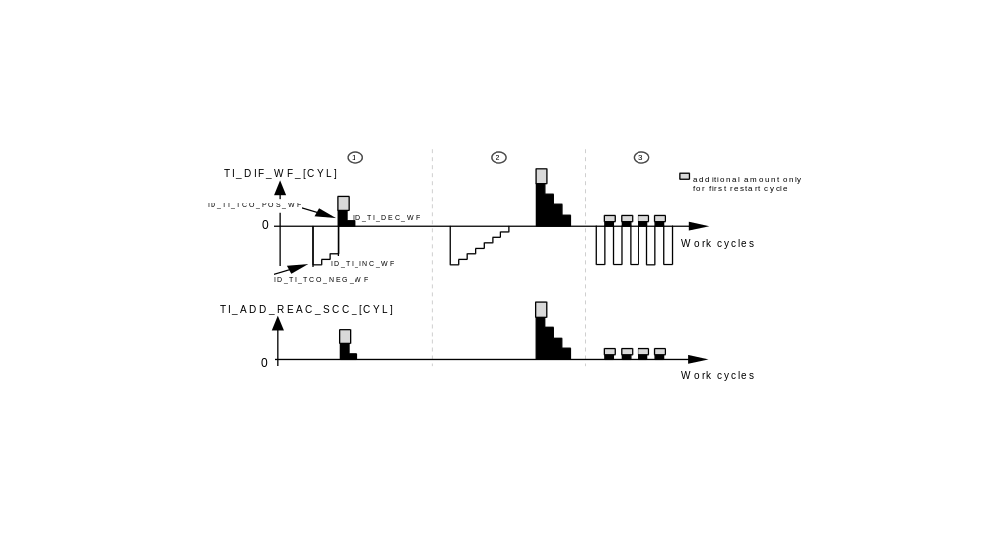
Case 1:
In this example the cylinder is activated again after three shut-off cycles. The wall-applied fuel film has not been removed completely. Therefore the re-starting fuel quantity TI_ADD_REAC_SCC_[CYL] takes into account the residual wall film as a negative value represented by TI_DIF_WF_[CYL]. The additional reactivation injection quantity TI_ADD_REAC_SCC_[CYL] is reset after two cycles.

Case 2:
After a longer cylinder shut-off the wall-applied fuel film is removed completely. The cylinder is re-activated with the maximum quantity for TI_ADD_REAC_SCC_[CYL]

Case 3:
This example shows alternating cylinder operation. Here an additional injection quantity is supplied with every combustion cycle.
Calibration data:
Name | Dim | Hex. limits | Phys. limits | Resol. | Unit
ID_TI_INC_WF__N_32 | 8 | 0...FFFFH | 0...262.14 | 0.004 | ms
increase of wall film
ID_TI_DEC_WF__N_32 | 8 | 0...FFFFH | 0...262.14 | 0.004 | ms
decrease of wall film
ID_TI_TCO_POS_WF__TCO | 8 | 0...FFFFH | 0...4 | 0.00006 | -
basic amount of fuel at restarting
ID_TI_TCO_NEG_WF__TCO | 8 | 0...FFFFH | 0...4 | 0.00006 | -
basic amount of wall film
ID_TI_N_POS_RG__N_32 | 8 | 0...FFFFH | 0...262.14 | 0.004 | ms
Residual exhaust gas compensation

Torque during an torque intervention (TQI_INTV)
Output data:
Name | Mode | Hex. limits | Phys. limits | Resol. | Unit
TQI_INTV | V | 0...FFH | 0...510 | 2 | Nm
indicated engine torque during torque reduction intervention
Input data:
IP_TQI__N_32__MAF | IP_FAC_LAM_TQI__LAM_SUB__IGA_DIF_REF_AV | TQR_REL_SCC_AV | TQR_REL_IGA_AV
LV_ES

The variable TQI_INTV represents the indicated engine torque during a torque reduction intervention.

Application conditions:
Activation: not ES
Deactivation: ES

Formula section:
TQI_INTV = IP_TQI__N_32__MAF (indicated engine torque)
* IP_FAC_LAM_TQI__LAM_SUB__IGA_DIF_REF_AV (lambda correction)
* [ 1 - (TQR_REL_SCC_AV (torque reduction by the actual cylinder shut-off)
+ TQR_REL_IGA_AV) ] (torque reduction by the ignition angle adjustment)

ASR Statistics Counters
Output data:
Name | Mode | Hex. limits | Phys. limits | Resol. | Unit
T_SCC_S | V | 0...1770H | 0...60 | 0.01 | s
short time counter for SCC
T_SCC_L | V | 0...FFFFH | 0...65535 | 1 | min
long time counter for SCC
ASR_STAT_0...15 | V | 0...FFFFH | 0...65535 | 1
ASR statistical array
T_ASR_CTR | V | 0...FFFFH | 0...65535 | 1 | s
ASR statistical counter
TQR_ASR_MAX | V | 0...FFH | 0...255 | 1 | %
depth of ASR intervention
Input data:
TQR_REL_ASR_NV | TQR_REL_SCC_AV

Cylinder Shut-Off Time Counter T_SCC_S and T_SCC_L
The cylinder shut-off time counter records all cylinder shut-off periods resulting from ASR requests. It is to demonstrate the connection between the cylinder shut-off period and the extent of additional aging of the catalytic converter.

There are two counters:
a) The short-time counter T_SCC_S (0...60 sec) is incremented in steps of 10 ms and reset to zero each 60 sec
b) The long-time counter T_SCC_L (0...65535 min) is incremented in steps of one.

The contents of both the counters are stored in the EEPROM and are available after the ignition is switched off.

Reset:
The contents of the SCC time counter can be reset to zero by the procedure resetting the adaptation values via SAMS 2000 application tool.

Enabling condition for SCC time counter:

TQR_REL_SCC_AV > 0

In this context, the value of the ignition angle intervention TQR_REL_IGA_AV is not considered.

Event Frequency Counter - Intervention Statistics ASR_STAT_0...15
16 event frequency counters ASR_STAT_0...15 which are arranged in the form of a 4x4 matrix array record ASR requests by their duration and depth of action.
The measure of the depth of action TQR_ASR_MAX is the requested torque reduction TQR_REL_ASR_NV. The duration of intervention is recorded by the ASR time counter T_ASR_CTR (resolution: 10 ms), which starts beginning with a valid ASR request (TQR_REL_ASR_NV > 0) and is stopped when the ASR request is terminated (TQR_REL_ASR_NV = 0).

During an active ASR phase, the maximum of (TQR_REL_IGA_AV + TQR_REL_SCC_AV) is stored. Once the ASR intervention is terminated, the maximum of TQR_REL_IGA_AV and TQR_REL_SCC_AV as well as T_ASR_CTR are stored in the array. If the maximum of 255 is reached for T_ASR_CTR, it remains unchanged until it is reset by hand.

Reset:
The contents of the statistic counter can be reset to zero by the procedure resetting the adaptation values via SAMS 2000 application tool.

The data points of the event frequency counter cannot be adjusted in the scope of the application, only via a software intervention.

Arrangement of event frequency counters

Depth of action TQR  TQR_ASR_MAX | ASR_CAN_STAT_0...15
0% ... < 25% | _0 | _1 | _2 | _3
25% ... < 50% | _4 | _5 | _6 | _7
50% ... < 75% | _8 | _9 | _10 | _11
75 % | _12 | _13 | _14 | _15
Duration of intervention in sec T_ASR_CTR | 0...0.5 | > 0.5 ... 2 | > 2 ... 8 | > 8

Torque Reduction Emergency Operation
Output data:
Name | Mode | Hex. limits | Phys. limits | Resol. | Unit
T_DLY_DIAG_TQR | V | 0...FFH | 0...2.55 | 0.01 | s
delay time for starting the emergency ramp

If a transmission error or a mixture-related component error (MAF-Sensor, Canister purge valve, injection valves ...) occurs during an active torque reduction phase, the current torque reduction is continued for the time T_DLY_DIAG_TQR and subsequently reset to TQR_REL_NV = 0 using LGRD_TQR_DEC_DIAG.

The emergency operation is carried out if an error is detect on one of the following components:
- Injection valve
- MAF-sensor
- Canister purge valve
- CAN component (bus-off or timeout)

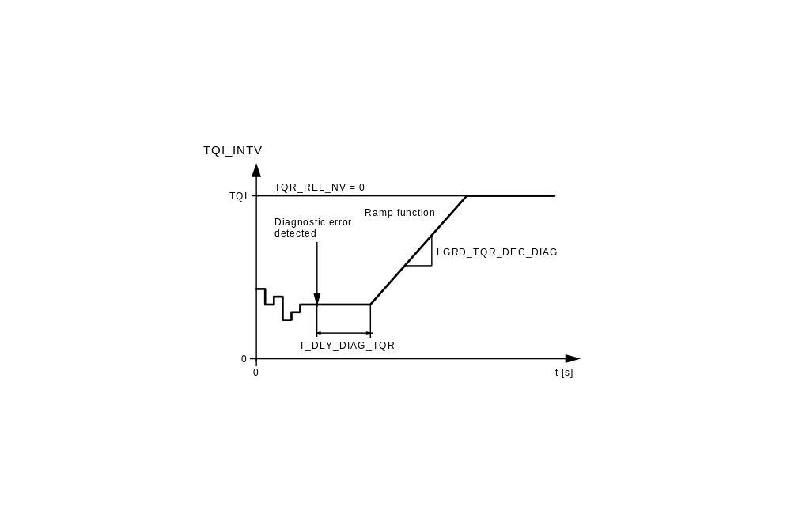
Calibration data:
Name | Dim | Hex. limits | Phys. limits | Resol. | Unit
C_LGRD_TQR_DEC_DIAG | 1 | 1...FFH | 0.004...1.02 | 0.04 | 1/100ms
limiting gradient for TQR-emergency ramp
C_T_DLY_DIAG_TQR | 1 | 0...FFH | 0...2.55 | 0.01 | s
delay time for emergency ramp

Fuel pump relay control
Input data:
LV_ES | LV_IGK
FUNCTION DESCRIPTION:
General information:
The fuel pump is switched ON for 4 sec. during the transition from the control unit initialization to engine operating state engine stopped (LV_ES = 1) with ignition key ON ( LV_IGK = active).

Following ignition key OFF (LV_IGK = passive), the fuel pump is switched OFF after a waiting period C_T_EFP.

Description:
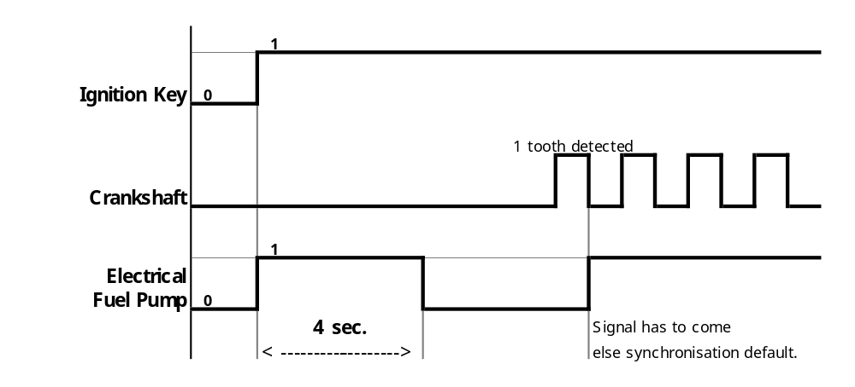

Calibration data:
Name | Type | Dim | Hex. limits | Phys. limits | Resol. | Unit
C_T_EFP | 2U | 1 | 01... FFFFH | 0,1... 6553,5 | 0,1 | sec.
Time delay to shut - off the electric fuel pump relay after ignition key OFF.

