Document: Injection
Project: Engine Management System
HMC_V6
Version: a
Date: 17-Dec-97
Number of pages: 121
Revision Code-No.: 153589 from 18.12.97
Construction protocol-No.: –––––
Software version: 650H0000

 | Name | Department | Phone | Date | Sign
Author | Müller O. | AT PT SI TSA 11 | 3211 | 09.12.97
1. Check | Pioch O. | AT PT SI TSA 11 | 3212 | 09.12.97
2. Check | Gessner S. | AT PT SI TSA 11 | 5398 | 09.12.97
Responsible | Brückner D. | AT PT SI TSA 16 | 4279 | 09.12.97
Vehicle Electronik Systems Division Identification No.: 657765.49.06
–––––
Version list
Version | Date | Author | Comment, Description
Table of contents Page
1.1 General
1.1.1 Total formulas
1.1.1.1 Cranking injection time
1.1.1.1.1 First injection at engine stopped (LV_ES)
1.1.1.1.2 Injection time at start (LV_ST)
1.1.1.2 Nominal injection time (out of start)
1.1.1.2.1 Closed loop variant
1.1.1.2.2 Open loop variant
1.1.1.2.3 Global injection time correction ( TI_FAC_COR )
1.1.1.3 Injection time mean value for injection phase determination ( TI_MV )
1.1.1.4 Cylinder individual injection time
1.1.1.5 Multiplexed cylinder individual injection time
1.1.2 Injection phase SOI ( Start ), EOI ( End )
1.1.3 Re-start correction factor ( TI_ST_REST )
1.2 Calculation of injection time corrections
1.2.1 Calculation of cranking injection time corrections
1.2.1.1 First injection time ( TIPR_CST )
1.2.1.2 Injection time at start ( TI_CST )
1.2.2 Calculation of nominal injection time corrections
1.2.2.1 Basic injection time ( TIB )
1.2.3 Injector dead time correction ( TI_ADD_DLY )
1.2.3.1 Cold post-start correction ( TI_CAST )
1.2.3.2 Warm-up correction ( TI_WUP )
1.2.3.3 Catalyst heating correction ( TI_CH )
1.2.3.4 Catalyst overheating prevention ( TI_COP )
1.2.3.5 Full load enrichment correction ( TI_FL )
1.2.3.6 Throttle acceleration enrichment correction ( TI_TPS_AE )
1.2.3.7 Load acceleration enrichment correction ( TI_MAF_AE )
1.2.3.8 Trailing throttle fuel reduction correction ( TI_PUR )
1.2.3.9 Idle speed correction ( TI_IS )
1.2.3.10 Altitude correction factor ( TI_FAC_ALTI )
1.2.3.11 Acceleration enrichment correction ( TI_AE )
1.2.4 Cylinder fuel shut-off
1.2.4.1 Progressive fuel cut-off (PUC) and rewetting in Part Load (PL)
1.2.5 Individual cylinder re-start fuel feed ( TI_ADD_REAC_SCC_[CYL] )
1.3 Lambda control (A/F regulation loop)
1.3.1 General
1.3.1.1 Conditions for lambda control
1.3.1.1.1 Closing conditions
1.3.1.1.2 Lambda controller status definition following A/F regulation in open loop
1.3.1.1.3 Lambda controller status definition relative to the A/F regulation loop
1.3.1.1.4 Opening conditions
1.3.2 Variables related to A/F regulation oxygen sensors signal voltages ( VLS_i )
1.3.2.1 Rich and lean mixture voltage thresholds ( VLS_AFR_i, VLS_AFL_i )
1.3.2.2 A/F regulation oxygen sensors operability ( LV_LS_i )
1.3.3 Variables related to A/F regulation oxygen sensors heater ( LSHPWM_i )
1.3.3.1 Initialization
1.3.3.2 Oxygen sensors duty cycle gradient limitation ( LSHPWM_LGRD_i )
1.3.3.3 Oxygen sensors preliminary heating phase ( LV_LSH_PHA_AST )
1.3.3.4 Oxygen sensors full rate heating phase ( LV_LSH_PHA_MAX_RATE )
1.3.3.5 Oxygen sensors heater controller
1.3.3.5.1 A/F regulation in open loop ( LV_LSCL_i = 0 (OFF) )
1.3.3.5.2 A/F regulation in closed loop ( LV_LSCL_i = 1 (ON) )
1.3.4 Lambda control ( TI_LAM_i )
1.3.4.1 Lambda controller limits
1.3.4.2 LAM_i and LAM_MV_i calculation
1.3.4.3 Conditions for limited dynamics
1.3.5 Lambda adaptation ( TI_AD_ADD_MMV_COR_i, TI_AD_FAC_MMV_COR_i )
1.3.5.1 Application conditions ( LV_TI_AD_ACT_i )
1.3.5.2 Learning area ( TI_AD_ACT_i )
1.3.5.3 Lambda adaptation calculation period
1.3.5.4 Correlation factor for lambda adaptation calculation
1.3.5.5 Lambda adaptation calculation ( TI_AD_ADD_MMV_i, TI_AD_FAC_MMV_i )
1.3.5.6 Lambda adaptation correction during warm-up
1.3.5.7 Lambda adaptation limitation
1.3.6 Downstream fuel trim regulation by LAM - P - Jump delay time
1.3.7 Catalyst enrichment function after PUC phase (CAT - purge function)
1.3.7.1 Oxygen-sensor heater downstream from catalyst

Index Page
C
C_CAT_DIAG_MAX_DLY
def 114
C_CRLC_DLY_AD
def 115
C_CYC_MAX_AE
def 54
C_EOI_N_MAX
def 30
C_FAC_MIN_P_CP
use 103
C_IGA_MIN_COP
def 45
C_LAM_ SUM_P_IS
def 96
C_LAM_AD_SUM_P
def 110
C_LAM_AD_SUM_P_IS
def 110
C_LAM_CYCNR
def 76
C_LAM_FAC_I_1
def 96
C_LAM_FAC_I_2
def 96
C_LAM_FAC_P
def 96
C_LAM_INI_MAX
def 84
C_LAM_MAF_KGH_MIN_DIAG
def 76
C_LAM_MAX
def 98
use 83
C_LAM_MIN
def 98
C_LAM_MV_DYW
def 102
C_LAM_N_MIN
def 76
C_LAM_NEG_I_IS
def 96
C_LAM_NEG_P_IS
def 96
C_LAM_POS_I_IS
def 96
C_LAM_POS_P_IS
def 96
C_LAM_TCO_VLS_MIN_INI
def 80
use 81, 83
C_LAM_TEMP_HYS_CAT_DLY
def 114
C_LAM_TEMP_MIN_CAT_DLY
def 114
C_LSHPWM_1_AS
def 91
C_LSHPWM_2_AS
def 91
C_LSHPWM_CAT_INI_1
def 121
C_LSHPWM_CAT_INI_2
def 121
C_LSHPWM_DIF_PUC
def 91
C_LSHPWM_FAC_INI
def 92
C_LSHPWM_FAC_MAX
def 91
C_LSHPWM_FAC_MIN
def 91
C_LSHPWM_INI_1
def 91
C_LSHPWM_INI_2
def 91
C_LSHPWM_LAM_P_SUM_FAC
def 91
C_LSHPWM_LGRD_MAX_CAT
def 121
C_LSHPWM_LGRD_NEG_CAT
def 121
C_LSHPWM_LGRD_POS_CAT
def 121
C_LSHPWM_T_FAC
def 91
C_LSHPWM_T_FAC_CAT
def 121
C_MAF_DYW
def 102
C_MAF_INT_DLY_PUC_MAX
def 118
C_MAF_INT_MIN_DLY
def 114
C_MAF_INT_MIN_DLY_PUC
def 114
C_MAF_INT_PUC_MIN
def 118
C_MAF_LAM_DLY_P_MAX
def 114
C_MAF_LAM_DLY_P_MIN
def 114
C_MAF_MIN_HYS_COP
def 45
C_N_DYW
def 102
C_N_LAM_DLY_P_MAX
def 114
C_N_LAM_DLY_P_MIN
def 114
C_SOI_CAM_DIAG
def 30
C_T_DLY_AD_DEC
def 115
C_T_DLY_AD_MAX
def 115
C_T_DLY_AD_MIN
def 115
C_T_DLY_I_MAX
def 115
C_T_DLY_I_MIN
def 115
C_T_LAM_DLY_NEG_IS
def 96
C_T_LAM_DLY_POS_IS
def 96
C_T_LAM_MAX_STATE
use 70
C_T_MAX_LSH_CAT_ST
def 121
C_T_MIN_LS
def 84
use 70, 85
C_T_PER_LSH
def 91
C_T_PER_LSH_CAT
def 121
C_T_VLS_FL
def 80
C_TCO_AE_RST
def 54
C_TCO_DLY_PUC_MIN
def 118
C_TCO_MAX_TIPR_SEQ
def 30
C_TCO_PAT_REAC_MIN
def 66
C_TEMP_MIN_SUB_CAT_ST
def 121
C_TI_AD_ADD_MAX
def 110
use 21
C_TI_AD_ADD_MIN
def 110
C_TI_AD_COR_CRLC
def 110
C_TI_AD_COR_CRLC_CP
def 110
C_TI_AD_COR_CRLC_IS
def 110
C_TI_AD_COR_CRLC_LD
def 110
C_TI_AD_FAC_MAX
def 110
C_TI_AD_FAC_MIN
def 110
C_TI_COP_COR
def 45
use 21
C_TI_COP_INC
def 45
C_TI_MAF_AD_ADD_MAX(_AT)
def 110
C_TI_MAF_AD_FAC_MIN(_AT)
def 110
C_TI_MAF_AD_MAX
def 110
C_TI_MIN
def 27
C_TI_N_AD_ADD_MAX(_AT)
def 110
use 21
C_TI_N_AD_FAC_MIN(_AT)
def 110
C_TI_TCO_AD_MIN
def 110
C_TI_TIA_AD_MAX
def 110
C_TI_VS_MAX_COR
use 21, 43
C_TIPR_END
def 30
C_TPS_CYCNR_MIN_AE
def 50
C_VB_MIN_JUMP
use 85
C_VLS_CAT_DLY_MAX_PUC
def 118
C_VLS_CRLC
def 80
C_VLS_FAC_AFL
def 82
C_VLS_FAC_AFR
def 82
C_VLS_INI
def 80
use 81, 83
C_VLS_INI_MIN
def 80
use 81, 83
C_VLS_LGRD_DEC_FL
def 80
C_VLS_MMV_HYS
def 80
C_VLS_SP
def 91
C_VLS_SUBT_BOL_FL
def 80
CAT_DIAG_TRIM_i
use 111, 116
CONF_LAM
use 21
CPPWM
use 70, 97, 103
CYCNR_ES_ST
use 34
CYCNR_ST_AST
use 38
E
EOI
def 28
EOI_TIPR
def 28
F
FAC_CAT_DLY_i
def 111
G
GR_MT
use 64
I
ID_MAF_TPS_FAC_AE(_AT)__MAF
def 50
ID_PAT_CYCNR_REAC_N_32__GR_MT
def 66
ID_PAT_INH_IV__PAT_INH_IV
def 63
ID_PAT_INH_IV_PUC_1__N_32
def 66
ID_PAT_INH_IV_PUC_2__N_32
def 66
ID_PAT_INH_IV_REAC__N_32__GR_MT
def 66
ID_TCO_LAM_MIN__TCO_ST
def 76
use 43
ID_TCO_LAM_MIN_IS__TCO_ST
def 76
ID_TI_DEC_WF__N_32
def 69
ID_TI_INC_WF__N_32
def 69
ID_TI_N_POS_RG__N_32
def 69
ID_TI_TCO_NEG_WF__TCO
def 69
ID_TI_TCO_POS_WF__TCO
def 69
ID_TPS_GRD_ADD_AE__TCO
use 47, 51
ID_TPS_GRD_BOL_AE__N_32__TPS
use 47, 51
IGA_COP
def 43
IGA_MV_KNK
use 43
IGA_TIA_TCO
use 43
INH_SWI_IV
def 62
IP_CRLC_DLY_I__MAF_KGH
def 115
IP_DEC_CYCNR_LSH__MAF_KGH
def 91
IP_EOI__N_32
def 30
IP_EOI_TIPR
def 30
IP_FAC_CAT_DLY__CAT_DIAG_TRIM_i
def 115
IP_FAC_CAT_DLY_PUC__CAT_DIAG_TRIM_i
def 118
IP_FAC_DLY_P__MAF_KGH
def 115
IP_FAC_LAM_DLY__N_32__MAF
def 115
IP_LAM_NEG_I__N__MAF
def 96
IP_LAM_NEG_P__N__MAF
def 96
IP_LAM_POS_I__N__MAF
def 96
IP_LAM_POS_P__N__MAF
def 96
IP_LSHPWM_1__N_32__MAF
def 91
IP_LSHPWM_2__N_32__MAF
def 91
IP_LSHPWM_CAT_1__N_32__MAF
def 121
IP_LSHPWM_CAT_2__N_32__MAF
def 121
IP_LSHPWM_CYCNR__TIA_ST
def 91
IP_LSHPWM_DIF_I_1__VLS_DIF_1
def 91
IP_LSHPWM_DIF_I_2__VLS_DIF_2
def 91
IP_LSHPWM_LGRD_NEG__MAF_KGH
def 91
IP_LSHPWM_LGRD_POS__MAF_KGH
def 91
IP_LSHPWM_VB_FAC__VB
def 91
IP_LSHPWM_VB_FAC_CAT__VB
def 121
IP_MAF_INT_DLY_PUC__MAF_INT_PUC_i
def 118
IP_MAF_LAM_DLY_AD_MAX__N_32
def 115
IP_MAF_LAM_DLY_AD_MIN__N_32
def 115
IP_MAF_LAM_DLY_I_MAX__N_32
def 115
IP_MAF_LAM_DLY_I_MIN__N_32
def 115
IP_MAF_MIN_COP__N_32__IGA_COP
def 45
IP_SOI__N_32__TI_MV
def 30
IP_SOI_ST__N_32__TI_MV
def 30
IP_SOI_TCO__TCO
def 30
IP_T_DLY_I_VLS__DIF_DLY_i
def 115
IP_T_DLY_P__VLS_DIF_DLY_i
def 115
IP_T_DLY_PUC__MAF_KGH
def 118
IP_T_LAM_DLY_NEG__N__MAF
def 96
IP_T_LAM_DLY_POS__N__MAF
def 96
IP_T_MAX_LSH_ST__TCO_ST
def 91
IP_TI_AD_ADD_FAC__TCO__TI_AD_ADD_MMV
def 110
IP_TI_AD_FAC_FAC__TCO__TI_AD_FAC_MMV
def 110
IP_TI_ADD_DLY__VB
def 37
IP_TI_AST_REST__TCO
def 39
IP_TI_CAST(_AT)__TIA__TCO_ST
def 39
IP_TI_CH__N_32__MAF
def 42
IP_TI_COP__N_32__MAF
def 45
IP_TI_COP_IGA__IGA_COP
def 45
IP_TI_CST(_AT)__N__TCO_ST
def 35
IP_TI_CYCNR_AE(_AT)__N_32__TCO
def 54
IP_TI_CYCNR_PUR(_AT)__N_32__TCO
def 58
IP_TI_DEAC_CAST(_AT)__CYCNR_ST_AST__TCO_ST
def 39
IP_TI_DEAC_CST(_AT)__CYCNR_ES_ST__TCO_ST
def 35
IP_TI_FAC_1_AE_RST(_AT)__CYC
def 54
IP_TI_FAC_2_AE_RST(_AT)__CYC
def 54
IP_TI_FAC_AE(_AT)__N_32__MAF
def 54
IP_TI_FAC_ALTI__MAF_FAC_ALTI_MMV
def 33, 60
IP_TI_FAC_CH__TCO__T_AST
def 42
IP_TI_FAC_NOT_CAT__TCO
def 27
IP_TI_FAC_PUR(_AT)__N_32__MAF
def 58
IP_TI_FAC_PUR_RST(_AT)__CYC
def 58
IP_TI_FAC_TRA_AE(_AT)__MAF_RATIO_AE__TCO
def 54
IP_TI_FAC_TRA_PUR(_AT)__MAF_RATIO_PUR__TCO
def 58
IP_TI_FL__N
def 46
IP_TI_IS__N_DIF_COR
def 59
IP_TI_LGRD_AST__TCO
def 35
use 21
IP_TI_NOT_CAT__N_32__MAF
def 27
IP_TI_ST_REST__TCO
def 31
IP_TI_TCO_CH__TCO
def 42
IP_TI_TCO_CH_IS__TCO
def 42
IP_TI_TCO_WUP(_AT)__TCO__TCO_ST
def 40
IP_TI_TCO_WUP_ASR__TCO__TCO_ST
def 40
IP_TI_TPS_FAC_AE(_AT)__TCO__TPS_GRD
def 50
IP_TI_WUP(_AT)__N_32__MAF
def 40
IP_TIB__N__MAF
def 36
IP_TIPR_CST(_AT)__TCO
def 33
IP_TIPR_FAC_ST_ES(_AT)__TCO
def 33
IP_TPS_CYCNR_AE(_AT)__N_32
def 50
IP_TPS_SUM_CYCNR_AE__N_32
def 50
IP_VLS_SP_DLY__N_32__MAF
def 114
L
L_INH_IV_[CYL]
use 70
LAM_1 99
LAM_2 99
LAM_MV_1 99
use 101
LAM_MV_2 99
use 101
LAM_MV_DYW_1 101
LAM_MV_DYW_2 101
LAM_MV_DYW_i
use 70, 103
LAM_MV_i
use 70, 103
LAM_TRA
use 21
LSHPWM_CAT_i 119
LSHPWM_CAT_LGRD_i 119
LSHPWM_CYCNR 85
LSHPWM_FAC_i 85
LSHPWM_i 85
LSHPWM_LGRD_i 85
LV_ACT_INT_PUC_i
def 116
use 111
LV_AE
use 47, 51, 61
LV_AFR_1
use 93, 99
LV_AFR_2
use 93, 99
LV_AFR_i
def 81
use 70
LV_AUTH_LAM_AD_CP
use 103
LV_AUTH_LAM_CYCNR
def 70
LV_AUTH_LAM_i_AD_LEARN_CP
use 103
LV_AUTH_LAM_SA
use 70
LV_CAM_ERR
use 103, 111
LV_COP
def 43
use 21, 70
LV_CPS_ERR
use 70, 103, 111
LV_CPS_MECHA_ERR
use 70, 103, 111
LV_CRK_ERR
use 111
LV_CRK_ERR_LIH
use 28
LV_DUR_IGC_[CYL]_ERR
use 70
LV_ES
use 21, 32, 34, 36, 70, 77, 83, 85, 119
LV_FL
use 46, 70, 77
LV_FSD_ERR
use 103
LV_FSD_i_ERR
use 111
LV_IGA_AST
use 70
LV_IGK
use 62
LV_IS
use 21, 41, 59, 93, 103
LV_ISA_i_ERR
use 103
LV_ISA_MECHA_ERR
use 103
LV_ISAPWM_IS_ACT
use 59
LV_IV_[CYL]_ERR
use 70
LV_LAM_ACT_i
def 70
use 77, 85
LV_LAM_DLY_i
def 111
LV_LAM_DYW_1
def 101
LV_LAM_DYW_2
def 101
LV_LAM_DYW_i
use 103
LV_LAM_i_READY
def 70
LV_LAM_LIM_i_ERR
use 70, 103
LV_LAM_STOP
use 111
LV_LDC_CAT_i
use 111
LV_LEARN_CP
use 70, 97, 101
LV_LS_i
def 83
use 70, 77, 85
LV_LSCL_1
use 43, 93
LV_LSCL_2
use 43, 93
LV_LSCL_i
def 70
use 77, 103, 111
LV_LSH_CAT_PHA_MAX_RATE
def 119
use 116
LV_LSH_DOWN_HP_i_ERR
use 111
LV_LSH_DOWN_i_ERR
use 111
LV_LSH_PHA_AST
def 85
LV_LSH_PHA_MAX_RATE
def 85
use 70
LV_LSH_UP_i_ERR
use 70, 85, 111
LV_MAF_ERR
use 41, 70, 103, 111
LV_MAF_PLAUS_ERR
use 103, 111
LV_MIS_[CYL]_ERR
use 111
LV_N_MAF_DYW_1
def 101
LV_N_MAF_DYW_2
def 101
LV_N_MAF_DYW_i
use 103
LV_OPL_VS_MAX
use 70
LV_PL
use 21, 46, 64, 93, 103
LV_PU
use 64
LV_PUC
use 64, 70, 85, 116
LV_PUR
use 55
LV_REST
use 31
LV_SAS_ERR
use 111
LV_SAV_ERR
use 103, 111
LV_SAV_MECHA_ERR
use 103, 111
LV_SCC_LAM_ASR
use 70
LV_SCC_TQR
use 40
LV_SLOP_CP
use 93
LV_ST
use 21, 28, 32, 34, 36, 38, 70, 85, 119
LV_ST_ES
use 32
LV_STATE_A_MIS
use 70
LV_STB_PHA_CP
use 103
LV_SYN_ENG
use 34
LV_T_DLY_AD_i
def 111
LV_TCO_ERR
use 64, 70, 103, 111
LV_TCO_PLAUS_ERR
use 103
LV_TI_AD_ACT_i
def 103
LV_TI_AST
use 21, 34, 38, 70
LV_TI_CH
use 41
LV_TIA_ERR
use 103
LV_TIPR_EOI_STOP
def 28
LV_TIPR_SEQ
def 28
LV_TPS_AE
def 47
LV_TPS_ERR
use 103, 111
LV_TPS_PLAUS_ERR
use 103, 111
LV_VB_JUMP
use 85, 119
LV_VLS_DOWN_i_ERR
use 111
LV_VLS_DOWN_LIM_i_ERR
use 111
LV_VLS_FREQ_i_ERR
use 111
LV_VLS_LIM_ERR
use 103
LV_VLS_LIM_i_ERR
use 81, 83, 111
LV_VLS_SLOP_i_ERR
use 111
LV_VLS_UP_i_ERR
use 70, 77, 81, 83, 111
LV_VS_MAX
use 21, 43
M
MAF
use 36, 40, 41, 43, 47, 51, 55, 85, 93, 101, 103, 111, 119
MAF_FAC_ALTI_MMV
use 32, 60
MAF_INT_DLY_i
def 111
MAF_INT_DLY_PUC_i
def 116
MAF_INT_PUC_i
def 116
MAF_KGH
use 70, 85, 103, 111, 116
MAF_MV_1
def 101
MAF_MV_2
def 101
MAF_RATIO_AE
use 51
MAF_RATIO_PUR
use 55
N
N
use 21, 34, 46, 93, 101, 103, 119
N_32
use 28, 36, 40, 41, 43, 47, 51, 55, 64, 67, 70, 85, 111
N_DIF_COR
use 59
N_MV_1
def 101
N_MV_2
def 101
NC_CYL_NO
use 64
NC_INI_INH_SWI_IV_SHIFT_NR
def 63
use 64
NC_LSHPWM_LGRD_MIN
def 92
NC_LSHPWM_MAX_DIAG
def 92
NC_LSHPWM_MIN_DIAG
def 92
NC_MAX_EOI
def 30
P
PAT_INH_IV
def 62
use 70
PAT_INH_IV_N_MAX
use 62
PAT_INH_IV_PUC_REAC
def 64
use 62
PAT_INH_IV_TQR
use 62
PAT_INH_IV_VS_MAX
use 62
S
SOI
def 28
SOI_AS
use 28
SOI_TIPR
def 28
T
T_AST
use 41
T_DLY_AD_i
def 111
T_DLY_I_i
def 111
T_DLY_P_i
def 111
T_DLY_PUC_1
use 93
T_DLY_PUC_2
use 93
T_DLY_PUC_i
def 116
T_LAM_DLY_1
use 93
T_LAM_DLY_2
use 93
T_LAM_DLY_i
def 111
T_LAM_DLY_NEG_1
def 93
T_LAM_DLY_NEG_2
def 93
T_LAM_DLY_POS_1
def 93
T_LAM_DLY_POS_2
def 93
TCO
use 28, 31, 32, 40, 41, 43, 47, 51, 55, 64, 67, 70, 77, 81, 83, 103, 116
TCO_ST
use 34, 38, 40, 43, 85
TEMP_MMV_SUB_CAT
use 111, 119
TI_[CYL]
use 37
TI_1
use 28, 34
TI_2
use 28, 34
TI_AD_ACT_i
def 103
TI_AD_ADD_MMV_COR_i
def 103
use 21
TI_AD_ADD_MMV_i
def 103
TI_AD_ADD_MMV_REL_i
def 103
use 70, 111
TI_AD_FAC_MMV_1
use 97
TI_AD_FAC_MMV_2
use 97
TI_AD_FAC_MMV_COR_i
def 103
use 21
TI_AD_FAC_MMV_i
def 103
use 70, 111
TI_ADD_DLY
def 37
use 21
TI_ADD_REAC_SCC_[CYL]
def 67
use 21
TI_AE
def 61
use 21
TI_AS_[CYL]
def 21
use 21
TI_CAST
def 38
use 21
TI_CH
def 41
TI_CO_IS
use 21
TI_COP
def 43
use 21
TI_CST
def 34
use 21
TI_CYL_[CYL]
def 21
TI_FAC_ALTI
def 60
use 21
TI_FAC_COR
def 21
use 43
TI_FL
def 46
use 21
TI_i
def 21
TI_IS
def 59
use 21
TI_LAM_1
def 93
use 99
TI_LAM_2
def 93
use 99
TI_LAM_i
use 21, 70, 77, 83, 85, 103, 111
TI_LAM_MAX_1
def 97
TI_LAM_MAX_2
def 97
TI_LAM_MAX_i
use 111
TI_LAM_MIN_1
def 97
TI_LAM_MIN_2
def 97
TI_LAM_MIN_i
use 111
TI_MAF_AE
def 51
use 21, 61
TI_MV
def 21
use 28
TI_PUR
def 55
use 21
TI_SAM
def 21
TI_ST_REST
def 31
use 21
TI_TPS_AE
def 47
use 21, 61
TI_WUP
def 40
TI_WUP_COR
use 21
TIA
use 38, 103
TIA_ST
use 85
TIB
def 36
use 21, 67, 103
TIPR
def 21
use 28
TIPR_CST
def 32
use 21
TPS
use 51
TPS_GRD
use 47, 51
V
VB
use 37, 85, 119
VLS_AFL_i
def 81
VLS_AFR_i
def 81
VLS_BOL_i
def 77
VLS_CAT_i
use 111, 116
VLS_DIF_DLY_i
def 111
VLS_DIF_i
def 85
VLS_i
use 77, 81
VLS_MMV_MAX_i
def 77
use 81, 85
VLS_MMV_MIN_i
def 77
use 81, 85
VLS_TOL_i
def 77

General

Total formulas
Output data:
Name | Mode | Hex. limits | Phys. limits | Resol. | Unit
TIPR | V | 0...FFFFH | 0...262,14 | 4 µsec | msec
Pre injection time calculation.
TI_i | V | 0...FFFFH | 0...262,14 | 4 µsec | msec
Injection time calculation for bank i (i = 1 or 2)
TI_CYL_[CYL] | V | 0...FFFFH | 0...262,14 | 4 µsec | msec
Cylinder individual injection time calculation (i = 1,2,3,4,5,6)
TI_SAM | V | 0...FFFFH | 0...262,14 | 4 µsec | msec
Multiplexed cylinder individual injection time calculation
TI_AS_[CYL] | V | 40...C0H | 0,5...1,5 | 0,0078 | -
Cylinder indiviual multiplicative factor set via application system (i = 1,2,3,4,5,6)
TI_MV | V | 0...FFFFH | 0...262,14 | 4 µsec | msec
Injection time mean value for injection phase determination.
TI_FAC_COR | - | 0...FFFFH | 0...16 | 0,000245 | -
Global injection time correction factor.
Input data:
TIPR_CST | IP_TI_LGRD_AST__TCO | TI_AD_ADD_MMV_COR_i | TI_AD_FAC_MMV_COR_i
TI_PUR | TI_CAST | TI_LAM_i | C_TI_AD_ADD_MAX
TI_FL | TI_IS | TI_CO_IS | C_TI_N_AD_ADD_MAX(_AT)
TI_AE | TI_TPS_AE | TI_MAF_AE | N
TI_COP | TI_CST | TI_ADD_DLY | TIB
LV_ES | LV_ST | LV_PL | LV_IS
LV_TI_AST | LV_COP | LV_VS_MAX | C_TI_COP_COR
TI_WUP_COR | TI_ST_REST | LAM_TRA | C_TI_VS_MAX_COR
TI_ADD_REAC_SCC_[CYL] | TI_FAC_ALTI | TI_AS_[CYL] | CONF_LAM

Remark :

i = 1 for bank 1.
i = 2 for bank 2.

Cranking injection time

First injection at engine stopped (LV_ES)

TIPR = ( TIPR_CST Pre injection time.

* TI_ST_REST Restart correction factor

* TI_AS_[1]) Application system intervention cylinder 1.

* TI_FAC_ALTI Altitude correction

Application recurrence : 200 msec

Injection time at start (LV_ST)

TI_i = ( TI_CST Cranking injection time.

* TI_ST_REST ) Re-start correction factor.

* TI_FAC_ALTI Altitude correction

Application recurrence : Segment

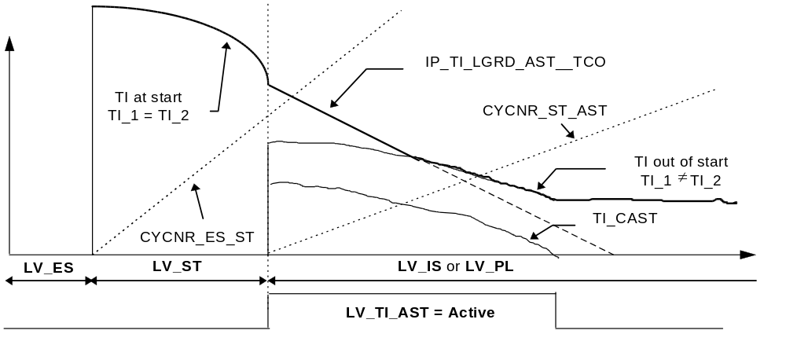

Nominal injection time (out of start)

Closed loop variant

If CONF_LAM ≠ 0
then

TI_i = [ TIB Basic injection time.

* ( 1 + TI_AD_FAC_MMV_COR_i Multiplicative adaptive correction

+ TI_LAM_i Lambda control correction.

+ LAM_TRA ) Evaporative emissions control.

+ TI_AD_ADD_MMV_COR_i ] Adaptive additive correction.

* TI_FAC_COR Global correction factor.

Application recurrence : Segment

⇒ See drawing on next page.

With:

TI_AD_ADD_MMV_COR_1 = C_TI_N_AD_ADD_MAX * TI_CO_IS / N

TI_AD_ADD_MMV_COR_1 is limited to C_TI_AD_ADD_MAX.

Remark:

The minimum injection time for TI_i is equal to C_TI_MIN.

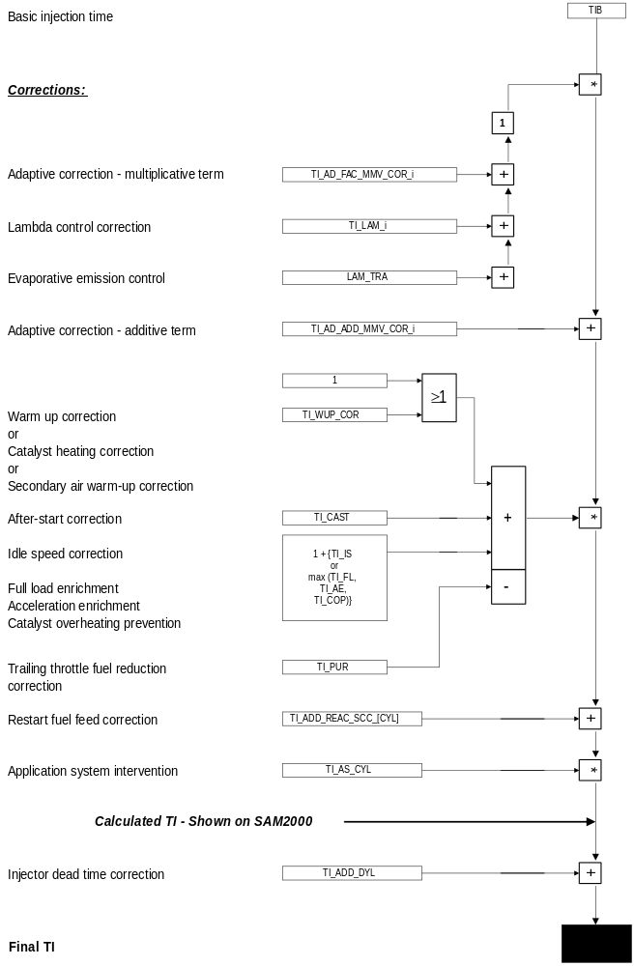

Open loop variant

If CONF_LAM = 0
then

TI_i = [ (TIB Basic injection time.

* ( 1 - (IP_TI_NOT_CAT__N__MAF * IP_TI_FAC_NOT_CAT__TCO))
Correction for fuel leaning

+ TI_AD_ADD_MMV_COR_1] Multiplicative adaptive correction

* TI_FAC_COR Global correction factor.

Application recurrence : Segment

With:

TI_AD_ADD_MMV_COR_1 = C_TI_N_AD_ADD_MAX * TI_CO_IS / N

TI_AD_ADD_MMV_COR_1 is limited to C_TI_AD_ADD_MAX.

Remark:

The minimum injection time for TI_i is equal to C_TI_MIN.

Global injection time correction ( TI_FAC_COR )

If LV_COP = 1 (catalyst overheating prevention active)
and at least 1 cylinder in fuel shut-off
then

If LV_VS_MAX = 0 (vehicle speed limitation not active)

then TI_FAC_COR = ( 1 - C_TI_COP_COR )
else TI_FAC_COR = [ 1 - max ( C_TI_COP_COR,
C_TI_VS_MAX_COR ) ]
else
If LV_VS_MAX = 1 (vehicle speed limitation active)
then TI_FAC_COR = ( 1 - C_TI_VS_MAX_COR )
else

If at least 1 cylinder in fuel shut-off
then TI_FAC_COR = 1
else the following calculation is performed :

TI_FAC_COR = TI_WUP_COR Warm-up correction or
Catalyst heating correction or
Rich Mixture Warm-up correction

+ TI_CAST Post-start correction.

- TI_PUR Trailing throttle fuel reduction correction.

+ { 1 + [ TI_IS Idle speed correction.
or
max (TI_FL, Full load enrichment.
TI_AE Acceleration enrichment.
TI_COP)] } Catalyst overheating prevention.

Application recurrence : Segment

Remarks :

TI_AE = TI_TPS_AE Transient correction on throttle variations.
+ TI_MAF_AE Transient correction on engine
load variations.

Injection time mean value for injection phase determination ( TI_MV )

TI_MV = ( TI_1 + TI_2 ) / 2 + TI_ADD_DLY

Application recurrence : Segment

Cylinder individual injection time

TI_CYL_[CYL] takes in account the cylinder individual corrections:

TI_CYL_[CYL] = ( TI_i + TI_ADD_REAC_SCC_[CYL] ) * TI_AS_[CYL]

TI_AS_[CYL] is a cylinder individual factor set via the application system.

Remark :

[CYL] = cylinder number
i = cylinder bank number

Depending on the cylinder number, i is equal to 1 or 2.

Multiplexed cylinder individual injection time

TI_SAM takes alternatively the value TI_CYL_[CYL] depending on the cycle number.

Calibration data:
Name | Dim | Hex. limits | Phys. limits | Resol. | Unit
C_TI_MIN | 1 | 0...FFFFH | 0...262,14 | 4 µsec | msec
Minimum injection time.
IP_TI_FAC_NOT_CAT__TCO | 16x16 | 0... FFH | 0...0,9961 | 1/256 | -
Injection time correction for open loop variant
IP_TI_NOT_CAT__N_32__MAF | 6x6 | 0... FFFH | 0...1 | 2,44 E-4 | -
Injection time correction for open loop variant

Injection phase SOI ( Start ), EOI ( End )
Output data:
Name | Mode | Hex. limits | Phys. limits | Resol. | Unit
SOI | V | 00...64H | 180...-420 | 6 | ° CRK
Start of nominal injection time.
EOI | V | 14...3CH | -300...-540 | 6 | ° CRK
End of nominal injection time.
SOI_TIPR | V | 00...64H | 180...-420 | 6 | ° CRK
Start of first injection
EOI_TIPR | V | 0...28H | -540...-300 | 6 | ° CRK
End of first injection time.
LV_TIPR_SEQ | - | 0...1H | 0...1 | 1 | -
Boolean information for first injection time: sequential after synchronisation (yes/no)
LV_TIPR_EOI_STOP | - | 0...1H | 0...1 | 1 | -
Boolean information for first injection time termination at NC_MAX_EOI
Input data:
TI_MV | N_32 | TCO | LV_CRK_ERR_LIH
LV_ST | TI_1 | TI_2 | TIPR
SOI_AS
FUNCTION DESCRIPTION:
General information:
In order to optimize engine emissions and performances, the injection phase is related to the engine operating state and to the engine working point. With the pre-injection a spontaneous engine start is ensured because A/F-mixture is offered as early as possible. But at very low start temperatures the undefined position of the first injection can lead to problems. Because of this the first injections are carried out sequential below the temperature C_TCO_MAX_TIPR_SEQ.

With the configuration byte C_TIPR_END it can be adjusted wether a pre-injection will be terminated at NC_MAX_EOI or not.

For graphical description of the first injection please refer to the output chapter.

Formula section:
* Start of injection :

* Start injection time (LV_ST = 1) :

SOI = IP_SOI_ST__N_32__TI_MV + SOI_AS

* First injection configuration :
Application recurrency: Transition to engine stop (LV_ES = 1)

If C_TIPR_END = 0
then LV_TIPR_EOI_STOP = 0
(First injection time will not be terminated at NC_MAX_EOI during synchronisation)
else LV_TIPR_EOI_STOP = 1

If C_TCO_MAX_TIPR_SEQ ≥ TCO
then LV_TIPR_SEQ =1
(First injection will be carried out sequential after synchronisation)
else LV_TIPR_SEQ = 0
(TIPR is carried out in semi full group)

* Nominal injection time (out of start) :
- for injection time TI_i out of start

If LV_CRK_ERR_LIH = 1
(camshaft signal missing - refer to “ Diagnosis Management “ )
then SOI = C_SOI_CAM_DIAG
else SOI = IP_SOI__N_32__TI_MV + IP_SOI_TCO__TCO + SOI_AS

* First injection time (TIPR) :

SOI_TIPR = IP_SOI_ST__N_32__TI_MV + SOI_AS
with N_32 = 0 and TI_MV = TIPR

* End of injection :
* Nominal injection time :
- for injection time TI_i

If LV_CRK_ERR_LIH = 1
(camshaft signal missing - refer to “ Diagnosis Management “ )
or engine operating state start (LV_ST)
or N_32 > C_EOI_N_MAX
then EOI = NC_MAX_EOI
else EOI = IP_EOI__N_32 + SOI_AS

* First injection time :
EOI_TIPR = IP_EOI_TIPR__TCO
Calibration data:
Name | Dim | Hex. limits | Phys. limits | Resol. | Unit
IP_SOI_ST__N_32__TI_MV | 4 x 4 | 00...64H | 180...-420 | 6 | ° CRK
Start of injection phase at start for nominal injection time TI_i.
IP_SOI__N_32__TI_MV | 6 x 6 | 00...64H | 180...-420 | 6 | ° CRK
Start of injection phase out of start for nominal injection time TI_i.
IP_SOI_TCO__TCO | 8 | 1C...E4H | 600...-600 | 6 | ° CRK
Start of injection phase offset versus coolant temperature, out of start for nominal injection time TI_i.
IP_EOI__N_32 | 6 | 14...3CH | -300...-540 | 6 | °CRK
End of injection phase for nominal injection time TI_i.
C_SOI_CAM_DIAG | 1 | 00...64H | 180...-420 | 6 | ° CRK
Start of injection phase out of start for nominal injection time TI_i with camshaft signal missing.
C_EOI_N_MAX | 1 | 00...FFH | 0...8160 | 32 | rpm
Engine speed threshold to select maximum EOI (NC_MAX_EOI).
NC_MAX_EOI | 1 | 14...3CH | -300...-540 | 6 | ° CRK
Maximum end of injection phase - Non adjustable calibration.
IP_EOI_TIPR | 8 | 00...28H | -540...-300 | 6 | ° CRK
End of injection phase for first injection
C_TIPR_END | 1 | 0...1H | 0...1 | 1 | -
Configuration byte for TIPR-termination at NC_MAX_EOI - position
C_TCO_MAX_TIPR_SEQ | 1 | 0...FEH | -48...142,5 | 0,75 | ° C
Maximum coolant temperatur for sequential TIPR-application

Applicative Value :

NC_MAX_EOI = 3CH = -540 °CRK

Re-start correction factor ( TI_ST_REST )
Output data:
Name | Mode | Hex. limits | Phys. limits | Resol. | Unit
TI_ST_REST | - | 80...FFH | 0,5...0,9961 | 0,0039 | -
Re-start correction factor for cranking injection time.
Input data:
TCO | LV_REST
FUNCTION DESCRIPTION:
General information:
In order to improve engine re-start, a correction factor is applied for cranking injection time calculation (pre injection time and injection time at start). This factor is multiplicative and decreases the injection time.

Formula section:

If LV_REST = 1 (Active) (re-start function active)
then TI_ST_REST = IP_TI_ST_REST__TCO

If LV_REST = 0 (Passive) (re-start function passive)
then TI_ST_REST = 1

Calibration data:
Name | Dim | Hex. limits | Phys. limits | Resol. | Unit
IP_TI_ST_REST__TCO | 8 | 80...FFH | 0,5...0,9961 | 0,0039 | -
Re-start correction factor for cranking injection time.

Calculation of injection time corrections

Calculation of cranking injection time corrections

First injection time ( TIPR_CST )
Output data:
Name | Mode | Hex. limits | Phys. limits | Resol. | Unit
TIPR_CST | - | 0...FFFFH | 0...262,14 | 4 µsec | msec
Pre injection time basic value.
Input data:
LV_ES | LV_ST | TCO | LV_ST_ES
MAF_FAC_ALTI_MMV
FUNCTION DESCRIPTION:
General information:
In order to improve engine cranking times, a pre injection takes place on each cylinder bank as soon as one tooth is detected.
(refer to chapter “ Fuel injection output “ in the major chapter “ Outputs “)

Formula section:

TIPR_CST = IP_TIPR_CST(_AT)__TCO

In case of transition from start (LV_ST) to engine stopped (LV_ES) and therefore LV_ST_ES=1, the next pre injection time will be weighted by a multiplicative factor :

If LV_ST_ES = 1
then TIPR_CST = IP_TIPR_CST(_AT)__TCO * IP_ TIPR_ FAC_ST_ES__TCO

The pre-injection is corrected with the altitude correction factor MAF_FAC_ALTI_MMV. For total formula see chapter 1.1.1.1.2.

Calibration data:
Name | Dim | Hex. limits | Phys. limits | Resol. | Unit
IP_TIPR_CST(_AT)__TCO | 8 | 0...FFFFH | 0...262,14 | 4 µsec | msec
Pre injection time basic value.
IP_TIPR_FAC_ST_ES(_AT)__TCO | 8 | 80...FFH | 0,5...0,9961 | 0,0039 | -
Weighting factor of pre injection time basic value in case of transition from LV_ST to LV_ES.
IP_TI_FAC_ALTI__MAF_FAC_ALTI_MMV | 8 | 80...FFH | 0,5...0,9961 | 0,0039 | -
Weighting factor of pre injection time basic value due to altitude correction.

Injection time at start ( TI_CST )
Output data:
Name | Mode | Hex. limits | Phys. limits | Resol. | Unit
TI_CST | - | 0...FFFFH | 0...262,14 | 4 µsec | msec
Cranking injection time basic value.
Input data:
LV_ES | LV_ST | TCO_ST | LV_SYN_ENG
LV_TI_AST | N | TI_1 | TI_2
CYCNR_ES_ST
FUNCTION DESCRIPTION:
General information:
As soon as synchronisation is fulfilled in engine operating state start (LV_ST), each cylinder is supplied with a specific fuel quantity for starting. This quantity is weighted by a de-activation factor in order to avoid engine flooding.

Formula section:

If engine operating state start (LV_ST)
and LV_SYN_ENG = 1 (synchronisation effective)
then

TI_CST = IP_TI_CST(_AT)__N__TCO_ST * IP_TI_DEAC_CST(_AT)__CYCNR_ES_ST__TCO_ST

Remark :

* CYCNR_ES_ST indicates the number of segments since engine stop; it is reset at
transition from LV_ES to LV_ST.

* The start fuel quantity (LV_ST) returned to the post - start fuel quantity (LV_TI_AST) is performed using change limitation IP_TI_LGRD_AST__TCO
Like cranking injection time TI_i is identical for bank 1 & 2 during engine operating state start (LV_ST), the change limitation IP_TI_LGRD_AST__TCO is applied as “ individual “ correction for TI_i during post-start function (LV_TI_AST) because TI_1 ≠ TI_2.
* For case 1 of the restart strategy the CYCNR_ES_ST counter will start with the old
value freezed at the previous transition LV_ST to LV_ES.
The injection time at start is corrected with the altitude correction factor MAF_FAC_ALTI_MMV. For total formula see chapter 1.1.1.1.2.

Calibration data:
Name | Dim | Hex. limits | Phys. limits | Resol. | Unit
IP_TI_CST(_AT)__N__TCO_ST | 5 x 8 | 0...FFFFH | 0...262,14 | 4 µsec | msec
Cranking injection time basic value.
IP_TI_DEAC_CST(_AT)__CYCNR_ES_ST__TCO_ST | 4 x 6 | 00...FFH | 0...0,997 | 3,895E-3 | -
Cranking injection time deactivation factor.
IP_TI_LGRD_AST__TCO | 8 | 08...07F8H | 0,0427...10,88 | 0,00533 | msec
Change limitation between cranking injection time and nominal injection time (x Segment).

Calculation of nominal injection time corrections

Basic injection time ( TIB )
Output data:
Name | Mode | Hex. limits | Phys. limits | Resol. | Unit
TIB | - | 0...FFFFH | 0...262,14 | 4 µsec | msec
Basic injection time.
Input data:
LV_ES | LV_ST | N_32 | MAF
FUNCTION DESCRIPTION:
General information:
The basic injection time is depending on engine working point (N_32, MAF).
It is applied for nominal injection time calculation TI_i out of engine stopped (LV_ES) and
out of start (LV_ST).

Application recurrence : Segment

Formula section:

TIB = IP_TIB__N__MAF

Calibration data:
Name | Dim | Hex. limits | Phys. limits | Resol. | Unit
IP_TIB__N__MAF | 16 x 12 | 0F...FFFH | 0...262,14 | 4 µsec | msec
Basic injection time.

Injector dead time correction ( TI_ADD_DLY )
Output data:
Name | Mode | Hex. limits | Phys. limits | Resol. | Unit
TI_ADD_DLY | - | 0...FFH | 0...8,16 | 0,0032 | msec
Injector dead time correction.
Input data:
TI_[CYL] | VB
FUNCTION DESCRIPTION:
General information:
The injection time TI_[CYL applied to the corresponding injector, is weighted by an additive correction TI_ADD_DLY in order to compensate the battery voltage dependent injector pick - up time.
( refer to chapter “ Fuel injection output “ in major chapter “ Outputs “ )

Application recurrence : 10 msec.
Formula section:

TI_ADD_DLY = IP_TI_ADD_DLY__VB

Calibration data:
Name | Dim | Hex. limits | Phys. limits | Resol. | Unit
IP_TI_ADD_DLY__VB | 8 | 0...FFH | 0...8,16 | 0,032 | msec
Injector dead time correction.

Cold post-start correction ( TI_CAST )
Output data:
Name | Mode | Hex. limits | Phys. limits | Resol. | Unit
TI_CAST | V | 0...3F40H | 0...3.953 | 16 / 65536 | -
Cold post-start correction.
Input data:
LV_TI_AST | LV_ST | TCO_ST | TIA
CYCNR_ST_AST
FUNCTION DESCRIPTION:
General information:
This enrichment is performed following engine operating start (LV_ST) in order to ensure the first combustion in cold conditions.

Application recurrence : Segment
Formula section:

If LV_TI_AST = 1 (Active) (cold post-start function active)
then

TI_CAST = IP_TI_CAST(_AT)__TIA__TCO_ST * IP_TI_DEAC_CAST(_AT)__CYCNR_ST_AST__TCO_ST * IP_TI_AST_REST__TCO

Remark :

* CYCNR_ST_AST indicates the number of segments since start; it is reset at the
transition LV_ST to LV_TI_AST.

* The post-start fuel quantity is initialized with the value coming from the interpolated table IP_TI_CAST(_AT)__TIA__TCO_ST as soon as LV_TI_AST = 1 (Active). Then, this initialized value is deactivated by
IP_TI_DEAC_CAST(_AT)__CYCNR_ST_AST__TCO_ST.
* IP_TI_AST_REST__TCO is applied to the post-start correction in case of restart.
Calibration data:
Name | Dim | Hex. limits | Phys. limits | Resol. | Unit
IP_TI_CAST(_AT)__TIA__TCO_ST | 6 x 8 | 0...FFH | 0...3.984 | 0.0156 | -
Initialized value for post-start enrichment factor.
IP_TI_DEAC_CAST(_AT)__CYCNR_ST_AST__TCO_ST | 6 x 8 | 0...FFH | 0...0.9961 | 0.0039 | -
Post-start enrichment deactivation factor.
IP_TI_AST_REST__TCO | 8 | 80...FFH | 0.5...0.9961 | 0.0039 | -
Restart correction factor .

Warm-up correction ( TI_WUP )
Output data:
Name | Mode | Hex. limits | Phys. limits | Resol. | Unit
TI_WUP | - | 1000...2FC0H | 1...2,9844 | 16 / 65536 | -
Warm-up correction for nominal injection time.
Input data:
LV_SCC_TQR | N_32 | MAF | TCO
TCO_ST
FUNCTION DESCRIPTION:
General information:
The warm-up injection time correction is performed when the corresponding warm-up phase is detected in order to ensure the increased fuel requirements for a cold engine.

Application recurrence : Segment

Formula section:

If LV_SCC_TQR = 0 (Passive) (no fuel shut-off active due to ASR or GS)
then TI_WUP = 1 + IP_TI_WUP(_AT)__N_32__MAF
* IP_TI_TCO_WUP(_AT)__TCO__TCO_ST

If LV_SCC_TQR = 1 (Active) (fuel shut-off active due to ASR or GS)
then TI_WUP = 1 + IP_TI_WUP(_AT)__N_32__MAF
* IP_TI_TCO_WUP_ASR__TCO__TCO_ST

Remark: For further information about torque intervention and effects on the system
please refer to the chapter „Traction Control System“.
Calibration data:
Name | Dim | Hex. limits | Phys. limits | Resol. | Unit
IP_TI_WUP(_AT)__N_32__MAF | 8 x 8 | 0...FFH | 0...0,9961 | 0,0039 | -
Warm-up correction versus engine operating point.
IP_TI_TCO_WUP(_AT)__TCO__TCO_ST | 8 x 3 | 0...FFH | 0...1,9922 | 0,00782 | -
Warm-up deactivation factor without TQR intervention.
IP_TI_TCO_WUP_ASR__TCO__TCO_ST | 6 x 6 | 0...FFH | 0...1,9922 | 0,00782 | -
Warm-up deactivation factor with TQR intervention.

Catalyst heating correction ( TI_CH )
Output data:
Name | Mode | Hex. limits | Phys. limits | Resol. | Unit
TI_CH | - | 0800...37C0 H | 0,5...3,4844 | 16 / 65536 | -
Catalyst heating correction for nominal injection time.
Input data:
LV_IS | TCO | T_AST | N_32
MAF | LV_TI_CH | LV_MAF_ERR
FUNCTION DESCRIPTION:
General information:
The catalyst heating correction for nominal injection time is performed when the corresponding warm-up phase is detected (LV_TI_CH = 1) in order to ensure a catalyst warm-up as quickly as possible and to operate the engine with low emissions.

This is an alternative to the warm-up function.

The engine can run with a lean mixture at high loads and engine speeds, even in cold engine conditions.

Application recurrence : Segment

Formula section:

This Function is performed if LV_MAF_ERR = 0.

* In idle (LV_IS) :

TI_CH = IP_TI_CH__N_32__MAF * IP_TI_TCO_CH_IS__TCO
+ IP_TI_FAC_CH__TCO__T_AST

* Out of idle :

TI_CH = IP_TI_CH__N_32__MAF * IP_TI_TCO_CH__TCO
+ IP_TI_FAC_CH__TCO__T_AST

Remark :
The transition from idle to out of idle calculation is made without change limitation.
Calibration data:
Name | Dim | Hex. limits | Phys. limits | Resol. | Unit
IP_TI_CH__N_32__MAF | 8 x 8 | 0...FFH | 0...0,9961 | 0,0039 | -
Catalyst heating correction for nominal injection time versus engine operating point.
IP_TI_TCO_CH__TCO | 8 | 00...FFH | 0...1,922 | 7,509E-3 | -
Catalyst heating correction for nominal injection time versus coolant temperature out of idle.
IP_TI_TCO_CH_IS__TCO | 8 | 00...FFH | 0...1,922 | 7,509E-3 | -
Catalyst heating correction for nominal injection time versus coolant temperature in idle (LV_IS).
IP_TI_FAC_CH__TCO__T_AST | 8 x 8 | 0800...1800H | 0,5...1,5 | 16 / 65536 | -
Minimum value of catalyst heating correction for nominal injection time.

Catalyst overheating prevention ( TI_COP )
Output data:
Name | Mode | Hex. limits | Phys. limits | Resol. | Unit
TI_COP | V | 0...FFH | 0...0,5 | 0,00196 | -
Injection time correction for catalyst overheating prevention.
LV_COP | V | 0...01H | 0...1 | 1 | -
Boolean for catalyst overheating prevention detection - ( Passive / Active ).
IGA_COP | V | 80...00H | -48...0 | 0,375 | °CRK
Ignition angle correction used as set point for catalyst overheating correction.
Input data:
TCO | N_32 | MAF | TCO_ST
ID_TCO_LAM_MIN__TCO_ST | TI_FAC_COR | LV_LSCL_1 | LV_LSCL_2
IGA_TIA_TCO | C_TI_VS_MAX_COR | LV_VS_MAX | IGA_MV_KNK
FUNCTION DESCRIPTION:
General information:
The catalyst overheating prevention function is provided in order to avoid an overheating phenomena in the catalyst. The emission temperatures drop through mixture enrichment.
The injection time correction is calculated depending on engine operating point and ignition through knock control ( IGA_MV_KNK ) and temperature ( IGA_TIA_TCO ) corrections.

Application recurrence : 720 °CRK

Application conditions:
Activation:
The injection time correction TI_COP proceeds over a ramp for activation.
Thus, TI_COP is increased with C_TI_COP_INC every 720 °CRK.

If engine operating state in part load (LV_PL)
and TCO > ID_TCO_LAM_MIN__TCO_ST
and MAF ≥ IP_MAF_MIN_COP__N_32__IGA_COP
and IGA_COP ≤ C_IGA_MIN_COP
then LV_COP = 1 (Active)
Deactivation:
The injection time correction TI_COP proceeds over a ramp for deactivation.
Thus, TI_COP is decreased with C_TI_COP_INC every 720 °CRK.

If MAF < IP_MAF_MIN_COP__N_32__IGA_COP - C_MAF_MIN_HYS_COP
or IGA_COP > C_IGA_MIN_COP
then LV_COP = 0 (Passive) as soon as TI_COP = 0.
Remark :
If LV_COP = 1 (Active) (catalyst overheating prevention active)
and engine operating state engine stopped (LV_ES)
or engine operating state start (LV_ST)
or engine operating state fuel cut-off (LV_PUC)
then TI_COP is decreased to 0 without change limitation.

Limitation :
0 ≤ TI_COP ≤ 0.5

Formula section:

TI_COP = IP_TI_COP__N_32__MAF + IP_TI_COP_IGA__IGA_COP

with :

IGA_COP = IGA_MV_KNK + IGA_TIA_TCO

Remark :
The global correction factor calculation TI_FAC_COR for the nominal injection time out of start is depending of the catalyst overheating prevention function :

If LV_COP = 1 (Active) (catalyst overheating prevention active)
and at least 1 cylinder in fuel shut-off

then
If LV_VS_MAX = 0 (Passive) (vehicle speed limitation passive)
then TI_FAC_COR = ( 1 - C_TI_COP_COR )
else TI_FAC_COR = [ 1 - max ( C_TI_COP_COR, C_TI_VS_MAX_COR ) ]

In this engine operating configuration, TI_COP is still updated but not used for injection time calculation, until regular TI_FAC_COR calculation will be performed again.

Description:

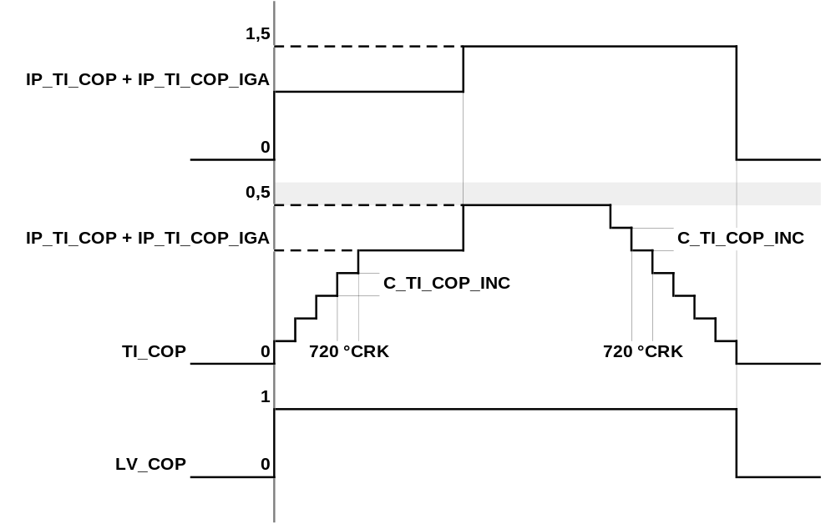

Calibration data:
Name | Dim | Hex. limits | Phys. limits | Resol. | Unit
IP_MAF_MIN_COP__N_32__IGA_COP | 6 x 4 | 0...FFH | 0...1389 | 5,4471 | mg/TDC
Minimum mass air flow threshold for catalyst overheating prevention activation.
IP_TI_COP__N_32__MAF | 6 x 6 | 0...FFH | 0...0,996 | 0,0039 | -
Injection time correction versus engine operating point for catalyst overheating prevention.
IP_TI_COP_IGA__IGA_COP | 4 | 0...FFH | -0,5...0,496 | 0,0039 | -
Injection time correction versus ignition angle correction through knock control for catalyst overheating prevention.
C_MAF_MIN_HYS_COP | 1 | 0...FFH | 0...1389 | 5,4471 | mg/TDC
Hysteresis for minimum mass air flow threshold for catalyst overheating prevention deactivation.
C_TI_COP_INC | 1 | 0...80H | 0...0,5 | 0,0039 | -
Injection time change limitation in case of activation or deactivation of catalyst overheating prevention function.
C_TI_COP_COR | 1 | 0...1000H | 0...1 | 0,00024414 | -
Injection time correction in case of catalyst overheating prevention activation with fuel shut-off out of vehicle speed limitation.
C_IGA_MIN_COP | 1 | 80...00H | -48...0 | 0,375 | °CRK
Ignition angle correction threshold through knock control for catalyst overheating prevention deactivation.

Full load enrichment correction ( TI_FL )
Output data:
Name | Mode | Hex. limits | Phys. limits | Resol. | Unit
TI_FL | V | 0...FFH | 0...0,9961 | 0,0039 | -
Full load enrichment factor for nominal injection time.
Input data:
LV_PL | LV_FL | N
FUNCTION DESCRIPTION:
General information:
This enrichment is performed following engine operating state part load (LV_PL) with full load detected (LV_FL) in order improve performances and to ensure temperature limitation for outlet valves, catalyst converter and exhaust gas.

Application recurrence : Segment (when full load is detected : LV_FL = FL)
Formula section:

If LV_FL = 1 (FL) (full load function active)
then TI_FL = IP_TI_FL__N

If LV_FL = 0 ( - ) (full load function inactive)
then TI_FL = 0

Calibration data:
Name | Dim | Hex. limits | Phys. limits | Resol. | Unit
IP_TI_FL__N | 16 | 00...FFH | 0...0,997 | 3,895E-3 | -
Full load enrichment factor for nominal injection time.

Throttle acceleration enrichment correction ( TI_TPS_AE )
Output data:
Name | Mode | Hex. limits | Phys. limits | Resol. | Unit
TI_TPS_AE | V | 0...1FE0H | 0...1,992 | 16 / 65536 | -
Throttle acceleration enrichment factor for nominal injection time.
LV_TPS_AE | V | 0...01H | 0...1 | 1 | -
Boolean for the duration of throttle acceleration enrichment factor application - ( Passive / Active ).
Input data:
ID_TPS_GRD_BOL_AE__N_32__TPS | TCO | MAF | N_32
ID_TPS_GRD_ADD_AE__TCO | TPS_GRD | LV_AE
FUNCTION DESCRIPTION:
General information:
The acceleration quality is depending on the throttle position TPS taken during the transient phase and the throttle gradient TPS_GRD. When the engine load is changing during transient, there is a difference between the mass air flow measurement and the real mass air flow in the cylinders. The transient phase behaviour is depending on response time and fuel wall wetting phenomena.
The engine richness cannot be constant on each transient phase segment, that’s why a temporary correction is applied on injection time. This correction TI_TPS_AE is quick and time limited to counteract the lean peak.

Application recurrence : Segment
Formula section:
* First triggering - Initialisation :

If LV_AE = 1 (AE) (acceleration enrichment function active)
then

TI_TPS_AE = IP_TI_TPS_FAC_AE(_AT)__TCO__TPS_GRD * ID_MAF_TPS_FAC_AE(_AT)__MAF

and initialisation of IP_TPS_SUM_CYCNR_AE
(maximum duration for TI_TPS_AE re-triggering)
and initialisation of C_TPS_CYCNR_MIN_AE
(timer for TI_TPS_AEre-triggering )
and initialisation of IP_TPS_CYCNR_AE(_AT)__N_32
(duration of TI_TPS_AE decrementation)
and LV_TPS_AE = 1 ( Active )
Remark :
The value from ID_MAF_TPS_FAC_AE(_AT)__MAF is set only when acceleration enrichment is detected for the first time.
Then, TI_TPS_AE is updated with IP_TI_TPS_FAC_AE(_AT)__TCO__TPS_GRD using the recurrence of TPS_GRD calculation ( Segment recurrence if N < 2000 rpm else 10 msec. ).

* New triggering :

If LV_AE = 1 (AE) (acceleration enrichment function active)
and LV_TPS_AE = 1 (Active) ( TI_TPS_AE ≠ 0 )
and IP_TPS_SUM_CYCNR_AE not elapsed
then
If TPS_GRD ≥ ID_TPS_GRD_BOL_AE__N_32__TPS + ID_TPS_GRD_ADD_AE__TCO
and TPS_GRD ≥ 0
and TI_TPS_AEnew calculation ≥ TI_TPS_AE previous calculation
then TI_TPS_AE new calculation is applied
and C_TPS_CYCNR_MIN_AE is initialized again
else TI_TPS_AE is performed until IP_TPS_SUM_CYCNR_AE is reached.

* Decrementation :

When IP_TPS_SUM_CYCNR_AE is reached, then TI_TPS_AE is in linear way decremented to 0 during IP_TPS_CYCNR_AE(_AT)__N_32 segments.

Remark :
When the re-triggering timer (set with C_TPS_CYCNR_MIN_AE) has elapsed and when the decrementation timer (set with IP_TPS_CYCNR_AE(_AT)__N_32) has also elapsed, then LV_TPS_AE = 0 ( Passive ) and TI_TPS_AE = 0.
Description:
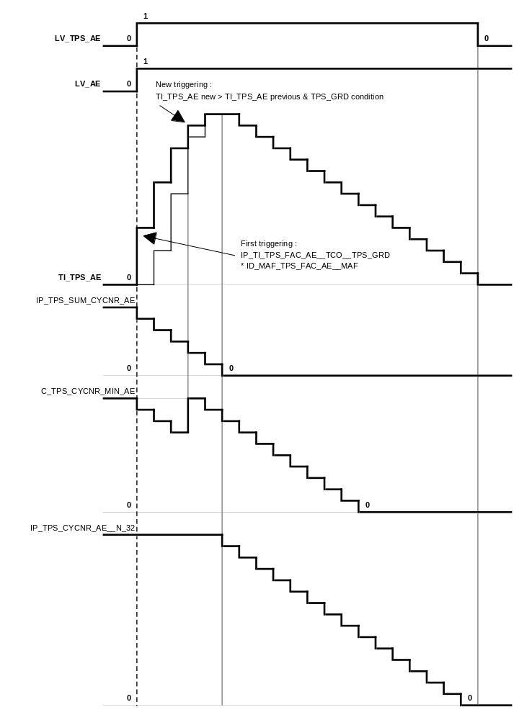
Calibration data:
Name | Dim | Hex. limits | Phys. limits | Resol. | Unit
IP_TI_TPS_FAC_AE(_AT)__TCO__TPS_GRD | 6 x 6 | 00...FFH | 0...3,98 | 1,562E-2 | -
Basic factor for throttle acceleration enrichment correction.
ID_MAF_TPS_FAC_AE(_AT)__MAF | 4 | 00...FFH | 0...0,997 | 3,895E-3 | -
Initialisation value versus MAF for acceleration enrichment correction calculation.
IP_TPS_CYCNR_AE(_AT)__N_32 | 4 | 01...FFH | 1...255 | 1 | -
Duration of TI_TPS_AE reset.
C_TPS_CYCNR_MIN_AE | 1 | 01...FFH | 1...255 | 1 | -
Re-triggering timer for throttle acceleration enrichment correction.
IP_TPS_SUM_CYCNR_AE__N_32 | 4 | 01...20H | 1...32 | 1 | -
Maximum duration of TI_TPS_AE updating calculation.

Load acceleration enrichment correction ( TI_MAF_AE )
Output data:
Name | Mode | Hex. limits | Phys. limits | Resol. | Unit
TI_MAF_AE | V | 0...FDFFH | 0...15,8745 | 16 / 65536 | -
Load acceleration enrichment factor correction for nominal injection time.
Input data:
MAF_RATIO_AE | TCO | ID_TPS_GRD_ADD_AE__TCO | MAF
TPS_GRD | TPS | ID_TPS_GRD_BOL_AE__N_32__TPS | LV_AE
N_32
FUNCTION DESCRIPTION:
General information:
The acceleration quality is depending on the wall wetting phenomena and the injection time correction factor TI_MAF_AE is representative of it.
The engine richness cannot be constant on each transient phase segment, that’s why a temporary correction is applied on injection time. This correction TI_MAF_AE is working together with the throttle acceleration enrichment correction and must compensate the lean trail.

Application recurrence : Segment
Formula section:

* First triggering - Initialisation :

If LV_AE = 1 (AE) (acceleration enrichment function active)
then the corresponding mass air flow filtering factor MAF_CRLC is set
and the calculation of MAF_RATIO_AE is performed
and

TI_MAF_AE = IP_TI_FAC_AE(_AT)__N_32__MAF * IP_TI_FAC_TRA_AE(_AT)__MAF_RATIO_AE__TCO

and TI_CYCNR_AE = 0 - Initialisation
(timer for TI_MAF_AE re-triggering - CYC calculation)
and initialisation of IP_TI_FAC_x_AE_RST__CYC
(deactivation factor of TI_MAF_AE )
If TCO < C_TCO_AE_RST
then IP_TI_FAC_x_AE_RST__CYC = IP_TI_FAC_1_AE_RST(_AT)__CYC
else IP_TI_FAC_x_AE_RST__CYC = IP_TI_FAC_2_AE_RST(_AT)__CYC
Remark :

* The value from IP_TI_FAC_AE(_AT)__N_32__MAF is set only on the first triggering of the load acceleration enrichment correction.
Then, TI_MAF_AE is updated with IP_TI_FAC_TRA_AE(_AT)__MAF_RATIO_AE__TCO using the segment recurrence.

* The timer for TI_MAF_AE re-triggering is calculating as following :

CYC_{n} = 1 - TI_CYCNR_AE_{n} / IP_TI_CYCNR_AE(_AT)__N_32__TCO

The value from IP_TI_CYCNR_AE(_AT)__N_32__TCO is set only on the first triggering of the load acceleration enrichment correction.

* New triggering :

If LV_AE = 1 (AE) (acceleration enrichment function active)
and CYC_{n} ≤ C_CYC_MAX_AE
then
If TPS_GRD ≥ ID_TPS_GRD_BOL_AE__N_32__TPS+ ID_TPS_GRD_ADD_AE__TCO
and TPS_GRD ≥ 0
and TI_MAF_AE new calculation ≥ TI_MAF_AE previous calculation
then the first triggering is performed again with TI_MAF_AE new calculation
else TI_MAF_AE is continuously calculated as following :

TI_MAF_AE = IP_TI_FAC_AE(_AT)__N_32__MAF * IP_TI_FAC_TRA_AE(_AT)__MAF_RATIO_AE__TCO * IP_TI_FAC_x_AE_RST__CYC

and TI_CYCNR_AE_{n} = TI_CYCNR_AE_{n-1} + 1
(n is the segment recurrence)
until TI_MAF_AE = 0 is reached
Description:

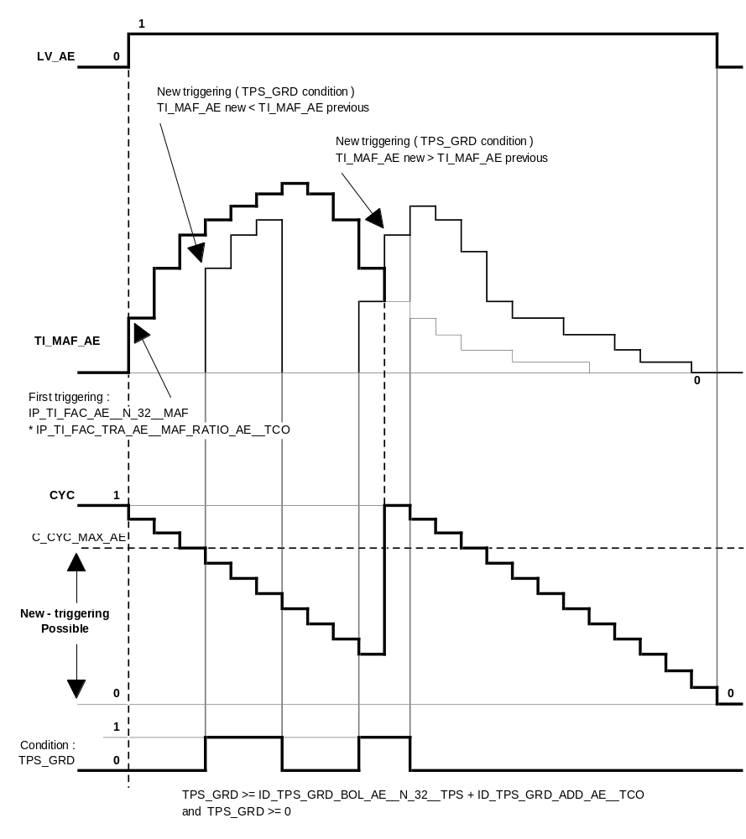
Calibration data:
Name | Dim | Hex. limits | Phys. limits | Resol. | Unit
IP_TI_FAC_AE(_AT)__N_32__MAF | 4 x 4 | 0...FFH | 0...1,9922 | 2 / 256 | -
Initialisation factor for load acceleration enrichment correction, versus engine operating point.
IP_TI_FAC_TRA_AE(_AT)__MAF_RATIO_AE__TCO | 4 x 6 | 0...7FFFH | 0...7,9995 | 8 / 32768 | -
Basic factor for load acceleration enrichment correction.
IP_TI_CYCNR_AE(_AT)__N_32__TCO | 4 x 6 | 01...FFFFH | 1...65535 | 1 | -
Re-triggering timer for load acceleration enrichment correction.
IP_TI_FAC_1_AE_RST(_AT)__CYC | 6 | 00...FFH | 0...0,997 | 3,895E-3 | -
Load acceleration enrichment deactivation factor if TCO < C_TCO_AE_RST.
IP_TI_FAC_2_AE_RST(_AT)__CYC | 6 | 00...FFH | 0...0,997 | 3,895E-3 | -
Load acceleration enrichment deactivation factor if TCO ( C_TCO_AE_RST.
C_TCO_AE_RST | 1 | 0...FEH | -48...142,5 | 0,75 | -
Coolant temperature threshold for selection of load acceleration enrichment deactivation factor.
C_CYC_MAX_AE | 1 | 00...FFH | 0...0,997 | 3,895E-3 | -
CYC value threshold for TI_MAF_AE re-triggering authorization.

Trailing throttle fuel reduction correction ( TI_PUR )
Output data:
Name | Mode | Hex. limits | Phys. limits | Resol. | Unit
TI_PUR | V | 0...0FD0H | 0...0,9883 | 16 / 65536 | -
Trailing throttle fuel reduction correction for nominal injection time.
Input data:
LV_PUR | N_32 | TCO | MAF
MAF_RATIO_PUR
FUNCTION DESCRIPTION:
General information:
In trailing throttle, a richness peak is sometimes met. That’s why, in order to keep the engine richness 1, the injection time is reduced to compensate the increased fuel film evaporation due to decreased intake manifold pressure.
This function is similar to the load acceleration enrichment correction but takes place during decelerations instead of accelerations.

Application recurrence : Segment

Formula section:

* First triggering - Initialisation :

If LV_PUR = 1 (PUR) (trailing throttle fuel reduction function active)
then the corresponding mass air flow filtering factor MAF_CRLC is set
and the calculation of MAF_RATIO_PUR is performed
and

TI_PUR = IP_TI_FAC_PUR__N_32__MAF * IP_TI_FAC_TRA_PUR(_AT)__MAF_RATIO_PUR__TCO

and TI_CYCNR_PUR = 0 - Initialisation
(timer for TI_PUR re-triggering - CYC calculation)
and initialisation of IP_TI_FAC_PUR_RST(_AT)__CYC
(deactivation factor of TI_PUR )
Remark :

* The value from IP_TI_FAC_PUR__N_32__MAF is set only on the first triggering of the trailing throttle fuel reduction function.
Then, TI_PUR is updated with IP_TI_FAC_TRA_PUR(_AT)__MAF_RATIO_PUR__TCO using the segment recurrence.

* The timer for TI_PUR re-triggering is calculating as following :

CYC_{n} = 1 - TI_CYCNR_PUR_{n} / IP_TI_CYCNR_PUR(_AT)__N_32__TCO

The value from IP_TI_CYCNR_PUR(_AT)__N_32__TCO is set only on the first triggering of the trailing throttle fuel reduction function.

* New triggering :

If LV_PUR = 1 (PUR) (trailing throttle fuel reduction function active)
then TI_PUR is continuously calculated as following :

TI_PUR = IP_TI_FAC_PUR__N_32__MAF
* IP_TI_FAC_TRA_PUR(_AT)__MAF_RATIO_PUR__TCO * IP_TI_FAC_PUR_RST(_AT)__CYC

and TI_CYCNR_PUR_{n} = TI_CYCNR_PUR_{n-1} + 1
until TI_PUR = 0 is reached (n is the segment recurrence)
Description:

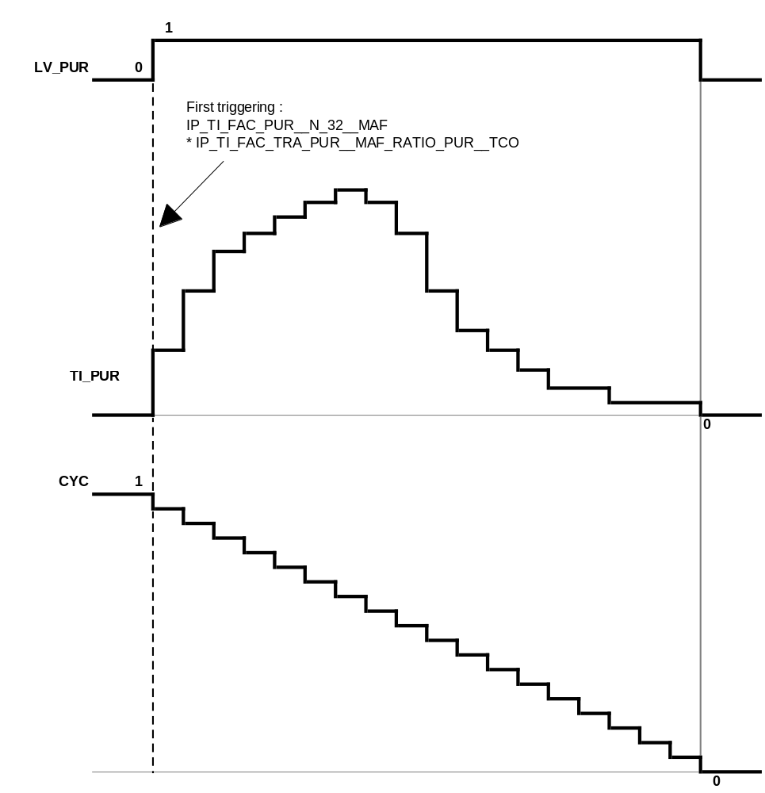

Calibration data:
Name | Dim | Hex. limits | Phys. limits | Resol. | Unit
IP_TI_FAC_PUR(_AT)__N_32__MAF | 4 x 4 | 0...FFH | 0...0,9961 | 1 / 256 | -
Initialisation factor for trailing throttle fuel reduction correction, versus engine operating point.
IP_TI_FAC_TRA_PUR(_AT)__MAF_RATIO_PUR__TCO | 4 x 6 | 0...03FCH | 0...3,9844 | 1 / 256 | -
Basic factor for trailing throttle fuel reduction correction.
IP_TI_CYCNR_PUR(_AT)__N_32__TCO | 4 x 4 | 01...FFFFH | 1...65535 | 1 | -
Re-triggering timer for trailing throttle fuel reduction correction.
IP_TI_FAC_PUR_RST(_AT)__CYC | 6 | 0...FFH | 0...0,9961 | 1 / 256 | -
Trailing throttle fuel reduction deactivation factor.

Idle speed correction ( TI_IS )
Output data:
Name | Mode | Hex. limits | Phys. limits | Resol. | Unit
TI_IS | V | 0...FFH | -0,5...0,496 | 1 / 256 | -
Idle speed correction for nominal injection time.
Input data:
LV_IS | LV_ISAPWM_IS_ACT | N_DIF_COR
FUNCTION DESCRIPTION:
General information:
In order to achieve an engine speed stabilization at idle (LV_IS), a mixture correction is performed as soon as the idle speed regulation is active.

Application recurrence : Segment

Formula section:

If engine operating state idle (LV_IS) active
and LV_ISAPWM_IS_ACT = 1 ( Active ) (idle speed regulation correction active)
then TI_IS = IP_TI_IS__N_DIF_COR
else TI_IS = 0

Calibration data:
Name | Dim | Hex. limits | Phys. limits | Resol. | Unit
IP_TI_IS__N_DIF_COR | 6 | 0...FFH | -0,5...0,496 | 1 / 256 | -
Idle speed correction for nominal injection time.

Altitude correction factor ( TI_FAC_ALTI )
Output data:
Name | Mode | Hex. limits | Phys. limits | Resol. | Unit
TI_FAC_ALTI | - | 80...FFH | 0,5...0,9961 | 0,0039 | -
Altitude injection time correction factor.
Input data:
MAF_FAC_ALTI_MMV
FUNCTION DESCRIPTION:
General information:
The pre-injection time and injection time at start is corrected with the altitude correction factor TI_FAC_ALTI, which depends on the mass air flow correction factor MAF_FAC_ALTI_MMV. For total formula see chapters 1.1.1.1.1. and 1.1.1.1.2.
Formula section:

TI_FAC_ALTI = IP_TI_FAC_ALTI__MAF_FAC_ALTI_MMV

Calibration data:
Name | Dim | Hex. limits | Phys. limits | Resol. | Unit
IP_TI_FAC_ALTI__MAF_FAC_ALTI_MMV | 8 | 80...FFH | 0,5...0,9961 | 0,0039 | -
Weighting factor of pre injection time basic value due to altitude correction.

Acceleration enrichment correction ( TI_AE )
Output data:
Name | Mode | Hex. limits | Phys. limits | Resol. | Unit
TI_AE | V | 0...FFFFH | 0...15,9998 | 16 / 65536 | -
Acceleration enrichment factor correction for nominal injection time.
Input data:
TI_TPS_AE | TI_MAF_AE | LV_AE
FUNCTION DESCRIPTION:
General information:
The acceleration quality is depending on measurement response time and fuel wall wetting phenomena.
The injection time correction factor TI_AE is representative of them.
The engine richness cannot be constant on each transient phase segment, that’s why this temporary correction is applied on nominal injection time. This correction TI_AE is the result of the throttle acceleration enrichment correction TI_TPS_AE and the load acceleration enrichment correction TI_MAF_AE.

Application recurrence : Segment

Formula section:

TI_AE = TI_TPS_AE + TI_MAF_AE

Remark :
The calculation is made independently of the acceleration enrichment information (LV_AE).

Cylinder fuel shut-off
Output data:
Name | Mode | Hex. limits | Phys. limits | Resol. | Unit
PAT_INH_IV | V | 00...maxH | 0...max | 1 | -
Fuel shut-off pattern index - max = NC_INI_INH_SWI_IV_SHIFT_NR.
INH_SWI_IV | - | 0...1FFFH | 0...8191 | 1 | -
Fuel shut-off pattern for 6 cylinders engine.
Input data:
PAT_INH_IV_VS_MAX | PAT_INH_IV_N_MAX | PAT_INH_IV_TQR | LV_IGK
PAT_INH_IV_PUC_REAC
FUNCTION DESCRIPTION:
General information:
For the following auxiliary functions injection must be disabled for individual cylinders :
- engine speed limitation
- vehicle speed limitation
- torque reduction requested by TCS (Traction Control System).
- Fuel cut-off
- Rewetting in Part Load

(refer to the chapter “ Fuel injection output “ in the major chapter “ Outputs “)

Application recurrence : Segment

Formula section:

If ignition key is detected off (LV_IGK = 0 ( Passive ))
then PAT_INH_IV_{n} = NC_INI_INH_SWI_IV_SHIFT_NR
else PAT_INH_IV_{n} = max { PAT_INH_IV_N_MAX, (engine speed limitation) PAT_INH_IV_VS_MAX, (vehicle speed limitation)
PAT_INH_IV_TQR (torque red. req. by TCS or TCU)
PAT_INH_IV_PUC_REAC (Progressive PUC Phase
and Rewetting in PL)

If PAT_INH_IV_{n} > PAT_INH_IV_{n-1}
then INH_SWI_IV = ID_PAT_INH_IV__PAT_INH_IV_{n} + 8000H
else INH_SWI_IV = ID_PAT_INH_IV__PAT_INH_IV_{n}
Description:

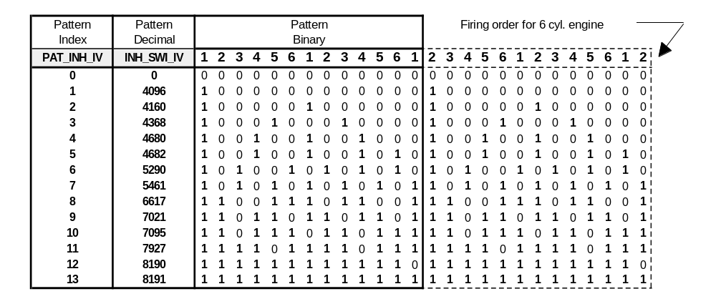
Calibration data:
Name | Dim | Hex. limits | Phys. limits | Resol. | Unit
ID_PAT_INH_IV__PAT_INH_IV | 14 | 0...1FFFH | 0...8191 | 1 | -
Fuel shut-off pattern for 6 cylinders engine.
NC_INI_INH_SWI_IV_SHIFT_NR | 1 | 0...FFH | 0...255 | 1 | -
Non adjustable calibration - Length of the pattern for fuel injection shut-off.

Applicative Value :
NC_INI_INH_SWI_IV_SHIFT_NR = 0DH = 13 dec.

Progressive fuel cut-off (PUC) and rewetting in Part Load (PL)
Output data:
Name | Mode | Hex. limits | Phys. limits | Resol. | Unit
PAT_INH_IV_PUC_REAC | V | 00...maxH | 0...max | 1 | -
Fuel shut-off pattern for progressive fuel cut-off phase (PUC) and rewetting in Part Load (PL)
Input data:
LV_PUC | NC_CYL_NO | NC_INI_INH_SWI_IV_SHIFT_NR | N_32
LV_PU | LV_PL | GR_MT | TCO
LV_TCO_ERR
FUNCTION DESCRIPTION:
General information:
In order to have smooth decelerations and accelerations, cylinders are progressively:
- switched OFF when “Trailing Throttle Fuel Cut Off (PUC)” is detected.
- switched ON when a transition “Trailing Throttle Fuel Cut Off (PUC)” to Part Load (PL) is detected.

Progressive cylinder cut-off and rewetting mainly depends on Engine Speed and Gear Ratio.

Formula section:

- Progressive cylinder shut-off :

If Transition LV_PU -> LV_PUC is detected
Then Following sequence is started:

1. PAT_INH_IV_PUC_REAC = ID_PAT_INH_IV_PUC_1__N_32 during 2 * NC_CYL_NO segments
2. PAT_INH_IV_PUC_REAC = ID_PAT_INH_IV_PUC_2__N_32 during 2 * NC_CYL_NO segments
3. PAT_INH_IV_PUC_REAC = NC_INI_SWI_IV_SHIFT_NR

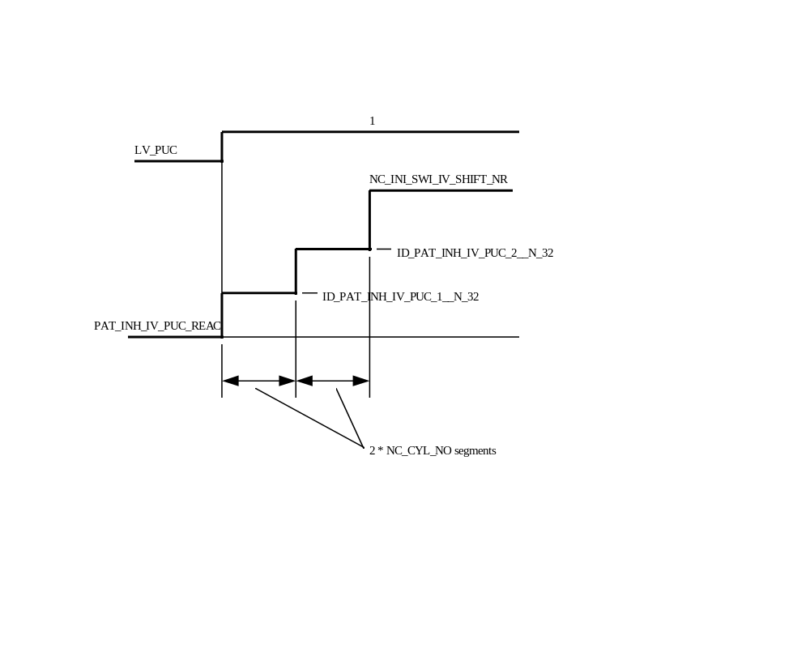

- Progressive cylinder rewetting :

If Transition LV_PUC -> LV_PL is detected
and TCO > C_TCO_PAT_REAC_MIN
and LV_TCO_ERR = 0

Then Following sequence is started and active if LV_PL = 1

1. PAT_INH_IV_PUC_REAC is set to ID_PAT_INH_IV_REAC__N_32__GR_MT
during ID_PAT_CYCNR_REAC_N_32__GR_MT segments
2. PAT_INH_IV_PUC_REAC = 0

Else
PAT_INH_IV_PUC_REAC = 0 immediately
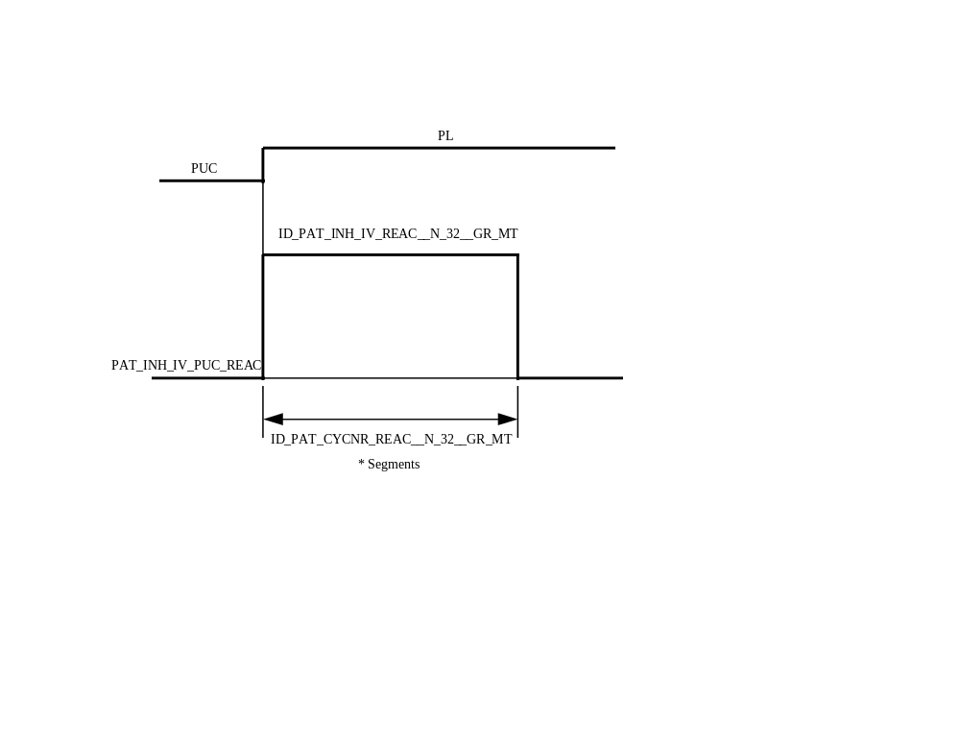
Calibration data:
Name | Dim | Hex. limits | Phys. limits | Resol. | Unit
ID_PAT_INH_IV_PUC_1__N_32 | 6 | 0...maxH | 0...max | 1 | -
Fuel shut-off pattern in case of “Trailing Throttle Fuel Cut-Off - max = NC_INI_INH_SWI_IV_SHIFT_NR
ID_PAT_INH_IV_PUC_2__N_32 | 6 | 0...maxH | 0...8191 | 1 | -
Fuel shut-off pattern in case of “Trailing Throttle Fuel Cut-Off - max = NC_INI_INH_SWI_IV_SHIFT_NR
ID_PAT_INH_IV_REAC__N_32__GR_MT | 6*6 | 0...maxH | 0...max | 1 | -
Fuel shut-off pattern in case of transition PUC->PL - max = NC_INI_INH_SWI_IV_SHIFT_NR
ID_PAT_CYCNR_REAC_N_32__GR_MT | 6*6 | 0...FFH | 0...255 | 1 | Segment
Number of cycles to activate Fuel shut-off pattern in case of transition PUC->PL
C_TCO_PAT_REAC_MIN | 1 | 0...FEH | -48...142,5 | 0,75 | °C
Minimum coolant temperature to activate progressive injection rewetting at transition to PL

Individual cylinder re-start fuel feed ( TI_ADD_REAC_SCC_[CYL] )
Output data:
Name | Mode | Hex. limits | Phys. limits | Resol. | Unit
TI_ADD_REAC_SCC_[CYL] | V | 8000...7FFFH | -131,072  ...131,068 | 4 µsec | msec
Individual cylinder re-start fuel feed.
Input data:
TCO | N_32 | TIB
FUNCTION DESCRIPTION:
General information:
This function is provided to make sure that the cylinder fuel feed which is re-started after an individual fuel shut-off begins to ignite safely and without misfires ensuring a fast torque build-up. The corresponding cylinder must be supplied with an additional fuel quantity for the following reasons :
- increased cylinder fill due to lack of residual exhaust gas
- removal of the wall-applied fuel film during cylinder shut-off.

There is no differentiation as to whether fuel feed is re-started after any one of the engine operating states.

(refer to the chapter “ Fuel injection output “ in the major chapter “ Outputs “)

Application recurrence : Segment
Formula section:
* Simulation of wall - applied fuel film removal ( calculation ) :

TI_DIF_WF_[CYL] is set only if cylinder individual fuel shut-off is requested from basis software layer.
It works like a negative offset for TI_ADD_REAC_SCC_[CYL] and performs the
simulation of wall - applied fuel film removal.

TI_DIF_WF_[CYL] = TIB * ID_TI_TCO_NEG_WF__TCO

As long as the corresponding cylinder is in fuel shut-off, an engine speed related additional fuel quantity ID_TI_INC_WF__N_32 is incremented cyclically at intervals of 720° CRK until the cylinder fuel shut-off is terminated or TI_DIF_WF_[CYL] = 0.

* Additional injection quantity for re-starting fuel feed ( application ) :

TI_REAC_WF_[CYL] is set only if cylinder re-start fuel feed is requested from basis software layer.
It works like a positive offset for TI_ADD_REAC_SCC_[CYL] and performs the wall - applied fuel film, which is not not completely removed.
Due to residual exhaust gas, an additive injection time compensation is performed only during the first triggering of the re-start fuel feed.

TI_REAC_WF_[CYL] = TIB * ID_TI_TCO_POS_WF__TCO + ID_TI_N_POS_RG__N_32

For reduction, an engine speed related decrement ID_TI_DEC_WF__N_32 is used until TI_ADD_REAC_SCC_[CYL] = 0.

Description:
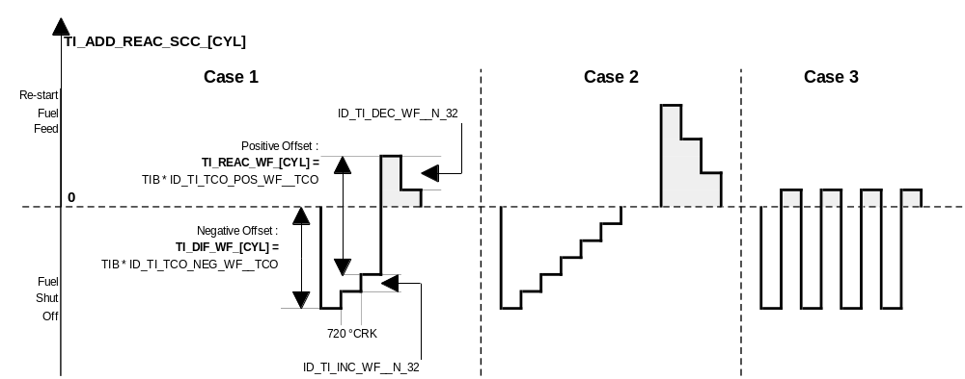

Case 1 : Re-start fuel feed is performed after 3 x 720 °CRK in fuel shut-off.
The wall - applied fuel film has not been removed totally.
The re-starting fuel quantity TI_ADD_REAC_SCC_[CYL] starts with the negative value TI_DIF_WF_[CYL]. The additional injection is defined by the positive offset TI_REAC_WF_[CYL]:

TI_ADD_REAC_SCC_[CYL] = TI_REAC_WF_[CYL]

The additional injection quantity is reset after 2 x 720 °CRK.

Case 2 : Following cylinder fuel shut-off, the wall - applied fuel film has been totally removed.
The re-starting fuel quantity TI_ADD_REAC_SCC_[CYL] is performed with the maximum value possible with TI_REAC_WF_[CYL]:

TI_ADD_REAC_SCC_[CYL] = TI_REAC_WF_[CYL]

The re-starting fuel feed injection is reset after 3 x 720 °CRK.

Case 3 : It shows alternating cylinder operation.
An additional injection quantity is supplied every combustion cycle (720 °CRK).
Calibration data:
Name | Dim | Hex. limits | Phys. limits | Resol. | Unit
ID_TI_TCO_NEG_WF__TCO | 8 | 0...FFFFH | 0...3,9999 | 4 / 65536 | -
Basic amount of wall - applied fuel film.
ID_TI_TCO_POS_WF__TCO | 8 | 0...FFFFH | 0...3,9999 | 4 / 65536 | -
Basic amount of fuel at fuel feed re-starting
ID_TI_N_POS_RG__N_32 | 8 | 0...FFFFH | 0...262,14 | 4 µsec | msec
First triggering fuel offset on re-start fuel feed for residual exhaust gas compensation.
ID_TI_INC_WF__N_32 | 8 | 0...FFFFH | 0...262,14 | 4 µsec | msec
Incrementation for wall - applied fuel film removing simulation.
ID_TI_DEC_WF__N_32 | 8 | 0...FFFFH | 0...262,14 | 4 µsec | msec
Fuel decrementation after re-starting fuel feed.

Lambda control (A/F regulation loop)

General
The lambda control adjusts the air-fuel mixture applied to the engine to the stoichiometric ratio corresponding to lambda = 1.
The lambda controller TI_LAM_i is a P / I controller. The reference variable for this controller is supplied by an exhaust gas probe, the oxygen sensor.

Conditions for lambda control
Output data:
Name | Mode | Hex. limits | Phys. limits | Resol. | Unit
LV_LSCL_i | V | 0...01H | 0...1 | 1 | -
Boolean for close loop enabled for bank n° 1/2 - ( OFF / ON ).
LV_LAM_ACT_i | V | 0...01H | 0...1 | 1 | -
Boolean for lambda controller operability in its own limits for bank n° 1/2 - ( Passive / Active ).
LV_LAM_i_READY | V | 0...01H | 0...1 | 1 | -
Boolean for lambda controller non operability for bank n° 1/2 - ( Passive / Active ).
LV_AUTH_LAM_CYCNR | V | 0...01H | 0...1 | 1 | -
Boolean for lambda controller authorized again following A/F regulation in open loop - ( Passive / Active ).
Input data:
LV_ES | LV_ST | LV_PUC | LV_FL
LV_TI_AST | LV_COP | LV_LEARN_CP | LV_SCC_LAM_ASR
LV_LSH_PHA_MAX_RATE | LV_IGA_AST | LV_AUTH_LAM_SA | LV_OPL_VS_MAX
LV_VLS_UP_i_ERR | LV_CPS_ERR | LV_DUR_IGC_[CYL]_ERR | LV_STATE_A_MIS
LV_TCO_ERR | LV_MAF_ERR | LV_LSH_UP_i_ERR | LV_IV_[CYL]_ERR
LV_CPS_ERR | LV_CPS_MECHA_ERR | LV_LAM_LIM_i_ERR | N_32
TI_LAM_i | MAF_KGH | TCO | TI_AD_FAC_MMV_i
LAM_MV_i | CPPWM | TI_AD_ADD_MMV_REL_i | LAM_MV_DYW_i
LV_AFR_i | C_T_MIN_LS | C_T_LAM_MAX_STATE | PAT_INH_IV
LV_LS_i | L_INH_IV_[CYL]

Closing conditions
Application conditions:
The conditions to close the A/F regulation loop for a cylinder bank n° i are :

If LV_ES = 0 (engine stopped inactive)
and LV_ST = 0 (engine operating state start inactive)
and LV_LSH_PHA_MAX_RATE = 1 (O2 sensor full rate heating phase finished)
and LV_TI_AST = LV_IGA_AST = 0 (Passive) (auxiliary function post start inactive)
and LV_AUTH_LAM_SA = 0 (Passive) (secondary air function inactive)
then
If LV_VLS_UP_i_ERR = 0
(no error currently present on O2 sensor signal acquisition)
and LV_IV_[CYL]_ERR = 0
(no error currently present on injection power stage)
and LV_DUR_IGC_[CYL]_ERR = 0
(no error concerning the corresponding ignition output)
and LV_STATE_A_MIS = 0
(no misfire status CARB A (catalyst damage))
and MAF_KGH > C_LAM_MAF_KGH_MIN_DIAG
or LV_LSH_UP_i_ERR = 0
(no error currently present on upstream O2-sensor heater power stage)
then
If L_INH_IV_[CYL] = 0 (no fuel shut-off)
and PAT_INH_IV = 0 (fuel shut-off pattern index state)
and LV_SCC_LAM_ASR = 0 (no ASR intervention)
and LV_FL = 0 (Passive) (auxiliary function full load inactive)
and LV_OPL_VS_MAX = 0 (Passive) (no A/F regulation loop opened
due to vehicle speed limitation)
then C_LAM_CYCNR initialisation
If N_32 > C_LAM_N_MIN
and LV_AUTH_LAM_CYCNR = 0 (Passive)
(timer C_LAM_CYCNR has elapsed after A/F regulation in open loop)
and TCO > ID_TCO_LAM_MIN_IS__TCO_ST in idle (LV_IS)
or TCO> ID_TCO_LAM_MIN__TCO_ST out of idle
(condition checked only once)
then
If LV_COP = 0 (Passive)
(catalyst overheating prevention function inactive)
and LV_LS_i = 1 (Active)
(A/F regulation oxygen sensor operability effective)
or C_T_MIN_LS expired
(A/F regulation loop closed and LV_LS_i = 0)
then

LV_LSCL_i = 1 (ON) (A/F regulation loop closed)

Lambda controller status definition following A/F regulation in open loop
(LV_AUTH_LAM_CYCNR)
General information:
This boolean information (LV_AUTH_LAM_CYCNR) is used as condition for closing again the A/F regulation loop following the A/F regulation previously opened.

Application conditions:
The A/F regulation loop will be closed again when C_LAM_CYCNR seconds have been performed following the conditions to leave LV_LSCL_i = 0 (OFF).
Thus, the lambda controller will be authorized again only if N_32 > C_LAM_N_MIN.

Lambda controller status definition relative to the A/F regulation loop
(LV_LAM_ACT_i , LV_LAM_i_READY)
General information:
Two boolean information (LV_LAM_ACT_i and LV_LAM_i_READY) are built using the boolean information LV_LSCL_i relative to the A/F regulation loop.
- The first one (LV_LAM_ACT_i) indicates an A/F regulation loop closed and a lambda controller TI_LAM_i running in its own limitation.
- The second one (LV_LAM_i_READY) indicates the operability status of the lambda controller TI_LAM_i
Application conditions:
Activation:
If LV_LSCL_i = 1 (ON) (A/F regulation loop closed)
and LV_LAM_LIM_i_ERR = 1 (error currently present on lambda controller)
then LV_LAM_i_READY = 0 (Passive)

Deactivation :
If LV_LSCL_i = 0 (OFF) (A/F regulation loop opened)
or (LV_LSCL_i = 1 (ON) (A/F regulation loop closed)
and LV_AFR_i = 0 (Lean) → 1 (Rich)
or LV_AFR_i = 1 (Rich) → 0 (Lean)
and LV_LAM_LIM_i_ERR = 0)
(no error currently present on lambda controller)
then LV_LAM_i_READY = 1 (Active)
Formula section:
If LV_LSCL_i = 1 (ON) (A/F regulation loop closed)
and LV_LAM_i_READY = 1 (Active) (lambda controller ready to operate)
then LV_LAM_ACT_i = 1 (Active)
else LV_LAM_ACT_i = 0 (Passive)

Opening conditions
Application conditions:
The conditions to open the A/F regulation loop for a cylinder bank n° i are :

If LV_ES = 1 (engine stopped active)
or LV_ST = 1 (engine operating state start active)
or LV_LSH_PHA_MAX_RATE = 0 (O2 sensor full rate heating phase not expired)
or LV_TI_AST = 1 (Active) (auxiliary function post start (TI correction) active)
or LV_IGA_AST = 1 (Active) (auxiliary function post start (IGA correction) active)
or LV_AUTH_LAM_SA = 1 (Active) (secondary air function active)
then

LV_LSCL_i = 0 (OFF) (A/F regulation loop opened)

and
TI_LAM_i reaches its default value (0 dec : 8000H),
using the last I - component calculated.
else
If LV_VLS_UP_i_ERR = 1
(error currently present on O2 sensor signal acquisition)
or LV_IV_[CYL]_ERR = 1
(error currently present on corresponding injection power stage)
or LV_DUR_IGC_[CYL]_ERR = 1
(error currently present on the corresponding ignition output)
or LV_STATE_A_MIS = 1
(misfire status CARB A (catalyst damage))
or MAF_KGH ≤ C_LAM_MAF_KGH_MIN_DIAG
and LV_LSH_UP_i_ERR = 1
(error currently present on upstream O2 sensor heater power stage)
then

LV_LSCL_i = 0 (OFF) (A/F regulation loop opened)

and
If LV_MAF_ERR = 1
(error currently present on mass air flow sensor)
or LV_MAF_PLAUS_ERR = 1
(error currently present on mass air flow signal)
or LV_LAM_LIM_i_ERR = 1
(error currently present on lambda controller)
or LV_VLS_UP_i_ERR = 1
(error currently present on O2 sensor signal acquisition)
or LV_TCO_ERR = 1
(error currently present on coolant temperature sensor)
or LV_TCO_PLAUS_ERR = 1
(error currently present on coolant temperature signal)
or LV_CPS_ERR = 1
(error currently present on evaporative emission control valve power stage)
or LV_DUR_IGC_[CYL]_ERR = 1
(error currently present on the corresponding ignition output)
or LV_IV_[CYL]_ERR = 1
(error currently present on corresponding injection power stage)
or LV_STATE_A_MIS = 1
(misfire status CARB A (catalyst damage))
or LV_CPS_MECHA_ERR = 1
(control valve mechanical error during evaporative system monitoring )
then

TI_LAM_i_{n} = TI_LAM_i_{n-1} + (TI_AD_FAC_MMV_i_{n-1}+ TI_AD_ADD_MMV_REL_i_{n-1} )
and
LAM_MV_i_{n} = LAM_MV_i_{n-1} + (TI_AD_FAC_MMV_i_{n-1}+ TI_AD_ADD_MMV_REL_i_{n-1} )
and
LAM_MV_DYW_i_{n} = LAM_MV_DYW_i_{n-1} + (TI_AD_FAC_MMV_i_{n-1}+ TI_AD_ADD_MMV_REL_i_{n-1} )

else
TI_LAM_i reaches its default value (0 dec : 8000H),
using the last I - component calculated.

else
If L_INH_IV_[CYL] = 1 (fuel shut-off active)
or PAT_INH_IV ≠ 0 (fuel shut-off pattern index)
or LV_SCC_LAM_ASR = 1 (ASR intervention)
or LV_FL = 1 (Active) (auxiliary function full load active)
or LV_OPL_VS_MAX = 1 (Active) (A/F regulation loop opened due to VS limitation)
then
If LV_LEARN_CP = 1
(LEARNING mode from evaporative emission control in process (CPPWM ≠ 0))
then
RAMP opening mode and LEARNING mode are aborted
and C_T_LAM_MAX_STATE is started
else

LV_LSCL_i = 0 (OFF) (A/F regulation loop opened)

and C_LAM_CYCNR is initialized
and
If LV_PUC = 1 (trailing throttle fuel cut-off active)
then TI_LAM_i = 0 dec. ( 8000H )
Endif
else
If N_32 ≤ C_LAM_N_MIN
or C_LAM_CYCNR not expired
or TCO ≤ ID_TCO_LAM_MIN_IS__TCO_ST in idle (LV_IS)
or TCO ≤ ID_TCO_LAM_MIN__TCO_ST out of idle
then

LV_LSCL_i = 0 (OFF) (A/F regulation loop opened)

and
TI_LAM_i reaches its default value (0 dec : 8000H),
using the last I - component calculated.
Calibration data:
Name | Dim | Hex. limits | Phys. limits | Resol. | Unit
ID_TCO_LAM_MIN_IS__TCO_ST | 6 | 0...FEH | -48...142,5 | 0,75 | °C
Minimum coolant temperature to close the A/F regulation loop in idle.
ID_TCO_LAM_MIN__TCO_ST | 6 | 0...FEH | -48...142,5 | 0,75 | °C
Minimum coolant temperature to close the A/F regulation loop out of idle
C_LAM_N_MIN | 1 | 0...FFH | 0...8160 | 32 | rpm
Minimum engine speed to close the A/F regulation loop.
C_LAM_MAF_KGH_MIN_DIAG | 1 | 0...FFFFH | 0...16383,75 | 0,25 | kg/h
Minimum mass air flow threshold for validation of the upstream O2 sensor heater power stage.
C_LAM_CYCNR | 1 | 01...FFFFH | 0,01...655,35 | 0,01 | sec
Authorization delay for closing again the A/F regulation loop following A/F regulation loop opened.

Variables related to A/F regulation oxygen sensors signal voltages ( VLS_i )
Output data:
Name | Mode | Hex. limits | Phys. limits | Resol. | Unit
VLS_MMV_MAX_i | V | 0...FFH | 0...4,9805 | 5 / 256 | V.
Moving mean maximum oxygen sensor n° 1 voltage.
VLS_MMV_MIN_i | V | 0...FFH | 0...4,9805 | 5 / 256 | V.
Moving mean minimum oxygen sensor n° 1 voltage.
VLS_TOL_i | V | 0...FFH | 0...4,9805 | 5 / 256 | V.
VLS_MMV_MIN_i corrected voltage.
VLS_BOL_i | V | 0...FFH | 0...4,9805 | 5 / 256 | V.
VLS_MMV_MAX_i corrected voltage.
Input data:
VLS_i | TI_LAM_i | LV_ES | TCO
LV_LS_i | LV_VLS_UP_i_ERR | LV_FL | LV_LSCL_i
LV_LAM_ACT_i
FUNCTION DESCRIPTION:
General information:
The different variables are calculated using the oxygen sensor voltage VLS_i in order to :
- define the lean / rich thresholds
- manage the A/F regulation oxygen sensor heater controller.

Remark : i = 1 for injection bank n° 1
i = 2 for injection bank n° 2

Application recurrence : 20 msec.
Formula section:
* Initialisation :
If engine stopped (LV_ES) active
and TCO ≥ C_LAM_TCO_VLS_MIN_INI
then VLS_MMV_MAX_i = VLS_MMV_MIN_i = VLS_TOL_i = VLS_BOL_i
= C_VLS_INI_MIN
else VLS_MMV_MAX_i = VLS_MMV_MIN_i = VLS_TOL_i = VLS_BOL_i
= C_VLS_INI
* Calculation :
If engine stopped (LV_ES) not active
and LV_VLS_UP_i_ERR = 0 (no error currently present on oxygen
sensor signal acquisition)
then
If LV_LS_i = 0 (oxygen sensor non operability for A/F
regulation)
then no calculation
else
If VLS_TOL_i ≤ VLS_i ≤ VLS_BOL_i
(case n° 2 - refer to the following “ Description “)
or LV_LAM_ACT_i = 0
(the condition for lambda controller active (LV_LSCL_i = 1) and injection time correction ( TI_LAM_i ) not on limit is not fulfilled)
then no calculation
else
If VLS_i < VLS_TOL_i
(case n° 1 - refer to the following “ Description “)
then

VLS_MMV_MIN_i_{n} = VLS_MMV_MIN_i_{n-1} * (1 - C_VLS_CRLC) + VLS_i_{n} * C_VLS_CRLC

VLS_TOL_i_{n} = VLS_MMV_MIN_i_{n} + C_VLS_MMV_HYS

else
If VLS_i > VLS_BOL_i
(case n° 3 - refer to the following “ Description “)
then

VLS_MMV_MAX_i_{n} = VLS_MMV_MAX_i_{n-1} * (1 - C_VLS_CRLC) + VLS_i_{n} * C_VLS_CRLC

VLS_BOL_i_{n} = VLS_MMV_MAX_i_{n} - C_VLS_MMV_HYS

(special treatment in case of full load detection (LV_FL))
If VLS_BOL_i ≤ VLS_TOL_i
then

VLS_BOL_i = VLS_TOL_i = ( VLS_MMV_MAX_i + VLS_MMV_MIN_i ) / 2

* Special treatment in case of full load detection :

In this case, VLS_MMV_MAX_i cannot be calculated and a correction is made on VLS_BOL_i determination after leaving full load operation.

If LV_FL = 1 (FL) during at least C_T_VLS_FL seconds
then when exiting (LV_FL)
VLS_BOL_i_{n} = VLS_BOL_i_{n-1} - C_VLS_SUBT_BOL_FL

(C_VLS_SUBT_BOL_FL will be removed using change limitation
C_VLS_LGRD_DEC_FL)

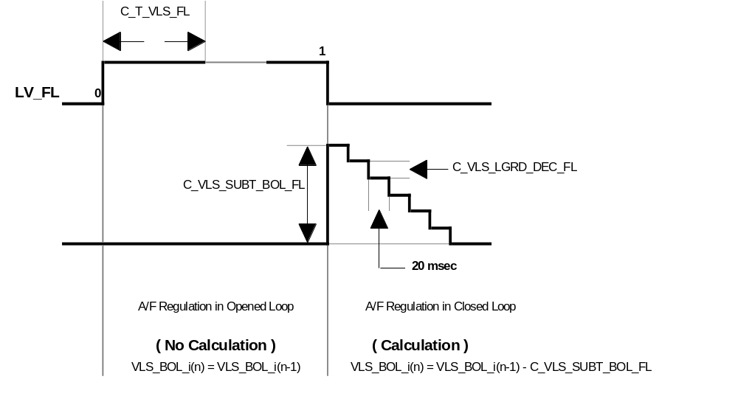
Description:
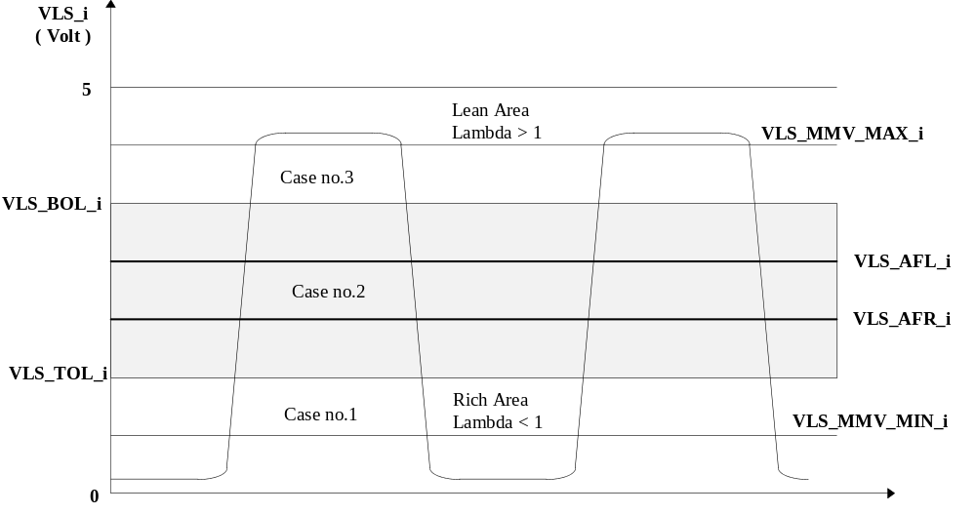

Calibration data:
Name | Dim | Hex. limits | Phys. limits | Resol. | Unit
C_LAM_TCO_VLS_MIN_INI | 1 | 0...FFH | -48...142,5 | 0,75 | °C
Coolant temperature threshold for initialisation of the variables related to A/F regulation oxygen sensors signal voltages.
C_VLS_INI_MIN | 1 | 0...FFH | 0...4,9805 | 5 / 256 | V.
Initialization of VLS_MMV_MAX_i, VLS_MMV_MIN_i, VLS_BOL_i, VLS_TOL_i depending on coolant temperature threshold.
C_VLS_INI | 1 | 0...FFH | 0...4,9805 | 5 / 256 | V.
Initialization of VLS_MMV_MAX_i, VLS_MMV_MIN_i, VLS_BOL_i, VLS_TOL_i depending on coolant temperature threshold.
C_VLS_CRLC | 1 | 00...FFH | 0...0,997 | 3,895E-3 | -
Correlation factor for VLS_MMV_MAX_i and VLS_MMV_MIN_i calculation.
C_VLS_MMV_HYS | 1 | 0...FFH | 0...4,9805 | 5 / 256 | V.
Hysteresis for VLS_TOL_i and VLS_BOL_i calculation.
C_T_VLS_FL | 1 | 01...FFH | 1...255 | 1 | sec.
Minimum duration of full load (LV_FL) for VLS_BOL_i correction application.
C_VLS_SUBT_BOL_FL | 1 | 0...FFH | 0...4,9805 | 5 / 256 | V.
Offset applied on VLS_BOL_i calculation when exiting from full load (LV_FL).
C_VLS_LGRD_DEC_FL | 1 | 01...FFH | 0,0195...4,9805 | 5 / 256 | V.
Change limitation for C_VLS_SUBT_BOL_FL removing.

Rich and lean mixture voltage thresholds ( VLS_AFR_i, VLS_AFL_i )
Output data:
Name | Mode | Hex. limits | Phys. limits | Resol. | Unit
VLS_AFR_i | V | 0...FFH | 0...4,9805 | 5 / 256 | V.
Oxygen sensor voltage threshold for rich mixture detection.
VLS_AFL_i | V | 0...FFH | 0...4,9805 | 5 / 256 | V.
Oxygen sensor voltage threshold for lean mixture detection.
LV_AFR_i | V | 0...01H | 0...1 | 1 | -
Boolean for A/F ratio state for oxygen sensor i - ( Lean / Rich ).
Input data:
VLS_MMV_MIN_i | VLS_MMV_MAX_i | C_LAM_TCO_VLS_MIN_INI | TCO
VLS_i | LV_VLS_LIM_i_ERR | C_VLS_INI | C_VLS_INI_MIN
LV_VLS_UP_i_ERR
FUNCTION DESCRIPTION:
General information:
Application recurrence : 20 msec.
Formula section:
* Initialisation :
If engine stopped (LV_ES) active
and TCO ≥ C_LAM_TCO_VLS_MIN_INI
then VLS_AFR_i = VLS_AFL_i = C_VLS_INI_MIN
else VLS_AFR_i = VLS_AFL_i = C_VLS_INI

* Calculation :
The calculation is performed as soon as all the conditions for calculation of the variables related to A/F regulation oxygen sensor signal voltage are met.
If LV_VLS_LIM_i_ERR = 0
(no error currently present on oxygen sensor signal voltage excursion diagnosis)
and LV_VLS_UP_i_ERR = 0
(no error currently present on oxygen sensor signal voltage diagnosis)
then

VLS_AFR_i = VLS_MMV_MIN_i + ( VLS_MMV_MAX_i - VLS_MMV_MIN_i ) * C_VLS_FAC_AFR
VLS_AFL_i = VLS_MMV_MIN_i + ( VLS_MMV_MAX_i - VLS_MMV_MIN_i ) * C_VLS_FAC_AFL

* Rich or Lean mixture detection :

If { LV_AFR_i = 1 ( Rich ) and VLS_i > VLS_AFL_i }
then LV_AFR_i = 0 ( Lean ) → Lambda > 1

If { LV_AFR_i = 0 ( Lean ) and VLS_i < VLS_AFR_i }
then LV_AFR_i = 1 ( Rich ) → Lambda < 1

Description:

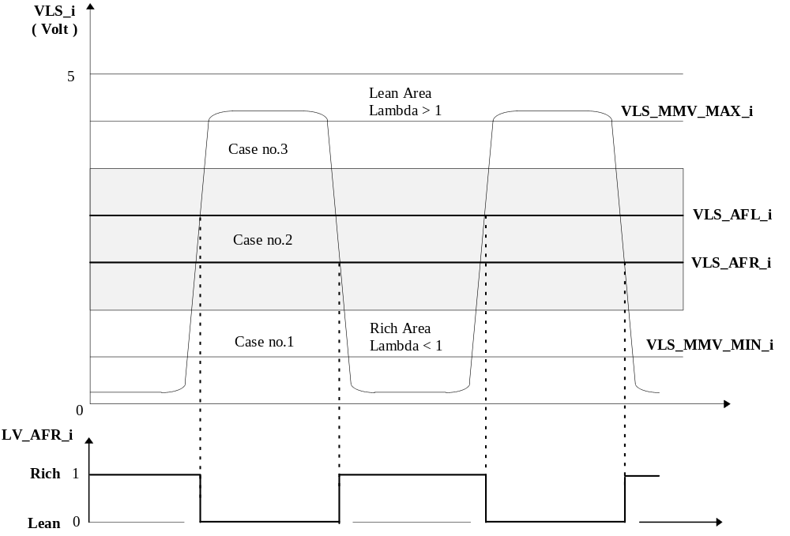
Calibration data:
Name | Dim | Hex. limits | Phys. limits | Resol. | Unit
C_VLS_FAC_AFR | 1 | 00...FFH | 0...0,997 | 3,895E-3 | -
Weighting factor to calculate oxygen sensors signal voltages VLS_AFR_i for rich mixture detection.
C_VLS_FAC_AFL | 1 | 00...FFH | 0...0,997 | 3,895E-3 | -
Weighting factor to calculate oxygen sensors signal voltages VLS_AFL_i for lean mixture detection.

A/F regulation oxygen sensors operability ( LV_LS_i )
Output data:
Name | Mode | Hex. limits | Phys. limits | Resol. | Unit
LV_LS_i | V | 0...01H | 0...1 | 1 | -
Boolean for A/F regulation oxygen sensor operability - ( 0 / 1 ).
Input data:
LV_ES | TCO | LV_VLS_LIM_i_ERR | LV_VLS_UP_i_ERR
TI_LAM_i | C_VLS_INI | C_LAM_MAX | C_VLS_INI_MIN
C_LAM_TCO_VLS_MIN_INI
FUNCTION DESCRIPTION:
General information:
In engine operating state engine stopped (LV_ES), the A/F regulation oxygen sensors are initialized to non operable condition (LV_LS_i = 0).
As soon as the engine operating state engine stopped is exited, the system checks whether the oxygen sensors signal voltages have dropped below a voltage threshold.

Application recurrence : 20 msec.
Formula section:
* Non operability :

If engine stopped (LV_ES) active
or LV_VLS_LIM_i_ERR = 1
(error currently present on oxygen sensor signal voltage excursion diagnosis)
then LV_LS_i = 0

* Operability :

If engine stopped (LV_ES) not active
and LV_VLS_UP_i_ERR = 0
(no error currently present on oxygen sensors signal voltages acquisition diagnosis)
and VLS_i signal voltage has dropped below :
C_VLS_INI if TCO < C_LAM_TCO_VLS_MIN_INI
or C_VLS_INI_MIN if TCO ≥ C_LAM_TCO_VLS_MIN_INI
then LV_LS_i = 1
Remark : Special treatment if LV_LSCL_i = 1 (ON) and LV_LS_i = 0 (Passive)
If one of the oxygen sensor is not operable (LV_LS_i = 0) when the timer C_T_MIN_LS has elapsed (C_T_MIN_LS starts when the preliminary heating phase for oxygen sensor is finished) and if the A/F regulation loop is authorized to be closed, then the corresponding lambda controller TI_LAM_i is started with the maximum limit C_LAM_INI_MAXinstead of C_LAM_MAX
Following the first lean to rich transition of the corresponding oxygen sensor, this limit is set again to C_LAM_MAX and LV_LS_i = 1 (Active).

The condition C_LAM_INI_MAX ≤ C_LAM_MAX must be met.

Calibration data:
Name | Dim | Hex. limits | Phys. limits | Resol. | Unit
C_T_MIN_LS | 1 | 01...FFH | 1...255 | 1 | sec
Minimum duration before closing the A/F regulation loop if the oxygen sensors are not ready.
C_LAM_INI_MAX | 1 | 8000...D000H | 0...31,25 | 100 / 65536 | %
Maximum value of the lambda controller TI_LAM_i when LV_LSCL_i = 1 (ON) and LV_LS_i = 0 (Passive).

Variables related to A/F regulation oxygen sensors heater ( LSHPWM_i )
Output data:
Name | Mode | Hex. limits | Phys. limits | Resol. | Unit
LSHPWM_i | V | 00...FFH | 0...99.609 | 0.3891 | %
Upstream oxygen sensors heating duty cycle.
LSHPWM_LGRD_i | V | 0...FFFFH | 0...99.6 | 0.0015 | %
Basic upstream oxygen sensors heating duty cycle with gradient limitation.
VLS_DIF_i | V | 0...FFH | -5...4.9609 | 10 / 256 | V.
Variable representative of the upstream oxygen sensors tip-temperature.
LSHPWM_FAC_i | V | 00...FFH | 0...1.992 | 7.782E-3 | -
Upstream oxygen sensors heater controller.
LSHPWM_CYCNR | V | 0...FFH | 0...65535 | 1 | -
Time delay for limited heating after Start (LV_ST).
LV_LSH_PHA_AST | V | 0...01H | 0...1 | 1 | -
Boolean for oxygen sensor preliminary heating phase (after start).
LV_LSH_PHA_MAX_RATE | V | 0...01H | 0...1 | 1 | -
Boolean for oxygen sensor full rate heating phase.
Input data:
LV_ES | LV_ST | LV_PUC | TIA_ST
VLS_MMV_MAX_i | LV_LS_i | LV_LAM_ACT_i | TI_LAM_i
VLS_MMV_MIN_i | LV_LSH_UP_i_ERR | LV_VB_JUMP | C_T_MIN_LS
MAF_KGH | VB | C_VB_MIN_JUMP | N_32
MAF | TCO_ST

FUNCTION DESCRIPTION:
General information:
The control of each heater is performed individually.
In order to avoid big temperature gradients after start, the oxygen sensors are heated preliminary => factor applied on the normal heating.
Following this pre-heating phase, the sensors are fully heated in order to reach their service temperature.
Then, the normal duty cycles LSHPWM_i are based on:
- a pre-control value (cylinder bank individual) weighted by battery voltage
- a heater controller (cylinder bank individual) based on the moving mean minimum and maximum oxygen sensors voltages.

- Application recurrence :
- Engine stopped: 100 msec. to start pre-heating phase
- Engine running: 1 sec. for pre-heating phase duration
C_T_PER_LSH sec. for LSHPWM_i calculation

Initialization
Application conditions:
If engine stopped (LV_ES) active
or LV_VB_JUMP = 1 (Active) (battery over voltage at start detected)
then LSHPWM_i = NC_LSHPWM_MIN_DIAG
and LSHPWM_FAC_i = C_LSHPWM_FAC_INI
and LSHPWM_CYCNR = 0
and A/F regulation - P jump counter (C_LSHPWM_LAM_P_SUM_FAC) is reset.

Remark :
Following over voltage event (LV_VB_JUMP = 1 (Active) → 0 (Passive) ) detected at start, the oxygen sensor preliminary heating phase is performed again.

Oxygen sensors duty cycle gradient limitation ( LSHPWM_LGRD_i )
General information:
The target duty cycle LSHPWM_i to be applied to the oxygen sensor heater is:

LSHPWM_LGRD_i = IP_LSHPWM_i__N_32__MAF * IP_LSHPWM_VB_FAC__VB

If the engine operating point (N_32, MAF) or VB change, a gradient limitation is applied to the previous value to reach the new value.
If the new value is lower, then IP_LSHPWM_LGRD_NEG__MAF_KGH is used; else if the new value is higher, then IP_LSHPWM_LGRD_POS__MAF_KGH is used.

Therefore, the internal variable LSHPWM_LGRD_i is used temporary by the software for calculation of the duty cycle LSHPWM_i.

At transition engine stop (LV_ES) to engine start (LV_ST) LSHPWM_LGRD_i is initialized with C_LSHPWM_INI_i :

LSHPWM_LGRD_i = C_LSHPWM_INI_i

Description:

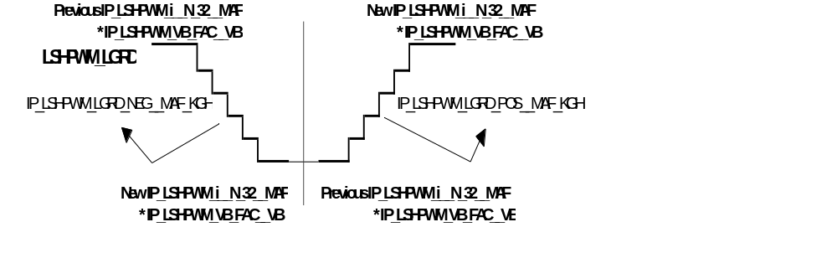

Oxygen sensors preliminary heating phase ( LV_LSH_PHA_AST )
Application conditions:
Activation:
If LV_ES → LV_ST
(transition from engine stopped to start)
or LV_VB_JUMP = 1 (Active) → 0 (Passive)
(battery over voltage at start removed)
then LSHPWM_CYCNR = IP_LSHPWM_CYCNR__TIA_ST
(timer initialization)

LSHPWM_CYCNR_{n} = LSHPWM_CYCNR_{n-1} - IP_DEC_CYCNR_LSH__MAF_KGH

(timer decrementation)
and

LSHPWM_i = LSHPWM_LGRD_i * C_LSHPWM_T_FAC + C_LSHPWM_i_AS

Remark :
During oxygen sensor preliminary heating phase, the weighting factor LSHPWM_FAC_i (calculation of LSHPWM_i in basis heating phase) is kept with its initialization value C_LSHPWM_FAC_INI.

- Deactivation :
If engine stopped (LV_ES) detected
or LV_VB_JUMP = 0 (Passive) → 1 (Active)
or LSHPWM_CYCNR = 0
then LV_LSH_PHA_AST = 1

- Limitation :

NC_LSHPWM_MIN_DIAG ≤ LSHPWM_i ≤ NC_LSHPWM_MAX_DIAG

Oxygen sensors full rate heating phase ( LV_LSH_PHA_MAX_RATE )
Application conditions:
Activation:
If LV_LSH_PHA_AST = 0 → 1
then the timer IP_T_MAX_LSH_ST__TCO_ST is started
and the timer C_T_MIN_LS is started
(refer to chapter“ A/F regulation oxygen sensors operability ( LV_LS_i ) “)
and

LSHPWM_i = NC_LSHPWM_MAX_DIAG

Deactivation:
If IP_T_MAX_LSH_ST__TCO_ST has elapsed
then LV_LSH_PHA_MAX_RATE = 1
and A/F regulation - P jump counter (C_LSHPWM_LAM_P_SUM_FAC) initialized.
and

LSHPWM_i = LSHPWM_LGRD_i + C_LSHPWM_i_AS

(without weighting factor C_LSHPWM_T_FAC).

Oxygen sensors heater controller

A/F regulation in open loop ( LV_LSCL_i = 0 (OFF) )
If LV_LAM_ACT_i = 0 (Passive)
(lambda controller TI_LAM_i not ready to operate)
or LV_LSH_i_ERR = 1
(error currently present on upstream oxygen sensor heater power stage)
or A/F regulation - P jump counter (C_LSHPWM_LAM_P_SUM_FAC) in process
or LSHPWM_LGRD_i < NC_LSHPWM_LGRD_MIN
then the weighting factor LSHPWM_FAC_i of the heater controller LSHPWM_i reaches the default value 1 using change limitation
C_LSHPWM_DIF_PUC

A/F regulation in closed loop ( LV_LSCL_i = 1 (ON) )
If LV_LAM_ACT_i = 1 (Active)
(A/F regulation loop closed and lambda controller TI_LAM_i running)
and LV_LSH_UP_i_ERR = 0
(no error currently present on upstream oxygen sensor heater power stage)
and A/F regulation - P jump counter (C_LSHPWM_LAM_P_SUM_FAC) has reached 0
and LSHPWM_LGRD_i ≥ NC_LSHPWM_LGRD_MIN
then

VLS_DIF_i = ( VLS_MMV_MAX_i + VLS_MMV_MIN_i) - C_VLS_SP

(representative value of oxygen sensor probe temperature)
and

If VLS_DIF_i < 0
then LSHPWM_FAC_i_{n} = LSHPWM_FAC_i_{n-1} - IP_LSHPWM_DIF_I_i__VLS_DIF_i

If VLS_DIF_i > 0
then LSHPWM_FAC_i_{n} = LSHPWM_FAC_i_{n-1} + IP_LSHPWM_DIF_I_i__VLS_DIF_i

Remark :

- Limitation :

C_LSHPWM_FAC_MIN ≤ LSHPWM_FAC_i ≤ C_LSHPWM_FAC_MAX

Formula section:
- Duty cycle LSHPWM_i calculation :

LSHPWM_i = LSHPWM_LGRD_i * LSHPWM_FAC_i + C_LSHPWM_i_AS

Remark :
- If LSHPWM_i reaches the maximum value, then the last calculated LSHPWM_FAC_i component is maintained while the heater controller moves in the opening direction.
- If LSHPWM_i reaches the minimum value, then the last calculated LSHPWM_FAC_i component is maintained while the heater controller moves in the closing direction.
Description:

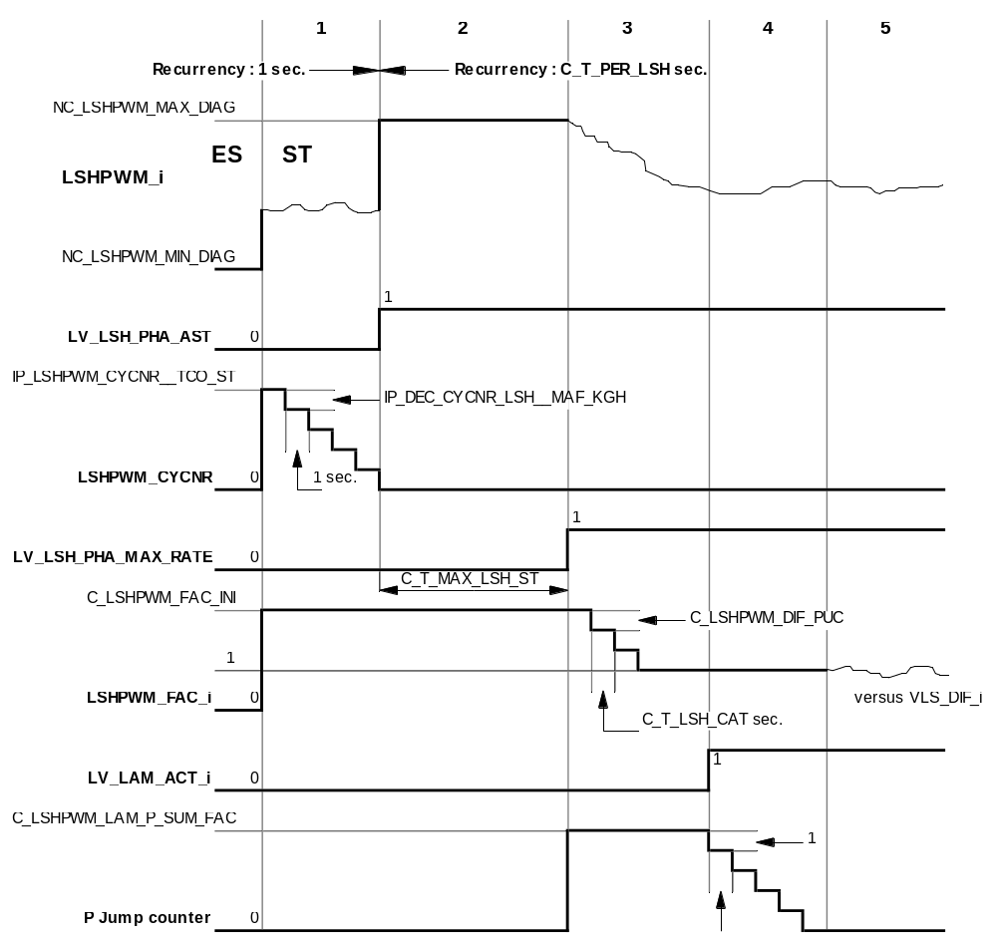

1 : LSHPWM_i = LSHPWM_LGRD_i * C_LSHPWM_T_FAC + C_LSHPWM_i_AS

2 : LSHPWM_i = NC_LSHPWM_MAX_DIAG

3, 4 : LSHPWM_i = LSHPWM_LGRD_i * 1 + C_LSHPWM_i_AS

5 : LSHPWM_i = LSHPWM_LGRD_i * LSHPWM_FAC_i + C_LSHPWM_i_AS
Calibration data:
Name | Dim | Hex. limits | Phys. limits | Resol. | Unit
IP_LSHPWM_CYCNR__TIA_ST | 6 | 0...FFFFH | 0...65535 | 1 | -
Cycle counter for preliminary heating phase.
IP_DEC_CYCNR_LSH__MAF_KGH | 6 | 0...FFFFH | 0...65535 | 1 | -
Decrementation of the cycle counter for preliminary heating phase.
IP_LSHPWM_1__N_32__MAF | 6 x 6 | 0...FFH | 0...99.61 | 100 / 256 | %
Basic upstream O2 sensor heating Bank n°1
IP_LSHPWM_2__N_32__MAF | 6 x 6 | 0...FFH | 0...99.61 | 100 / 256 | %
Basic upstream O2 sensor heating Bank n°2
IP_LSHPWM_VB_FAC__VB | 6 | 0...FFH | 0...3.9844 | 0.0156 | -
Battery voltage weighting factor for basic upstream O2 sensors heating
IP_LSHPWM_LGRD_POS__MAF_KGH | 6 | 01...FFFFH | 0.0015...99.998 | 0.0015 | %
Gradient limitation for upstream O2 sensors heating in increasing direction.
IP_LSHPWM_LGRD_NEG__MAF_KGH | 6 | 01...FFFFH | 0.0015...99.998 | 0.0015 | %
Gradient limitation for upstream O2 sensor heating in decreasing direction.
IP_LSHPWM_DIF_I_1__VLS_DIF_1 | 8 | 00...FFH | 0...1.922 | 7.509E-3 | -
LSHPWM_FAC_i integral correction for upstream O2 sensor Bank n° 1.
IP_LSHPWM_DIF_I_2__VLS_DIF_2 | 8 | 00...FFH | 0...1.922 | 7.509E-3 | -
LSHPWM_FAC_i integral correction for upstream O2 sensor Bank n° 2.
C_LSHPWM_DIF_PUC | 1 | 00...FFH | 0...1.992 | 7.782E-3 | -
LSHPWM_FAC_i gradient limitation in case of un-controlled oxygen sensor heater.
C_LSHPWM_FAC_MIN | 1 | 0...80H | 0...1.9922 | 2 / 256 | -
LSHPWM_FAC_i minimum limit.
C_LSHPWM_FAC_MAX | 1 | 80...FFH | 1...1.9922 | 2 / 256 | -
LSHPWM_FAC_i maximum limit.
C_VLS_SP | 1 | 0...FFH | 0...9.96 | 10 / 256 | V.
VLS_i variation target value for heating regulation.
C_T_PER_LSH | 1 | 01...32H | 0.1...5 | 0.1 | sec
LSHPWM_i calculation recurrence.
IP_T_MAX_LSH_ST__TCO_ST | 6 | 01...FFH | 1...255 | 1 | sec
Time counter for full rating heating (LSHPWM_i = NC_LSHPWM_MAX_DIAG %) following pre-heating phase.
C_LSHPWM_T_FAC | 1 | 0...80H | 0...0.9961 | 2 / 256 | -
Weighting factor for basic control duty cycle during preliminary heating phase.
C_LSHPWM_1_AS | 1 | 80...7FH | -50...49.609 | 0.3891 | %
Specific heating duty cycle by application system for oxygen sensor n° 1.
C_LSHPWM_2_AS | 1 | 80...7FH | -50...49.609 | 0.3891 | %
Specific heating duty cycle by application system for oxygen sensor n° 2.
C_LSHPWM_INI_1 | 1 | 00...FFH | 0...99.6 | 0.3891 | %
Initialisation-value of LSHPWM_LGRD_1 at transition LV_ES to LV_ST.
C_LSHPWM_INI_2 | 1 | 00...FFH | 0...99.6 | 0.3891 | %
Initialisation-value of LSHPWM_LGRD_2 at transition LV_ES to LV_ST.
C_LSHPWM_LAM_P_SUM_FAC | 1 | 0...FFH | 0...255 | 1 | -
Number of P jumps from TI_LAM_i to start oxygen sensor controller.
Calibration data:
Name | Dim | Hex. limits | Phys. limits | Resol. | Unit
C_LSHPWM_FAC_INI | 1 | 40...C0H | 0.5...1.5 | 2 / 256 | -
LSHPWM_FAC_i initialization value.
NC_LSHPWM_MIN_DIAG | 1 | 0...FFH | 0...99.610 | 100 / 256 | %
Minimum O2 sensor heater duty cycle - Non applicative value.
NC_LSHPWM_MAX_DIAG | 1 | 0...FFH | 0...99.610 | 100 / 256 | %
Maximum O2 sensor heater duty cycle - Non applicative value.
NC_LSHPWM_LGRD_MIN | 1 | 0...FFH | 0...99.610 | 100 / 256 | %
Minimum gradient limitation O2 sensor heater duty cycle - Non applicative value.

Applicative Values :
NC_LSHPWM_MIN_DIAG = 06H = 2,3438 %
NC_LSHPWM_MAX_DIAG = F9H = 97,2656 %
NC_LSHPWM_LGRD_MIN = 19H = 9,7652 %

Lambda control ( TI_LAM_i )
Output data:
Name | Mode | Hex. limits | Phys. limits | Resol. | Unit
TI_LAM_1 | V | 0...FFH | -50...49.609 | 0.3891 | %
Lambda control injection time correction for bank 1
TI_LAM_2 | V | 0...FFH | -50...49.609 | 0.3891 | %
Lambda control injection time correction for bank 2
T_LAM_DLY_POS_1 | V | 8000...7FFFH | -2560...2559.9 | 0.078 | ms
Total LAM-p-jump delay time from lean to rich transition for bank 1
T_LAM_DLY_POS_2 | V | 8000...7FFFH | -2560...2559.9 | 0.078 | ms
Total LAM-p-jump delay time from lean to rich transition for bank 2
T_LAM_DLY_NEG_1 | V | 8000...7FFFH | -2560...2559.9 | 0.078 | ms
Total LAM-p-jump delay time from rich to lean transition for bank 1
T_LAM_DLY_NEG_2 | V | 8000...7FFFH | -2560...2559.9 | 0.078 | ms
Total LAM-p-jump delay time from rich to lean transition for bank 2
Input data:
N | MAF | LV_IS | LV_PL
LV_LSCL_1 | LV_LSCL_2 | T_LAM_DLY_1 | T_LAM_DLY_2
T_DLY_PUC_1 | T_DLY_PUC_2 | LV_AFR_1 | LV_AFR_2
LV_SLOP_CP
FUNCTION DESCRIPTION:
General information:
The A/F regulation loop adjusts the air / fuel mixture to richness 1. The lambda controller uses a P / I strategy. It is adjusted to produce a leaner or a richer mixture according to the oxygen sensor information of each cylinder bank.
The P / I values are different in idle (LV_IS) and out of idle.

- Application recurrence : 10 msec.

After entry in idle (LV_IS) from any other engine operating state, the P / I component of the lambda controller is switched to the P / I value for idle (LV_IS) after an adjustable number C_LAM_SUM_P_IS of P jumps.
Description:
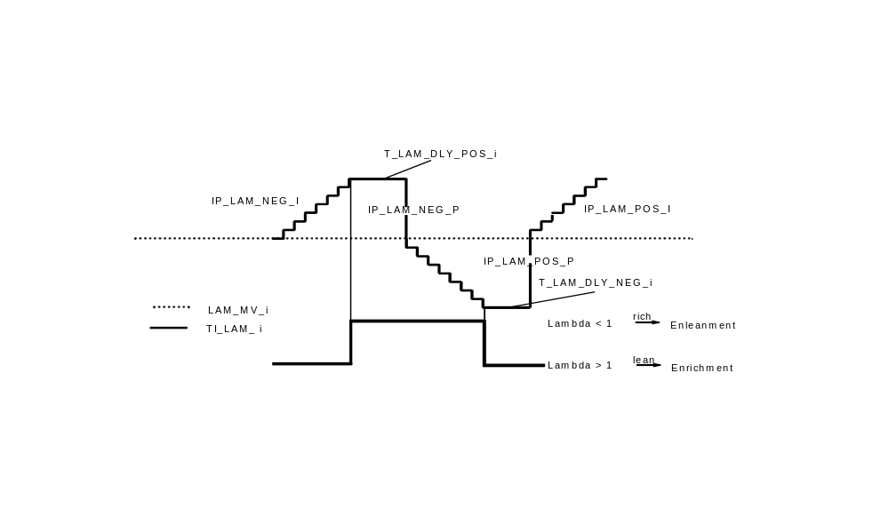
Application conditions:
Activation:
A/F regulation loop closed ( LV_LSCL_i = 1 (ON) )
Deactivation:
A/F regulation loop opened ( LV_LSCL_i = 0 (OFF) )
Formula section:
- Initialisation :

From engine stopped (LV_ES) to start (LV_ST) or during system reset, the lambda controller TI_LAM_i is set to 0.

- In idle (LV_IS) :

P component for transition from lambda > 1 (Lean) ----> lambda < 1 (Rich) :
TI_LAM_i_{n} = TI_LAM_i_{n-1} - C_LAM_NEG_P_IS * C_LAM_FAC_P

P-jump delay time for transition from lambda > 1 (Lean) ----> lambda < 1 (Rich) :
If T_LAM_DLY_NEG_i > 0
then T_LAM_DLY_POS_i = C_T_LAM_DLY_POS_IS
else T_LAM_DLY_POS_i = C_T_LAM_DLY_POS_IS -
C_T_LAM_DLY_NEG_IS + T_DLY_PUC_i + T_LAM_DLY_i
I component for lambda < 1 (Rich) :
TI_LAM_i_{n} = TI_LAM_i_{n-1} - C_LAM_NEG_I_IS * C_LAM_FAC_I_i
Exception:
If LV_SLOP_CP = 1 (Canister purge in Ramp-mode)
then TI_LAM_i_{n} = TI_LAM_i_{n-1} - IP_LAM_NEG_I__N__MAF * C_LAM_FAC_I_i

P component for transition from lambda < 1 (Rich) ----> lambda > 1 (Lean) :
TI_LAM_i_{n} = TI_LAM_i_{n-1} + C_LAM_POS_P_IS * C_LAM_FAC_P

P-jump delay time for transition from lambda < 1 (Rich) ----> lambda > 1 (Lean) :
T_LAM_DLY_NEG_i = C_T_LAM_DLY_NEG_IS - T_DLY_PUC_i - T_LAM_DLY_i
T_LAM_DLY_NEG_i minimum limit is 0.

I component for lambda > 1 (Lean) :
TI_LAM_i_{n} = TI_LAM_i_{n-1} + C_LAM_POS_I_IS * C_LAM_FAC_I_i
Exception:
If LV_SLOP_CP = 1 (Canister purge in Ramp-mode)
then TI_LAM_i_{n} = TI_LAM_i_{n-1} - IP_LAM_POS_I__N__MAF * C_LAM_FAC_I_i

- Out of idle :

P component for transition from lambda > 1 (Lean) ----> lambda < 1 (Rich) :
TI_LAM_i_{n} = TI_LAM_i_{n-1} - IP_LAM_NEG_P__N__MAF * C_LAM_FAC_P

P-jump delay time for transition from lambda > 1 (Lean) ----> lambda < 1 (Rich) :
If T_LAM_DLY_NEG_i > 0
then T_LAM_DLY_POS_i = IP_T_LAM_DLY_POS__N__MAF
else T_LAM_DLY_POS_i = IP_T_LAM_DLY_POS__N__MAF -
IP_T_LAM_DLY_NEG__N__MAF + T_DLY_PUC_i + T_LAM_DLY_i

I component for lambda < 1 (Rich) :
TI_LAM_i_{n} = TI_LAM_i_{n-1} - IP_LAM_NEG_I__N__MAF * C_LAM_FAC_I_i

P component for transition from lambda < 1 (Rich) ----> lambda > 1 (Lean) :
TI_LAM_i_{n} = TI_LAM_i_{n-1} + IP_LAM_POS_P__N__MAF * C_LAM_FAC_P

P-jump delay time for transition from lambda < 1 (Rich) ----> lambda > 1 (Lean) :
T_LAM_DLY_NEG_i = IP_T_LAM_DLY_NEG__N__MAF - T_DLY_PUC_i - T_LAM_DLY_i

T_LAM_DLY_NEG_i minimum limit is 0.

I component for lambda > 1 (Lean) :
TI_LAM_i_{n} = TI_LAM_i_{n-1} + IP_LAM_POS_I__N__MAF * C_LAM_FAC_I_i

Remark :
The interpolated table IP_LAM_xx_yy__N__MAF have common list of data points.

Calibration data:
Name | Dim | Hex. limits | Phys. limits | Resol. | Unit
IP_LAM_POS_P__N__MAF | 8 * 8 | 0...7FH | 0...0.49609 | 1 / 256 | -
Basic value of TI_LAM proportional component out of idle during transition lambda < 1 (Rich) --> lambda > 1 (Lean).
IP_LAM_NEG_P__N__MAF | 8 * 8 | 0...7FH | 0...0.49609 | 1 / 256 | -
Basic value of TI_LAM proportional component out of idle during transition lambda > 1 (Lean) --> lambda < 1 (Rich).
IP_LAM_POS_I__N__MAF | 8 * 8 | 0...7FH | 0...0.49609 | 1 / 256 | -
Basic value of TI_LAM integral component out of idle when lambda > 1 (Lean).
IP_LAM_NEG_I__N__MAF | 8 * 8 | 0...7FH | 0...0.49609 | 1 / 256 | -
Basic value of TI_LAM integral component out idle when lambda < 1 (Rich).
C_LAM_FAC_P | 1 | 00...FFH | 0...0.997 | 3.895E-3 | -
Scale factor for TI_LAM proportional component.
C_LAM_FAC_I_1 | 1 | 00...FFH | 0...0.997 | 3.895E-3 | -
Scale factor for TI_LAM integral component for bank n° 1
C_LAM_FAC_I_2 | 1 | 00...FFH | 0...0.997 | 3.895E-3 | -
Scale factor for TI_LAM integral component for bank n° 2
C_LAM_POS_P_IS | 1 | 0...7FH | 0...0.49609 | 1 / 256 | -
Basic value of TI_LAM proportional component in idle during transition lambda < 1 (Rich) --> lambda > 1 (Lean).
C_LAM_NEG_P_IS | 1 | 0...7FH | 0...0.49609 | 1 / 256 | -
Basic value of TI_LAM proportional component in idle during transition lambda > 1 (Lean) --> lambda < 1 (Rich).
C_LAM_POS_I_IS | 1 | 0...7FH | 0...0.49609 | 1 / 256 | -
Basic value of TI_LAM integral component in idle when lambda > 1 (Lean).
C_LAM_NEG_I_IS | 1 | 0...7FH | 0...0.49609 | 1 / 256 | -
Basic value of TI_LAM integral component in idle when lambda < 1 (Rich).
C_LAM_ SUM_P_IS | 1 | 0...FFH | 0...255 | 1 | -
Lambda controller P jump delay to have idle P/I values.
IP_T_LAM_DLY_POS__N__MAF | 8*8 | 0...3FFFH | 0...1279.9 | 0.078 | ms
Basic LAM-p-jump delay for transition from lean to rich
IP_T_LAM_DLY_NEG__N__MAF | 8*8 | 0...3FFFH | 0...1279.9 | 0.078 | ms
Basic LAM-p-jump delay for transition from rich to lean
C_T_LAM_DLY_POS_IS | 1 | 0...3FFFH | 0...1279.9 | 0.078 | ms
Basic LAM-p-jump delay for transition from lean to rich in idle
C_T_LAM_DLY_NEG_IS | 1 | 0...3FFFH | 0...1279.9 | 0.078 | ms
Basic LAM-p-jump delay for transition from rich to lean in idle

Lambda controller limits
Output data:
Name | Mode | Hex. limits | Phys. limits | Resol. | Unit
TI_LAM_MAX_1 | - | 0...FFH | -50...49.609 | 0.3891 | %
Upper lambda controller limit for bank 1
TI_LAM_MAX_2 | - | 0...FFH | -50...49.609 | 0.3891 | %
Upper lambda controller limit for bank 2
TI_LAM_MIN_1 | - | 0...FFH | -50...49.609 | 0.3891 | %
Lower lambda controller limit for bank 1
TI_LAM_MIN_2 | - | 0...FFH | -50...49.609 | 0.3891 | %
Lower lambda controller limit for bank 2
Input data:
TI_AD_FAC_MMV_1 | TI_AD_FAC_MMV_2 | LV_LEARN_CP | CPPWM
FUNCTION DESCRIPTION:
General information:
The limits for the lambda controller are C_LAM_MAX and C_LAM_MIN.
If the lambda adaptation value TI_AD_FAC_MMV_i ≠ 0, these limits are changed.

Formula section:
TI_AD_FAC_MMV_i > 0 :

- TI_LAM_MIN_i = C_LAM_MIN
- TI_LAM_MAX_i :
If LV_LEARN_CP = 1
(LEARNING mode from evaporative emission control in process (CPPWM ≠ 0)
then TI_LAM_MAX_i = C_LAM_MAX
else
If TI_AD_FAC_MMV_i < C_LAM_MAX
then TI_LAM_MAX_i = C_LAM_MAX - TI_AD_FAC_MMV_i
else TI_LAM_MAX_i = 0

TI_AD_FAC_MMV_i < 0 :

- TI_LAM_MAX_i = C_LAM_MAX
- TI_LAM_MIN_i :
If LV_LEARN_CP = 1
(LEARNING mode from evaporative emission control in process (CPPWM ≠ 0)
then TI_LAM_MIN_i = C_LAM_MIN
else
If C_LAM_MIN < TI_AD_FAC_MMV_i
then TI_LAM_MIN_i = C_LAM_MIN - TI_AD_FAC_MMV_i
else TI_LAM_MIN_i = 0

Calibration data:
Name | Dim | Hex. limits | Phys. limits | Resol. | Unit
C_LAM_MIN | 1 | 3000...8000H | -31.25...0 | 100 / 65536 | %
Minimum TI_LAM value.
C_LAM_MAX | 1 | 8000...D000H | 0...31.25 | 100 / 65536 | %
Maximum TI_LAM value.

LAM_i and LAM_MV_i calculation
Output data:
Name | Mode | Hex. limits | Phys. limits | Resol. | Unit
LAM_1 | - | 0...FFH | -50...49.609 | 100 / 256 | %
TI_LAM value after a P jump for bank n° 1
LAM_2 | - | 0...FFH | -50...49.609 | 100 / 256 | %
TI_LAM value after a P jump for bank n° 2
LAM_MV_1 | V | 0...FFH | -50...49.609 | 100 / 256 | %
TI_LAM average value for bank n° 1
LAM_MV_2 | V | 0...FFH | -50...49.609 | 100 / 256 | %
TI_LAM average value for bank n° 2
Input data:
TI_LAM_1 | TI_LAM_2 | LV_AFR_1 | LV_AFR_2
FUNCTION DESCRIPTION:
General information:
Various functions, e.g. lambda adaptation and control of the evaporative emissions control system, require the lambda controller mean value LAM_MV_i.
LAM_i (used for LAM_MV_ calculation) is the TI_LAM_i value after each P jump of the lambda controller.
- Application recurrence : P Jump
Description:
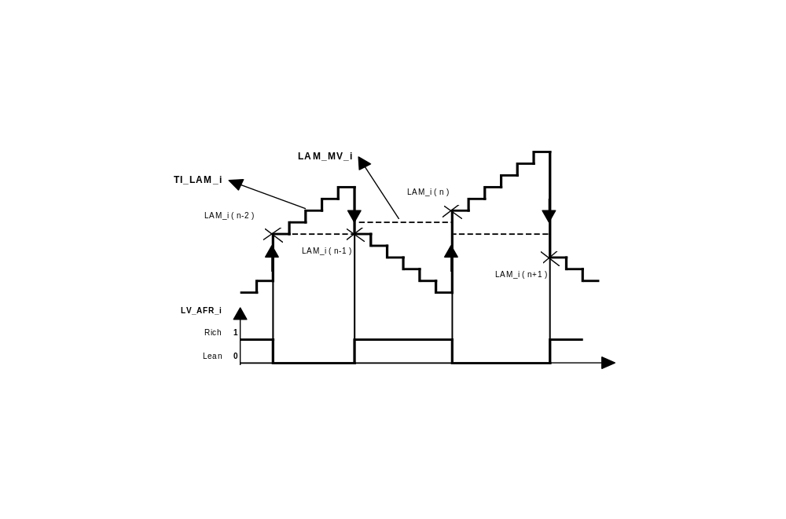

Formula section:
LAM_MV_i_{n} = ( LAM_i_{n-1} + LAM_i_{n} ) / 2

Conditions for limited dynamics
Output data:
Name | Mode | Hex. limits | Phys. limits | Resol. | Unit
MAF_MV_1 | V | 0...FFH | 0...1389 | 5.45 | mg/TDC
MAF average value for bank n° 1
MAF_MV_2 | V | 0...FFH | 0...1389 | 5.45 | mg/TDC
MAF average value for bank n° 2
N_MV_1 | V | 0...FFH | 0...8160 | 32 | rpm
N average value for bank n° 1
N_MV_2 | V | 0...FFH | 0...8160 | 32 | rpm
N average value for bank n° 2
LAM_MV_DYW_1 | V | 00...FFH | -50...49.609 | 0.3891 | %
LAM_MV average value for bank n° 1
LAM_MV_DYW_2 | V | 00...FFH | -50...49.609 | 0.3891 | %
LAM_MV average value for bank n° 2
LV_N_MAF_DYW_1 | V | 0...01H | 0...1 | 1 | -
Boolean for limited dynamics N, MAF for bank n° 1 - ( Passive / Active ).
LV_N_MAF_DYW_2 | V | 0...01H | 0...1 | 1 | -
Boolean for limited dynamics N, MAF for bank n° 2 - ( Passive / Active ).
LV_LAM_DYW_1 | V | 0...01H | 0...1 | 1 | -
Boolean for limited dynamics LAM for bank n° 1 - ( Passive / Active ).
LV_LAM_DYW_2 | V | 0...01H | 0...1 | 1 | -
Boolean for limited dynamics LAM for bank n° 2 - ( Passive / Active ).
Input data:
MAF | N | LAM_MV_1 | LAM_MV_2
LV_LEARN_CP
FUNCTION DESCRIPTION:
General information:
Limited dynamics conditions for a variable exist if the current value stays around its mean value within a tolerance window. This check is made each P jump of the lambda controller.

Variables checked :
MAF
N
LAM_MV_i

Mean variables :
MAF_MV_i
N_MV_i
LAM_MV_DYW_i
Formula section:
- Limited dynamics conditions for engine operating point ( N, MAF ) :
If ⏐ MAF - MAF_MV_i ⏐ < C_MAF_DYW
and ⏐ N - N_MV_i ⏐ < C_N_DYW
then LV_N_MAF_DYW_i = 1 (Active)
else LV_N_MAF_DYW_i = 0 (Passive)
and MAF_MV_i = MAF
and N_MV_i = N
and LAM_MV_DYW_i = LAM_MV_i
Endif.

- Limited dynamics conditions for lambda controller ( LAM_MV_i ) :
If ⏐ LAM_MV_i - LAM_MV_DYW_i ⏐ < C_LAM_MV_DYW
and LV_LEARN_CP = 0
(LEARNING mode from evaporative emission control over)
then LV_LAM_DYW_i = 1 (Active)
else LV_LAM_DYW_i= 0 (Passive)
and LAM_MV_DYW_i = LAM_MV_i
and MAF_MV_i = MAF
and N_MV_i = N
Endif.

Calibration data:
Name | Dim | Hex. limits | Phys. limits | Resol. | Unit
C_MAF_DYW | 1 | 0...FFH | 0...1389 | 5.45 | mg/TDC
MAF window for limited dynamics.
C_N_DYW | 1 | 0...1FE0H | 0...8160 | 1 | rpm
N window for limited dynamics.
C_LAM_MV_DYW | 1 | 00...FFH | 0...99.609 | 0.3891 | %
LAM_MV window for limited dynamics.

Lambda adaptation ( TI_AD_ADD_MMV_COR_i, TI_AD_FAC_MMV_COR_i )
Output data:
Name | Mode | Hex. limits | Phys. limits | Resol. | Unit
TI_AD_ADD_MMV_i | V/S | 8000...7FFFH | -131.07...131.06 | 4 µsec | msec
Additive adaptative factor for bank n° i
TI_AD_FAC_MMV_i | V/S | 00...FFFFH | -50...49.998 | 1.526E-3 | %
Multiplicative adaptative factor for bank n° i
TI_AD_ADD_MMV_REL_i | V | 8000...7FFFH | -50...49.998 | 1.526E-3 | msec
Relative additive adaptative factor for bank n° i
TI_AD_ADD_MMV_COR_i | V | 8000...7FFFH | -131.07...131.06 | 4 µsec | msec
Additive adaptative factor for bank n° i weighted by coolant temperature during warm-up.
TI_AD_FAC_MMV_COR_i | V | 00...FFFFH | -50...49.998 | 1.526E-3 | %
Multiplicative adaptative factor for bank n° i weighted by coolant temperature during warm-up
LV_TI_AD_ACT_i | V | 0...01H | 0...1 | 1 | -
Boolean for TI adaptation activation for bank n° i ( Passive / Active ).
TI_AD_ACT_i | V | 0...04H | 0...4 | 1 | -
Information for TI adaptation calculation type for bank n° i - ( 0 : Passive, 1 : ADD_ACT, 3 : FAC_ACT )
Input data:
TCO | TIA | N | MAF
TI_LAM_i | TIB | CPPWM | MAF_KGH
LAM_MV_i | LAM_MV_DYW_i | LV_LSCL_i | C_FAC_MIN_P_CP
LV_PL | LV_IS | LV_AUTH_LAM_AD_CP | LV_STB_PHA_CP
LV_LAM_DYW_i | LV_N_MAF_DYW_i | LV_AUTH_LAM_i_AD_LEARN_CP | LV_LAM_LIM_i_ERR
LV_TPS_ERR | LV_TPS_PLAUS_ERR | LV_MAF_ERR | LV_MAF_PLAUS_ERR
LV_ISA_i_ERR | LV_ISA_MECHA_ERR | LV_CAM_ERR | LV_TIA_ERR
LV_SAV_ERR | LV_SAV_MECHA_ERR | LV_TCO_ERR | LV_TCO_PLAUS_ERR
LV_CPS_ERR | LV_CPS_MECHA_ERR | LV_VLS_LIM_ERR | LV_FSD_ERR
FUNCTION DESCRIPTION:
General information:
In order to compensate serial production tolerances of components, adaptative corrections (additive and multiplicative) are calculated, versus the TI_LAM_i values.
They must be centered to 0 dec. (80H).

- Application recurrence : 20 msec.

Application conditions ( LV_TI_AD_ACT_i )

If TCO > C_TI_TCO_AD_MIN
and TIA < C_TI_TIA_AD_MAX
and MAF_KGH < C_TI_MAF_AD_MAX
and LV_LSCL_i = 1 (A/F regulation loop closed)
and LV_LAM_LIM_i_ERR = 0 (no error currently present on Lambda controller)
and LV_TPS_ERR = 0 (no error currently present on throttle position sensor)
and LV_TPS_PLAUS_ERR = 0
(no plausibility error currently present on throttle position sensor)
and LV_MAF_ERR = 0
(no error currently present on mass air flow sensor)
and LV_MAF_PLAUS_ERR = 0
(no plausibility error currently present on mass air flow sensor)
and LV_ISA_i_ERR = 0
(no error currently present on idle charge actuator command signal)
and LV_ISA_MECHA_ERR = 0
(no mechanical error currently present on idle speed actuator)
and LV_CAM_ERR = 0
(no error currently present on camshaft sensor)
and LV_TIA_ERR = 0
(no error currently present on air temperature sensor)
and LV_TCO_ERR = 0
(no error currently present on coolant temperature sensor)
and LV_TCO_PLAUS_ERR = 0
(no plausibility error currently present on coolant temperature sensor)
and LV_VLS_LIM_ERR = 0
(no error currently present on O2-sensor voltage excursion)
and LV_FSD_ERR = 0
(no error currently present on fuel system)
and LV_CPS_ERR = 0
(no error currently present on canister purge solenoid)
and LV_CPS_MECHA_ERR = 0
(no mechanical error currently present on canister purge solenoid)
and LV_SAV_ERR = 0
(no error currently present on secondary air valve power stage)
and LV_SAV_MECHA_ERR = 0 (Passive)
(diagnosis inactive for mechanical error detection on secondary air valve)
and LV_LAM_DYW_i = 1 (Active)
(steady state defined by limited dynamics conditions for lambda controller)
and LV_AUTH_LAM_AD_CP = 1 (Active)
(lambda adaptation authorized by evaporative emissions control process)
or LV_AUTH_LAM_i_AD_LEARN_CP = 1 (Active)
(lambda adaptation authorized by evaporative emissions control process)
and LV_AUTH_LAM_i_AD_LEARN_CP = 1 (Active)
(lambda adaptation authorized by evaporative emissions control process)
or LV_N_MAF_DYW_i = 1 (Active)
(steady state defined by limited dynamics cond. for engine op. point)
then LV_TI_AD_ACT_i = 1 (Active)
else LV_TI_AD_ACT_i = 0 (Passive)

Learning area ( TI_AD_ACT_i )

If LV_TI_AD_ACT_i = 1 (Active)
(application conditions for lambda adaptation are fulfilled)
then
If N< C_TI_N_AD_ADD_MAX(_AT)
and MAF< C_TI_MAF_AD_ADD_MAX(_AT)
then TI_AD_ACT_i = 1 (= ADD_ACT)
(additive adaptation correction calculation for injection time authorized)
else
If N > C_TI_N_AD_FAC_MIN(_AT)
and MAF > C_TI_MAF_AD_FAC_MIN(_AT)
then TI_AD_ACT_i = 3 (= FAC_ACT)
(multiplicative adaptation correction calculation for injection time authorized)
else TI_AD_ACT_i = 0 (Passive)

Description:
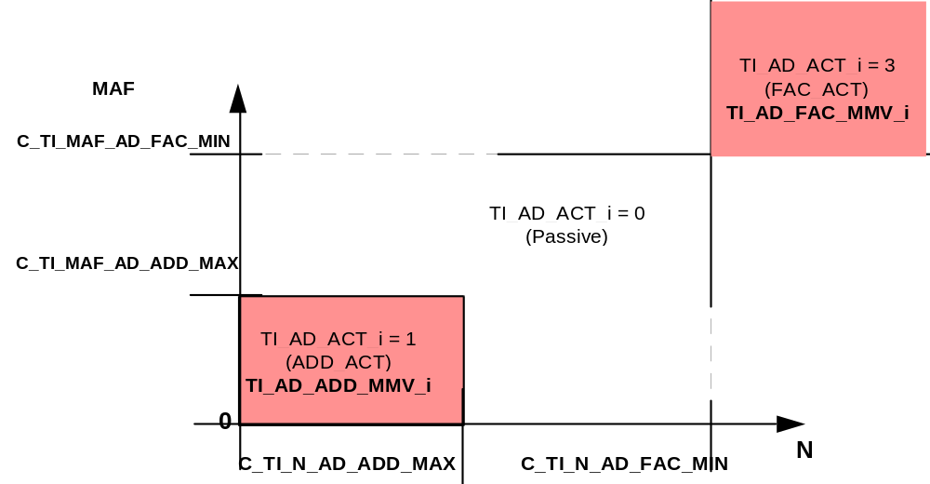

Lambda adaptation calculation period
Once the activation conditions are active ( LV_TI_AD_ACT_i = 1 (Active) ), the adaptation calculation takes place when a number of P - Jumps are performed by the lambda controller:

- in idle (LV_IS = 1) : C_LAM_AD_SUM_P_IS
- out of idle : C_LAM_AD_SUM_P

Another adaptation calculation occurs when the number of P - Jumps is reached.
When the activation conditions are exited ( LV_TI_AD_ACT_i = 0 (Passive) ), the current number of P - Jumps is reset.

Remark :
If LV_AUTH_LAM_i_AD_LEARN_CP = 1 (Active) (lambda adaptation authorized by evaporative emissions control process during LEARNING mode with CPPWM = 0) and the number of P - Jumps from lambda controller is more than C_FAC_MIN_P_CP, then the adaptation calculation is performed.

Correlation factor for lambda adaptation calculation
- Canister purge in Stand-by-mode: Lambda adaptation possible, correlation factor is:
C_TI_AD_COR_CRLC_XX = C_TI_AD_COR_CRLC_IS if LV_IS = 1
C_TI_AD_COR_CRLC_XX = C_TI_AD_COR_CRLC if LV_IS = 0

- Canister purge in Min-mode: Lambda adaptation possible if CPPWM = 0, correlation factor is:
C_TI_AD_COR_CRLC_XX = C_TI_AD_COR_CRLC_IS if LV_IS = 1
C_TI_AD_COR_CRLC_XX = C_TI_AD_COR_CRLC if LV_IS = 0

- Canister purge in Normal-mode: Lambda adaptation possible, correlation factor is:
C_TI_AD_COR_CRLC_XX = C_TI_AD_COR_CRLC_CP

- Canister purge in Ramp-mode: Lambda adaptation is not possible, Exception: with LAM_MV_BEG determination at FAC_CP = 0; weighting factor is
C_TI_AD_COR_CRLC_XX = C_TI_AD_COR_CRLC_LD

Lambda adaptation calculation ( TI_AD_ADD_MMV_i, TI_AD_FAC_MMV_i )

If LV_TI_AD_ACT_i = 1
(application conditions for lambda adaptation are fulfilled)
and TI_AD_ACT_i = 1 (ADD_ACT)
(additive adaptation correction calculation for injection time authorized)
then

TI_AD_ADD_MMV_i_{n} = TI_AD_ADD_MMV_i_{n-1}
+ [ C_TI_AD_COR_CRLC_xx * LAM_MV_DYW_i * TIB * N / C_TI_N_AD_ADD_MAX(_AT) ]

and

TI_AD_ADD_MMV_REL_i_{n}= [ TI_AD_ADD_MMV_i_{n} * C_TI_N_AD_ADD_MAX(_AT) / N ] / TIB

and
K = [ TI_AD_ADD_MMV_REL_i_{n} - TI_AD_ADD_MMV_REL_i_{n-1} ]
TI_LAM_i_{n} = TI_LAM_i_{n-1} - K
LAM_MV_i_{n} = LAM_MV_i_{n-1} - K
LAM_MV_DYW_i_{n} = LAM_MV_DYW_i_{n-1} - K
else

If LV_TI_AD_ACT_i = 1
(application conditions for lambda adaptation are fulfilled)
and TI_AD_ACT_i = 3 (FAC_ACT)
(multiplicative adaptation correction calculation for injection time authorized)
then

TI_AD_FAC_MMV_i_{n} = TI_AD_FAC_MMV_i_{n-1} + [ C_TI_AD_COR_CRLC_xx * LAM_MV_DYW_i ]

and
K = [ TI_AD_FAC_MMV_i_{n} - TI_AD_FAC_MMV_i_{n-1} ]
TI_LAM_i_{n} = TI_LAM_i_{n-1} - K
LAM_MV_i_{n} = LAM_MV_i_{n-1} - K
LAM_MV_DYW_i_{n} = LAM_MV_DYW_i_{n-1} - K

Lambda adaptation correction during warm-up
General information:
In order to avoid mixture problems when the engine has not reached its service temperature, the lambda adaptation values (additive and multiplicative) can be decreased versus TCO and their own value (applied when engine runs with its service temperature).
It is performed by weighting the adaptative factors as long as the lambda adaptation is disabled due to the coolant temperature threshold C_TI_TCO_AD_MIN.

Formula section:
If TCO < C_TI_TCO_AD_MIN
then

TI_AD_ADD_MMV_i_{n} = TI_AD_ADD_MMV_i_{n-1} * IP_TI_AD_ADD_FAC__TCO__TI_AD_ADD_MMV
and
TI_AD_FAC_MMV_i_{n} = TI_AD_FAC_MMV_i_{n-1} * IP_TI_AD_FAC_FAC__TCO__TI_AD_FAC_MMV

Endif.

If TCO ≥ C_TI_TCO_AD_MIN
then

TI_AD_ADD_MMV_COR_i_{n} = TI_AD_ADD_MMV_i_{n} * C_TI_N_AD_ADD_MAX(_AT) / N
and
TI_AD_FAC_MMV_COR_i_{n} = TI_AD_FAC_MMV_i_{n}

else

TI_AD_ADD_MMV_COR_i_{n} = TI_AD_ADD_MMV_i_{n} * C_TI_N_AD_ADD_MAX(_AT) / N
* IP_TI_AD_ADD_FAC__TCO__TI_AD_ADD_MMV
and
TI_AD_FAC_MMV_COR_i_{n} = TI_AD_FAC_MMV_i_{n} * IP_TI_AD_FAC_FAC__TCO__TI_AD_FAC_MMV

Endif.

Lambda adaptation limitation
General information:
In order to avoid big injection time deviation and to detect system failure, the lambda adaptation values are limited. The limitation takes place following calculation of the lambda adaptation values.

C_TI_AD_ADD_MIN ≤ TI_AD_ADD_MMV_COR_i ≤ C_TI_AD_ADD_MAX

C_TI_AD_FAC_MIN ≤ TI_AD_FAC_MMV_COR_i ≤ C_TI_AD_FAC_MAX

Calibration data:
Name | Dim | Hex. limits | Phys. limits | Resol. | Unit
C_TI_TCO_AD_MIN | 1 | 0...FEH | -48...142.5 | 0.75 | °C
Minimum coolant temperature for adaptative learning.
C_TI_TIA_AD_MAX | 1 | 0...FEH | -48...142.5 | 0.75 | °C
Maximum air temperature for adaptive learning
C_TI_MAF_AD_MAX | 1 | 0...FFFFH | 0...16383.75 | 0.25 | kg/h
Maximum MAF for adaptative learning.
C_TI_N_AD_ADD_MAX(_AT) | 1 | 01...1FE0H | 1...8160 | 1 | rpm
Maximum engine speed for additive adaptative learning.
C_TI_MAF_AD_ADD_MAX(_AT) | 1 | 0...FFH | 0...1389 | 5.447 | mg/TDC
Maximum MAF for additive adaptative learning.
C_TI_N_AD_FAC_MIN(_AT) | 1 | 01...1FE0H | 1...8160 | 1 | rpm
Minimum engine speed for multiplicative adaptative learning.
C_TI_MAF_AD_FAC_MIN(_AT) | 1 | 0...FFH | 0...1389 | 5.447 | mg/TDC
Minimum MAF for multiplicative adaptative learning.
C_LAM_AD_SUM_P_IS | 1 | 01...FFH | 1...255 | 1 | -
P component jump delay between two adaptative learning in idle.
C_LAM_AD_SUM_P | 1 | 0...FFH | 0...255 | 1 | -
P component jump delay between two adaptative learning out of idle.
C_TI_AD_COR_CRLC | 1 | 00...FFH | 0...0.997 | 3.895E-3 | -
Correlation factor for adaptative learning out of idle with LV_AUTH_LAM_AD_CP = 1 or LV_AUTH_LAM_i_AD_LEARN_CP = 0.
C_TI_AD_COR_CRLC_IS | 1 | 00...FFH | 0...0.997 | 3.895E-3 | -
Correlation factor for adaptative learning in idle with LV_AUTH_LAM_AD_CP = 1 or LV_AUTH_LAM_i_AD_LEARN_CP = 0.
C_TI_AD_COR_CRLC_CP | 1 | 00...FFH | 0...0.997 | 3.895E-3 | -
Correlation factor for adaptative learning in NORMAL operation of evaporative emissions control.
C_TI_AD_COR_CRLC_LD | 1 | 00...FFH | 0...0.997 | 3.895E-3 | -
Correlation factor for adaptative learning with LV_AUTH_LAM_i_AD_LEARN_CP = 0.
IP_TI_AD_ADD_FAC__TCO__TI_AD_ADD_MMV | 5 x 5 | 00...FFH | 0...0.997 | 3.895E-3 | -
Multiplicative factor on additive adaptative learning during warm-up.
IP_TI_AD_FAC_FAC__TCO__TI_AD_FAC_MMV | 5 x 5 | 00...FFH | 0...0.997 | 3.895E-3 | -
Multiplicative factor on multiplicative adaptative learning during warm-up.
C_TI_AD_FAC_MIN | 1 | 3000...8000H | -31.25...0 | 100 / 65536 | %
Minimum value of lambda adaptation multiplicative factor.
C_TI_AD_FAC_MAX | 1 | 8000...D000H | 0...31.25 | 100 / 65536 | %
Maximum value of lambda adaptation multiplicative factor.
C_TI_AD_ADD_MIN | 1 | 7B1E...8000H | -5...0 | 4 µsec | msec
Minimum value of lambda adaptation additive factor.
C_TI_AD_ADD_MAX | 1 | 8000...84E2H | 0...+5 | 4 µsec | msec
Maximum value of lambda adaptation additive factor.

Downstream fuel trim regulation by LAM - P - Jump delay time
Output data:
Name | Mode | Hex. limits | Phys. limits | Resol. | Unit
VLS_DIF_DLY_i | V | 80...7FH | -2,5...2,48 | 0,0196 | V
difference between setpoint and actual downstream LS signal
T_DLY_P_i | V | 0000...FFFFH | 0...1279,98 | 0,0195 | ms
LAM -P-jump delay time from P-share
T_DLY_I_i | V | 0000...FFFFH | 0...1279,98 | 0,0195 | ms
LAM -P-jump delay time from I-share
T_DLY_AD_i | V/S | 0000...FFFFH | 0...1279,98 | 0,0195 | ms
LAM -P-jump delay time from AD-share
T_LAM_DLY_i | V | 0000...FFFFH | 0...1279,98 | 0,0195 | ms
LAM -P-jump delay time from downstream trim controller
FAC_CAT_DLY_i | V | 0...FFH | 0 ...0,996 | 3,9e-3 | -
weight factor for P-share regarding catalyst conversion capability
MAF_INT_DLY_i | V | 0...FFFFH | 0...11650,66 | 0,178 | g
integral of air mass flow since LAM activation
LV_LAM_DLY_i | V | 0...01H | 0...1 | 1 | -
Status for downstream fuel trim regulation activation
LV_T_DLY_AD_i | V | 0...01H | 0...1 | 1 | -
Status for downstream fuel trim adaptative term calculation
Input data:
VLS_CAT_i | CAT_DIAG_TRIM_i | N_32 | MAF
TEMP_MMV_SUB_CAT | TI_LAM_i | TI_AD_FAC_MMV_i | TI_AD_ADD_MMV_REL_i
TI_LAM_MIN_i | TI_LAM_MAX_i | LV_LDC_CAT_i | LV_LSCL_i
MAF_KGH | LV_VLS_DOWN_i_ERR | LV_ACT_INT_PUC_i | LV_LSH_DOWN_HP_i_ERR
LV_MAF_ERR | LV_MAF_PLAUS_ERR | LV_TPS_ERR | LV_TPS_PLAUS_ERR
LV_CRK_ERR | LV_CAM_ERR | LV_SAV_ERR | LV_SAV_MECHA_ERR
LV_SAS_ERR | LV_TCO_ERR | LV_CPS_ERR | LV_CPS_MECHA_ERR
LV_LSH_UP_i_ERR | LV_LSH_DOWN_i_ERR | LV_VLS_UP_i_ERR | LV_FSD_i_ERR
LV_VLS_FREQ_i_ERR | LV_VLS_SLOP_i_ERR | LV_VLS_LIM_i_ERR | LV_VLS_DOWN_LIM_i_ERR
LV_LAM_STOP | LV_MIS_[CYL]_ERR
FUNCTION DESCRIPTION:
General information:
Downstream fuel trim regulation target is to keep a constant dynamic lambda during all the life of the vehicle.

According to downstream O2 sensor voltage, a P-jump time delay is applied on the lambda regulation. This time delay contains three parts:

- integral part: T_DLY_I_i
- proportional part: T_DLY_P_i
- adaptative part: T_DLY_AD_i

The downstream O2 sensor voltage represents the target dynamic lambda. Any deviation from this target, is entered in the P-I-AD regulation.

If two separate catalyst systems are concerned then :
i = 1, for cylinder bank 1
i = 2, for cylinder bank 2

Application recurrency: 20ms

Application conditions:
Activation: (LV_LAM_DLY_i = 1)
1) No relevant diagnosis entry:
LV_MAF_ERR = 0 and LV_MAF_PLAUS_ERR = 0
and LV_TPS_ERR = 0 and LV_TPS_PLAUS_ERR = 0
and LV_CRK_ERR = 0 and LV_CAM_ERR = 0 and LV_SAV_ERR = 0 and LV_SAV_MECHA_ERR = 0 and LV_SAS_ERR = 0 and LV_TCO_ERR = 0 and LV_CPS_ERR = 0 and LV_CPS_MECHA_ERR = 0
and LV_LSH_UP_i_ERR = 0 and LV_LSH_DOWN_i_ERR = 0
and LV_LSH_DOWN_HP_i_ERR = 0
and LV_VLS_UP_i_ERR = 0 and LV_VLS_DOWN_i_ERR = 0
and LV_VLS_LIM_i_ERR = 0 and LV_VLS_DOWN_LIM_i_ERR = 0
and LV_VLS_FREQ_i_ERR = 0 and LV_VLS_SLOP_i_ERR = 0
and LV_LAM_STOP = 0 and LV_MIS_[CYL]_ERR = 0
and LV_FSD_i_ERR = 0

2) TEMP_MMV_SUB_CAT > C_LAM_TEMP_MIN_CAT_DLY
(Catalyst is working) (Hysteresis C_LAM_TEMP_HYS_CAT_DLY is applied when the function is started)
3) and TI_LAM_MIN_i < TI_LAM_i + TI_AD_FAC_MMV_i + TI_AD_ADD_MMV_REL_i < TI_LAM_MAX_i
(LAM-current value is not limited)
4) and CAT_DIAG_TRIM_i < C_CAT_DIAG_MAX_DLY
(this condition is considered only if CAT_DIAG_TRIM_i < 256)
and CAT_DIAG_i < C_CAT_DIAG_MAX_DLY
(Catalyst efficiency is in the valid area)
5) and LV_LDC_CAT_i = 1 (Limited dynamic is fulfilled)
6) and LV_LSCL_i = 1 (Lambda regulation active)
7) and After each activation of the Lambda regulation :
MAF_INT_DLY_i > C_MAF_INT_MIN_DLY if LV_ACT_INT_PUC_i = 0
MAF_INT_DLY_i > C_MAF_INT_MIN_DLY_PUC if LV_ACT_INT_PUC_i = 1
MAF_INT_DLY_i calculation:
At each transition LV_LSCL_i 0->1, MAF_INT_DLY_i is initialised to 0 and then calculated like this:
MAF_INT_DLY_i_{n} = MAF_INT_DLY_i_{n-1} + MAF_KGH * NC_FAC_MAF_INT

(NC_FAC_MAF_INT = 20ms/3,6)

Deactivation: (LV_LAM_DLY_i = 0)
The function is deactivated if one of the activation condition is not true.
Formula section:

- VLS_DIF_DLY_i calculation :

VLS_DIF_DLY_i = IP_VLS_SP_DLY__N_32__MAF - VLS_CAT_i

- T_DLY_P_i calculation :

The P-share of the controller is calculated only in a specific N/MAF-areas:
C_MAF_LAM_DLY_P_MIN < MAF < C_MAF_LAM_DLY_P_MAX
and C_N_LAM_DLY_P_MIN < N_32 < C_N_LAM_DLY_P_MAX

When this conditions are not fulfilled or LV_LAM_DLY = 0, the corresponding P-share is initialized with 0.

T_DLY_P_i = IP_T_DLY_P__VLS_DLY_i
* IP_FAC_DLY_P__MAF_KGH
* IP_FAC_CAT_DLY__CAT_DIAG_TRIM_i

Remark: IP_FAC_CAT_DLY is constant for the present driving cycle, even if there is a new CAT_DIAG determination.

- T_DLY_I_i calculation :

The I-share of the controller is calculated only in a specific MAF-area:
IP_MAF_LAM_DLY_I_MIN__N_32 < MAF < IP_MAF_LAM_DLY_I_MAX__N_32

When this conditions are not fulfilled or LV_LAM_DLY = 0, the corresponding I-share is initialized with 0.

T_DLY_I_i_{n} = T_DLY_I_i_{n-1}
+ IP_CRLC_DLY_I__MAF_KGH * IP_T_DLY_I__VLS_DIF_DLY_i

T_DLY_I_i is limited with following limits:
C_T_DLY_I_MIN < T_DLY_I_i < C_T_DLY_I_MAX

- T_DLY_AD_i calculation :

The AD-share of the controller is calculated only in a specific MAF-area:
IP_MAF_LAM_DLY_AD_MIN__N_32 < MAF < IP_MAF_LAM_DLY_AD_MAX__N_32

If AD-share calculation is active, then the flag LV_T_DLY_AD_i is set to 1.

T_DLY_AD_i_{n} = T_DLY_AD_i_{n-1} + C_CRLC_DLY_AD * T_DLY_I_i

Additionnaly, T_DLY_AD_i is decreased by C_T_DLY_AD_DEC ms each second if LV_T_DLY_AD_i = 1

T_DLY_AD_i is limited with following limits:
C_T_DLY_AD_MIN < T_DLY_AD_i < C_T_DLY_AD_MAX

At the end of the driving cycle, T_DLY_AD_i is stored in the flash memory. At the beginning of the next driving cycle, T_DLY_AD_i is initialized with this stored value. After ECU reset, T_DLY_AD_i is initialized with 0.

- Global T_LAM_DLY_i calculation :

T_LAM_DLY_i = ( T_DLY_P_i + T_DLY_I_i + T_DLY_AD_i )
* IP_FAC_LAM_DLY__N_32__MAF

Calibration data:
Name | Dim | Hex. limits | Phys. limits | Resol. | Unit
C_LAM_TEMP_MIN_CAT_DLY | - | 0...FEH | -33...990 | 4 | °C
minimum catalyst temperature model threshold for fuel trim regulation function activation
C_LAM_TEMP_HYS_CAT_DLY | - | 0...FEH | -33...990 | 4 | °C
Hysteresis on minimum catalyst temperature model threshold for fuel trim regulation function activation
C_MAF_INT_MIN_DLY_PUC | - | 0...FFFFH | 0...11650,66 | 0,178 | g
threshold for MAF integral while restart of LAM after PUC
C_MAF_INT_MIN_DLY | - | 0...FFFFH | 0...11650,66 | 0,178 | g
threshold for MAF integral while restart of LAM after inactive
C_CAT_DIAG_MAX_DLY | - | 0...FFFFH | 0...255,996 | 3,9e-3 | -
threshold of catalyst conversion capability for activation
IP_VLS_SP_DLY__N_32__MAF | 4 * 4 | 0...3FFH | 0...4,9805 | 4,87e-3 | V
setpoint for downstream fuel trim controller
C_MAF_LAM_DLY_P_MIN | - | 0...FFFFH | 0...1389 | 0,021 | mg/stroke
min MAF threshold for activation P-share
C_MAF_LAM_DLY_P_MAX | - | 0...FFFFH | 0...1389 | 0,021 | mg/stroke
max MAF threshold for activation P-share
C_N_LAM_DLY_P_MIN | - | 0...FFH | 0...8160 | 32 | 1/min
min N threshold for activation P-share
C_N_LAM_DLY_P_MAX | - | 0...FFH | 0...8160 | 32 | 1/min
max N threshold for activation P-share
Calibration data:
Name | Dim | Hex. limits | Phys. limits | Resol. | Unit
IP_T_DLY_P__VLS_DIF_DLY_i | 12 | 0...FFFFH | -640...639,98 | 0,0195 | ms
LAM - P - jump delay time from P-share
IP_FAC_DLY_P__MAF_KGH | 6 | 0...FFH | 0...0,996 | 3,9e-3 | -
weight factor for P-share regarding engine load and speed conditions
IP_FAC_CAT_DLY__CAT_DIAG_TRIM_i | 6 | 0...FFH | 0...0,996 | 3,9e-3 | -
weight factor for P-share regarding catalyst conversion capability
IP_MAF_LAM_DLY_I_MIN__N_32 | 6 | 0...FFFFH | 0...1389 | 0,021 | mg/stroke
min MAF threshold for activation I-share
IP_MAF_LAM_DLY_I_MAX__N_32 | 6 | 0...FFFFH | 0...1389 | 0,021 | mg/stroke
max MAF threshold for activation I-share
IP_T_DLY_I_VLS__DIF_DLY_i | 12 | 0...FFFFH | -640...639,98 | 0,0195 | ms
LAM - P - jump delay time from I-share
IP_CRLC_DLY_I__MAF_KGH | 6 | 0...FFH | 0...0,996 | 3,9e-3 | -
correlation constant for I-share calculation
C_T_DLY_I_MIN | - | 0000...FFFFH | 0...1279,98 | 0,0195 | ms
min. limit of I-share
C_T_DLY_I_MAX | - | 0000...FFFFH | 0...1279,98 | 0,0195 | ms
max. limit of I-share
IP_MAF_LAM_DLY_AD_MIN__N_32 | 6 | 0...FFFFH | 0...1389 | 0,021 | mg/stroke
min MAF threshold for calculation AD-share
IP_MAF_LAM_DLY_AD_MAX__N_32 | 6 | 0...FFFFH | 0...1389 | 0,021 | mg/stroke
max MAF threshold for calculation AD-share
C_T_DLY_AD_DEC | - | 8000...7FFFH | -640...639,98 | 0,0195 | ms
Decrement for AD-share
C_T_DLY_AD_MIN | - | 0000...FFFFH | 0...1279,98 | 0,0195 | ms
min. limit of AD-share
C_T_DLY_AD_MAX | - | 0000...FFFFH | 0...1279,98 | 0,0195 | ms
max. limit of AD-share
C_CRLC_DLY_AD | - | 0...FFH | 0...0,996 | 3,9e-3 | -
correlation constant for AD-share calculation
IP_FAC_LAM_DLY__N_32__MAF | 8*8 | 0...FFH | 0...0,996 | 3,9e-3 | -
normalization factor for total LAM -P-jump delay time regarding engine load and speed conditions

Catalyst enrichment function after PUC phase (CAT - purge function)
Output data:
Name | Mode | Hex. limits | Phys. limits | Resol. | Unit
MAF_INT_PUC_i | V | 0...FFFFH | 0...11650,67 | 0,178 | g
integral of air mass flow while PUC active
MAF_INT_DLY_PUC_i | V | 0...FFFFH | 0...11650,67 | 0,178 | g
rest of the integral of air mass flow until catalyst purge deactivation
T_DLY_PUC_i | V | 0...3FFFH | 0...1279,9 | 0,078 | ms
LAM-P-jump delay time of the catalyst purge function
LV_ACT_INT_PUC_i | V | 0...1H | 0...1 | 1 | -
status of catalyst purge activation
Input data:
TCO | CAT_DIAG_TRIM_i | LV_PUC | VLS_CAT_i
MAF_KGH | LV_LSH_CAT_PHA_MAX_RATE
FUNCTION DESCRIPTION:
General information:
After a fuel cut-off phase (PUC), the catalyst is full with oxygen. The target of this function is to make the lambda regulation a little more rich than normal in order to purge the oxygen contained in the catalyst.

The rich lambda shift is made with a P-jump delay T_DLY_PUC_i.

In order to evaluate the quantity of oxygen contained in the catalyst, air flow during fuel cut-off is integrated by the counter MAF_INT_PUC. The purge phase duration is calculated according to this counter.

If two seperate catalyst systems are concerned then
i = 1, for cylinder bank 1
i = 2, for cylinder bank 2
Application conditions:
Activation: -> LV_ACT_INT_PUC_i = 1
- TCO > C_TCO_DLY_PUC_MIN
- and LV_PUC = 1 -> LV_PUC = 0
- and MAF_INT_PUC_i > C_MAF_INT_PUC_MIN
- and MAF_INT_DLY_PUC_i > 0
- and LV_LSH_CAT_PHA_MAX_RATE = 1
Deactivation: -> LV_ACT_INT_PUC_i = 0

- MAF_INT_DLY_PUC_i = 0
- or VLS_CAT_i < C_VLS_CAT_DLY_MAX_PUC for the first time
- or LV_PUC = 1

Formula section:

- MAF_INT_PUC_i calculation:

If LV_PUC = 1
and MAF_INT_PUC_i < max. value (11650,7g)

Then
MAF_INT_PUC_{n} _i = MAF_INT_PUC_{n-1} _i+ MAF_KGH * NC_FAC_MAF_INT

Remark:
- MAF_INT_PUC is calculated each 20ms
- MAF_INT_PUC is initialized with 0 at each PUC phase detection

- MAF_INT_DLY_PUC_i calculation:

. At each transition LV_PUC = 1 -> LV_PUC = 0, MAF_INT_DLY_PUC_i is initialized with IP_MAF_INT_DLY_PUC__MAF_INT_PUC_i and limited to C_MAF_INT_DLY_PUC_MAX.

. If the catalyst balance function is deactivated by the interruption of the lambda controller
due to another PUC phase the initialisation is:
MAF_INT_DLY_PUC_i _{new} = IP_MAF_INT_DLY_PUC + MAF_INT_DLY_PUC_i _{old}

As long as LV_PUC = 0, MAF_INT_DLY_PUC is decreased to 0:

MAF_INT_DLY_PUC_i_{n} = MAF_INT_DLY_PUC_i_{n-1} - (MAF_KGH * NC_FAC_MAF_INT *
IP_FAC_CAT_DLY_PUC)

If VLS_CAT_i < C_VLS_CAT_DLY_MAX_PUC then MAF_INT_DLY_PUC_i is reseted to 0.

Remark: MAF_INT_DLY_PUC is calculated each 20ms

- T_DLY_PUC_i calculation:

If LV_ACT_INT_PUC = 1
Then
T_DLY_PUC_i = IP_T_DLY_PUC__MAF_KGH
Else
T_DLY_PUC_i = 0

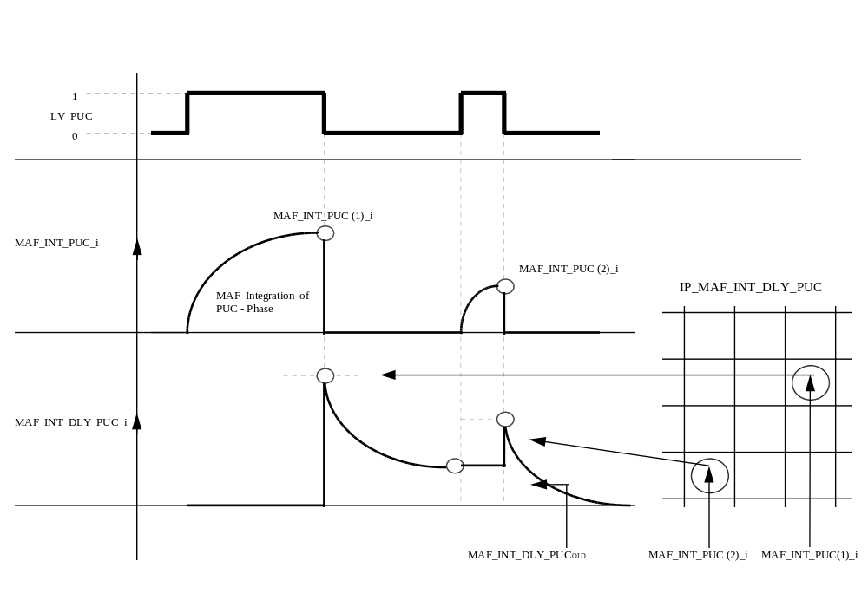
Calibration data:
Name | Dim | Hex. limits | Phys. limits | Resol. | Unit
C_TCO_DLY_PUC_MIN | - | 0...FEH | -48...142,5 | 0,75 | °C
min. TCO threshold for activation
C_MAF_INT_PUC_MIN | - | 0...FFFFH | 0...11650,67 | 0,178 | g
min. MAF_INT_PUC threshold for activation
C_VLS_CAT_DLY_MAX_PUC | - | 0...FFH | 0...4,98 | 0,0195 | V
max. VLS threshold for deactivation
IP_MAF_INT_DLY_PUC__MAF_INT_PUC_i | 6 | 0...FFFFH | 0...11650,67 | 0,178 | g
initialisation value for the rest of the air mass flow for deactivation
C_MAF_INT_DLY_PUC_MAX | - | 0...FFFFH | 0...11650,67 | 0,178 | g
limit value for the rest of the air mass flow for deactivation
IP_T_DLY_PUC__MAF_KGH | 6 | 0...3FFFH | 0...1279,9 | 0,078 | ms
basic LAM-P-jump delay time of the catalyst purge function
IP_FAC_CAT_DLY_PUC__CAT_DIAG_TRIM_i | 6 | 0...FFH | 0...0,996 | 3.9e-3 | -
weight factor of catalyst diagnosis result

NC_FAC_MAF_INT = 20ms/3,6

Oxygen-sensor heater downstream from catalyst
Output data:
Name | Mode | Hex. limits | Phys. limits | Resol. | Unit
LSHPWM_CAT_i | V | 00...FFH | 0...99.609 | 0.3891 | %
Downstream oxygen sensors heating duty cycle
LSHPWM_CAT_LGRD_i | V | 00...FFFFH | 0...99.998 | 1.526E-3 | %
Basic downstream oxygen sensors heating duty cycle with gradient limitation.
LV_LSH_CAT_PHA_MAX_RATE | V | 0...01H | 0...1 | 1 | -
Boolean to indicate if pre-heating and full heating phases for downstream O2 sensors are finished.
Input data:
TEMP_MMV_SUB_CAT | VB | N | MAF
LV_ES | LV_ST | LV_VB_JUMP
FUNCTION DESCRIPTION:
General information:
Downstream O2 senors heating strategy is working like for the upstream but without heater controller.

In order to avoid big temperature gradient after start, heater power is reduced until the catalyst system has reached its service temperature. Then, heating power is maximum during a time delay in order to reach quickly the target tip-temperature.

After this two phases, heating power is normally calculated from a basic map (cylinder bank individual) weighted by a battery voltage correction. A gradient limitation is applied in negative and positive directions.

Application recurrence :
- Engine stopped: 1 sec.
- Engine running: C_T_PER_LSH_CAT sec.

Formula section:

- LSHPWM_CAT_LGRD_i calculation:

The basic heater power is:
IP_LSHPWM_CAT_i__N_32__MAF * IP_LSHPWM_VB_FAC_CAT__VB

The result of this multiplication is the target value for LSHPWM_CAT_LGRD_i.

Like for the upstream O2 sensors, a gradient limitation is applied to LSHPWM_CAT_LGRD_i.

If the target value is lower, C_LSHPWM_LGRD_NEG_CAT is used. Otherwise, if the target value is higher, C_LSHPWM_LGRD_POS_CAT is used.

At transition engine stop (LV_ES) to engine start (LV_ST) LSHPWM_CAT_LGRD_i is initialized with C_LSHPWM_CAT_INI_i :

LSHPWM_CAT_LGRD_i = C_LSHPWM_CAT_INI_i

- Heating phases

O2 sensors heating phases are divided in 4 parts:

- Stand-by phase
- Pre-heating phase
- Full heating phase
- Normal heating phase

This phases are performed in a sequential order.

- Stand-by phase:

If Engine stopped (LV_ES) active or LV_VB_JUMP = 1 (Active)
then
LSHPWM_CAT_i = NC_LSHPWM_MIN_DIAG

- Pre-heating phase:

If a) Engine stopped (LV_ES) not active and LV_VB_JUMP = 0 (Not active) )
b) and TEMP_MMV_SUB_CAT < C_TEMP_MIN_SUB_CAT_ST
then
LSHPWM_CAT_i = LSHPWM_CAT_LGRD_i * C_LSHPWM_T_FAC_CAT + C_LSHPWM_CAT_i_AS
else
“Full-heating” phase is started

- Full-heating phase:

If Pre-heating phase is finished
(TEMP_MMV_SUB_CAT > C_TEMP_MIN_SUB_CAT_ST)
then
LSHPWM_CAT_i = NC_LSHPWM_MAX_DIAG
during C_T_MAX_LSH_CAT_ST seconds

When this Full-heating phase is finished, the flag LV_LSH_CAT_PHA_MAX_RATE is set to 1.

- Normal heating phase:

If Full heating phase is finished
(time C_T_MAX_LSH_CAT_ST elapsed)
then
LSHPWM_CAT_i = LSHPWM_CAT_LGRD_i + C_LSHPWM_CAT_i_AS

Remark: At the end of the full-heating phase, LSHPWM_CAT_LGRD_i is set to NC_LSHPWM_MAX_DIAG and decreased to the target LSHPWM_CAT_i with the specific change limitation C_LSHPWM_LGRD_MAX_CAT

Calibration data:
Name | Dim | Hex. limits | Phys. limits | Resol. | Unit
IP_LSHPWM_CAT_1__N_32__MAF | 6*6 | 0...FFH | 0...99.6 | 0.389 | %
Basic downstream O2 sensor heating Bank n°1
IP_LSHPWM_CAT_2__N_32__MAF | 6*6 | 0...FFH | 0...99.6 | 0.389 | %
Basic downstream O2 sensor heating Bank n°2
IP_LSHPWM_VB_FAC_CAT__VB | 6 | 0...FFH | 0...3.9844 | 0.0156 | -
Battery voltage weighting factor for basic downstream O2 sensors heating
C_LSHPWM_LGRD_POS_CAT | - | 00...FFFFH | 0...99.998 | 1.526E-3 | %
limited gradient for LSHPWM_CAT while incrementation
C_LSHPWM_LGRD_NEG_CAT | - | 00...FFFFH | 0...99.998 | 1.526E-3 | %
limited gradient for LSHPWM_CAT while decrementation
C_LSHPWM_LGRD_MAX_CAT | - | 00...FFFFH | 0...99.998 | 1.526E-3 | %
limited gradient for LSHPWM_CAT after full heating phase
C_LSHPWM_CAT_INI_1 | 1 | 00...FFH | 0...99.6 | 0.3891 | %
Initialisation-value of LSHPWM_CAT_LGRD_1 at transition LV_ES to LV_ST.
C_LSHPWM_CAT_INI_2 | 1 | 00...FFH | 0...99.6 | 0.3891 | %
Initialisation-value of LSHPWM_CAT_LGRD_2 at transition LV_ES to LV_ST.
C_T_PER_LSH_CAT | - | 1...FFH | 1...255 | 1 | sec
time interval for LSHPWM_CAT calculation
C_TEMP_MIN_SUB_CAT_ST | - | 0...FFH | -33...990 | 4 | °C
Catalyst temperature threshold for ending pre-heating phase
C_T_MAX_LSH_CAT_ST | - | 1...FFH | 1...255 | 1 | sec
Full heating phase duration
C_LSHPWM_T_FAC_CAT | 1 | 1...FFH | 0.04...0.996 | 1/256 | -
Weighting factor for basic downstream O2 sensors heating during pre-heating phase

Applicative Values:

NC_LSHPWM_MIN_DIAG = 2,34%
NC_LSHPWM_MAX_DIAG = 97,26%

